Programming Note

# //Check fw build date

cat /etc/openwrt_release

cat /proc/version

# //check CPU usage

top

# //snmpwalk run in teraterm or ssh

snmpwalk -Os -c public -v 1 -u admin 192.168.1.1

# //enable snmp

/etc/init.d/snmpd start

snmpwalk -v 1 -c public 192.168.1.20

# // disable ignore broadcasts

echo 0 >/proc/sys/net/ipv4/icmp_echo_ignore_broadcasts

# //1216VX board ID 5G- 11

2.4G- 12

//1216V5-20 board id

5G = 31

//1216V2-20 board id

2G = 30

# //upgrade fw from the command line without tftp mode

sysupgrade /path/to/firmware

# //alternative to upgrade fw

winscp or scp the *firmware* to */tmp* of the board

run `*sysupgrade /tmp/firmeware_name*`

# //show wireless config

cat /etc/config/wireless

config wifi-device 'wifi0'

option type 'atheros'

option hwmode '11ng'

option antenna_gain '0'

option txpower 'max'

option country '356'

option channel 'auto'

option ochann '1'

option chainmask '3'

option anienablelua '1'

option dcsenablelua '0'

config wifi-iface

option device 'wifi0'

option network 'lan'

option id_ssid 'wifi0_1'

option manrate 'auto'

option mode 'sta'

option ssid 'telenet'

option shortgi '1'

option mcastenhance '2'

option disablecoext '0'

option wds '1'

option encryption 'wpa2+tkip+ccmp'

option eap_type 't'

option auth 'MSCHAPV2'

option identity 'telenet'

option password 'telenet'

root@MimoAP:~# uci show wireless

wireless.wifi0=wifi-device

wireless.wifi0.type='qcawifi'

wireless.wifi0.macaddr='04:f0:21:2f:6d:61'

wireless.wifi0.channel='36'

wireless.wifi0.hwmode='11ac'

wireless.wifi0.txpower='18'

wireless.wifi0.htmode='HT80'

wireless.@wifi-iface[0]=wifi-iface

wireless.@wifi-iface[0].device='wifi0'

wireless.@wifi-iface[0].network='lan'

wireless.@wifi-iface[0].mode='ap'

wireless.@wifi-iface[0].ssid='Test'

wireless.@wifi-iface[0].wds='1'

wireless.@wifi-iface[0].disablecoext='1'

wireless.@wifi-iface[0].vht_11ng='1'

wireless.@wifi-iface[0].encryption='psk2'

wireless.@wifi-iface[0].key='123456789'

# //set country code and tx power in qca ref fw

Please use uci command:

uci set wireless.wifi1.country=843

uci commit wireless

wifi down

wifi up

iwconfig ath1 txpower 31

iwconfig ath1

The tx power shown is either the calibrated max power

or the max power by country limit, whichever is lower.

For WLE600V5-27, the value should be 30 (2 chains).

# //arp

arp -d 192.168.1.1

//872 MACID: machid: 8010008 -> NAND

# //change IP address of eth0

ifconfig eth0 192.168.1.1

ifconfig br-lan 192.168.1.203

# //restart network

/etc/init.d/network restart

# //check environment pre-defined variable

export

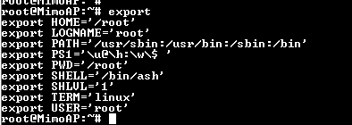

# //WPQ872 erase cal data

sf probe && sf erase 5d0000 30000

# //backup art.bin

To backup the caldata for the board to art.bin using u-boot console command:

run "smeminfo", check the location of ART partition

For nor, it should be 0x2a0000

8: 0:ART 0x0000ffff 0x2a0000 0x40000

For norplusnand, it should be 0x5d0000

17: 0:ART 0x0000ffff 0x5d0000 0x40000

sf probe

sf read 0x44000000 0x2a0000 0x40000

--or--

sf read 0x44000000 0x5d0000 0x40000

sf probe

setenv ipaddr 192.168.1.1 && setenv serverip 192.168.1.10

tftpput 0x44000000 0x40000 art.bin

//Nand read ART.bin

nand info

nand read 0x44000000 0x1100000 0x80000

tftpput 0x44000000 0x80000 art.bin

For WPQ618:

15: 0:ART 0x0000ffff 0x660000 0x40000

sf probe

sf read 0x44000000 0x660000 0x40000

tftpput 0x44000000 0x40000 art.bin

//Replaced Cal data to Uboot (覆盖校验数据）

To flash the art.bin using u-boot console command:

run "smeminfo", check the location of ART partition

For norplusnand, it should be 0x660000

15: 0:ART 0x0000ffff 0x660000 0x40000

setenv ipaddr 192.168.1.1 && setenv serverip 192.168.1.10

tftpboot 0x44000000 art.bin

sf probe

sf erase 0x660000 +0x40000

sf write 0x44000000 0x660000 $filesize

nand read.raw <addr> <offset>|<partition> [count]

从NAND的offset或某个分区中，读取count页，写到内存addr开始的地址处，读取过程跳过ECC的检查

Exp: // read 4 paging, 4096 is bytes, 0X431BDC0 is the file size read out, but in Hex code

nand read.raw 0x44000000 0 4096

tftpput 0x44000000 0x431BDC0 nand.bin

# //force override root password

* First boot into fail safe mode : Enter + Key F
* root@(none):~# mount_root
* switching to jffs2 overlay
* root@(none):/rom/root# passwd
* Changing password for root
* New password:
* Retype password:
* passwd: password for root changed by root
* root@(none):/rom/root# reboot -f

# //check if there is `luci` folder at `/usr/lib/lua/luci

ls /usr/lib/lua/luci

# //check oeminfo

uci show cpxoeminfo

# //check wifi interface

cat /etc/config/wireless

# //Flash References Firmware on 864/865

-------------------------------------------------------------------------------

Flashing QCA reference APPS firmware to nand using u-boot

tftpboot norplusnand-ipq6018_64-single.img

imgaddr=0x42000000 && source $imgaddr:script

-------------------------------------------------------------------------------

# //WPQ864 and WPQ865

Put jumper in JP13 (leave JP9 open) to boot from nand.

Put jumper in JP9 (leave JP13 open) to boot from nor.

# //change root password

passwd

# //iperf

iperf3 -c 192.168.1.10

iperf3 -s

iperf3 -c 192.168.1.10 -b 1000mb -i 1 -t 60

Iperf command for server : iperf -s -i 1 -w 3M

Iperf command for client : iperf -c 192.168.1.137 -i 1 -t 30 -P 5 -w 3M

iperf –s -u –i 1 –f m –w 3M

iperf –c 192.168.1.138 -u –i 1 –f m –w 2M –t 10 –b 100M

# How to calculate Max Tx power on 4 Chain. For example:

4x4 : 20dBm Max Per Chain -> 100mW

Total Power= 100mW * 4 = 400mW

Convert to dBm = 10* (log 400)

= 26dBm (Max for 4 chain)

3x3 : 20dBm Max Per Chain -> 100mW

Total Power= 100mW * 3= 300mW

Convert to dBm = 10* (log 300)

= 24.78dBm (max for 3 Chain)

# //All chain tx power

1x1 : 1

2x2 : 3

3x3 : 5

4x4 : 6

# //Kill Process in Linux

pgreg iperf <-track pid

kill -9 PID <-Kill process ID instantly

# //Show VLAN interface

swconfig dev switch0 show

# //how the current bitrate

iwlist ath0 bitrate

# //factory reset

mtd erase rootfs_data -r

or

rm -rf /overlay/*

reboot

# //check mac hex

md 0x9fff1000

## //change mac address in IPQ8064

set ethaddr 00:aa:bb:cc:dd:ee

set eth1addr 00:aa:bb:cc:dd:ee

saveenv

# //CompexWRT v6.212 LTE module support List

**MiniPCIe v2.0**

**Huawei Me909s:** WPJ563, WPJ419, WPQ864 and WPQ865,

**Sierra Wireless MC7455:** WPJ563, WPJ419, WPQ864 and WPQ865

**Quectel EC25:** WPJ419, WPQ864

**Quectel EP06-E:** WPJ419, WPQ864

**M.2 v3.0**

**Sierra Wireless EM7455**: WPJ428, WPQ865

**Huawei ME906s**: WPJ428, WPQ865

**M.2 5G PCIE3.0 B key**

**Quectel RM500Q-GL:** WPQ873

**//change password for admin in luci**

passwd admin

# //WLE1216V5-20, 20Mhz 11ac bitrate

Bitrate: 346.7Mbps

# //WLE1216V2-20, 20Mhz 11n bitrate

Bitrate: 378.4Mbps

# //show MCS configuration

iwpriv ath1 vhtmcs 9

iwpriv ath1 get_vhtmcs

iwpriv ath1 get_mode

***qca***

//Set country code to CZ and normal channel

wifi down

uci set wireless.wifi1.country=203

uci set wireless.wifi1.channel=36

uci commit wireless

wifi

# // Identify vendor ID:device id

lspci –n

### // Identify the WiFi module is able to detect on Linux PC

* dmesg | grep -i ath10k
* lspci

**//Get TX RX of station**

iwpriv wifi2 enable_ol_stats 1

acfg_tool acfg_assoc_sta_info ath2|awk '{if(NR>1)print}'

*** openWRT ***

# //flash DD

tftp 0x80060000 openwrt-ar71xx-generic-wpj531-16M-rootfs-squashfs.bin&&erase 0x9f050000 +0x630000&&cp.b $fileaddr 0x9f050000 $filesize

tftp 0x80060000 openwrt-ar71xx-generic-wpj531-16M-kernel.bin&&erase 0x9f680000 +$filesize&&cp.b $fileaddr 0x9f680000 $filesize

Linux Board data location

Cd /lib/firmware/ath10k/QCAXXXX

# //iwinfo

iwinfo wlan1 freqlist

# //set country code

iw reg set VN

iw reg get

# //check country code

iwinfo wlan1 countrylist |grep *

iwpriv wifi1 getCountryID

iwpriv wifi0 getCountryID

# //wlan

ifconfig wlan1 down; iw wlan1 set channel 1; ifconfig wlan1 up; iwinfo wlan1 freqlist

iwinfo wlan1 info

# //check the installed packages

opkg list|grep -I xxxxxx

# //vlan tcpdump

Connect to internet then

opkg update

opkg install tcpdump

Or

opkg install /tmp/*.ipk

tcpdump -i eth0 -Ue -w /ipv6_APend_clienttest_G3_noSSDP.pcapng

tcpdump -i eth0 -Ue -w /ipv6_APend_servertest_G3_noSSDP.pcapng

tcpdump -i eth0 -Ue -w /ipv6_Staend_servertest_G3_noSSDP.pcapng

tcpdump -i eth0 -Ue -w /ipv6_Staend_clienttest_G3_noSSDP.pcapng

# //add interface

Brctl addif br-lan eth0.2

For Static

network.lan=interface

network.lan.ifname='eth1 eth0'

network.lan.force_link='1'

network.lan.type='bridge'

network.lan.proto='static'

network.lan.ipaddr='192.168.1.1'

network.lan.netmask='255.255.255.0'

network.lan.ip6assign='60'

network.lan.multicast_querier='0'

network.lan.igmp_snooping='0'

network.lan.ieee1905managed='1'

For DHCP(WPJ344Special Firmware)

network.lan=interface

network.lan.ifname='eth0 eth1'

network.lan.type='bridge'

network.lan._orig_ifname='eth0 eth1 ath0 ath1'

network.lan._orig_bridge='true'

network.lan.proto='dhcp'

network.lan.ieee1905managed='1'

# //delete vlan bridge

brctl delbr br-vlan89

# // add new vlan interface

uci commands to add new interface:

uci set network.test=interface

uci set network.test.proto='dhcp'

uci set network.test.ifname='eth0'

e.g.

uci set network.vlan100=interface

uci set network.vlan100.proto='static'

uci set network.vlan100.ipaddr='192.168.2.1'

uci set network.vlan100.netmask='255.255.255.0'

uci set network.vlan100.ifname='eth0.100'

uci set network.vlan200=interface

uci set network.vlan200.proto='static'

uci set network.vlan200.ipaddr='192.168.3.1'

uci set network.vlan200.netmask='255.255.255.0'

uci set network.vlan200.ifname='eth0.200'

This firmware does support keeping the vlan tag for wireless packet.  
To keep the vlan tag, use:  
uci set wireless.wifi0.no_vlan='1'  
uci set wireless.wifi1.no_vlan='1'

However, the Ethernet driver will remove the vlan tag too.  
For WPJ428, to pass vlan tag 77  
uci add network switch_vlan  
uci set network.@switch_vlan[-1].device='switch0'  
uci set network.@switch_vlan[-1].vlan='77'  
uci set network.@switch_vlan[-1].ports='0t 4t'  
uci set network.@switch_vlan[-1].vid='77'  
uci commit network  
# port 0 is cpu, port 4 is port near to power input.  
To pass more tags, add  more switch_vlan sections  
  
The configurations are similar for WPQ865 and WPQ864.  
Normally switch_vlan can be configured in the webui "Switch" tab,  
but the "ADD" button does not work.

# QCA8081 Change Phy Speed:

ssdk_sh port speed set <port_id> <10|100|1000|2500|5000|10000>

swconfig dev switch0 show

ssdk_sh port speed set 6 10000

dev0@qca>port speed set 3 100

dev0@qca>debug phy set 2 0x04 0x0d01

dev0@qca>debug phy set 2 9 0

dev0@qca>debug phy set 2 0 0x1200

# //show AP information –TX RX

wlanconfig ath0 list sta

For station:

iwpriv wifi2 enable_ol_stats 1

acfg_tool acfg_assoc_sta_info ath1|awk '{if(NR>1)print}'

//Show Radio Tx Statistic

iwpriv wifi1 enable_ol_stats 1

iwpriv ath1 txrx_stats 261

## Getting station statistics

To get station statistic information such as the amount of tx/rx bytes, the last TX bitrate (including MCS rate) you can do:

$ iw dev wlan1 station dump

Station 12:34:56:78:9a:bc (on wlan0)

inactive time: 304 ms

rx bytes: 18816

rx packets: 75

tx bytes: 5386

tx packets: 21

signal: -29 dBm

tx bitrate: 54.0 MBit/s

# //show radio information

cat /etc/config/wireless

## //Athtest cmd to check target power from module

athtestcmd -i wifi0 --tx tx99 --txfreq 2412 --txrate 12 --txchain 1 --tpcm tgtpwr ->ht20 mcs0

athtestcmd --tx off

athtestcmd -i wifi0 --tx tx99 --txfreq 2412 --txrate 19 --txchain 1 --tpcm tgtpwr -> ht20 mcs 7

athtestcmd --tx off

athtestcmd -i wifi0 --tx tx99 --txfreq 2437 --txrate 12 --txchain 1 --tpcm tgtpwr ->ht20 mcs0

athtestcmd --tx off

athtestcmd -i wifi0 --tx tx99 --txfreq 2437 --txrate 19 --txchain 1 --tpcm tgtpwr -> ht20 mcs 7

athtestcmd --tx off

athtestcmd -i wifi0 --tx tx99 --txfreq 5180 --txrate 28 --txchain 1 --tpcm tgtpwr ->ht20 mcs0

athtestcmd --tx off

athtestcmd -i wifi0 --tx tx99 --txfreq 5180 --txrate 35 --txchain 1 --tpcm tgtpwr -> ht20 mcs 7

athtestcmd --tx off

athtestcmd -i wifi0 --tx tx99 --txfreq 5500 --txrate 28 --txchain 1 --tpcm tgtpwr ->ht20 mcs0

athtestcmd --tx off

athtestcmd -i wifi0 --tx tx99 --txfreq 5500 --txrate 35 --txchain 1 --tpcm tgtpwr -> ht20 mcs 7

athtestcmd --tx off

# //set channel

iwconfig ath0 channel 177

# //ACS

iwpriv wifi0 acs_dbgtrace 0xffff

Wait for every minute and check if the scan work. The console will print scanning log

# //vim change wireless config

vim /etc/config/wireless

## //insert change

click insert

## //exit

Esc + :q!

## //exit after write

Esc + :wq!

# //check channel supported in particular bandwidth

wlanconfig ath0 list chan

# //Check firmware source

cat /proc/version

# // check mtd

cat /proc/mtd

cat /dev/mtd

cat .dev.mtd5 > /tmp/xxx.img

hexdump /tmp/

hexdump /tmp/xxx.img

# //kick mac

iwpriv athN kickmac -mac-addrres

Ct- iwpriv ath0 kickmac 3C:33:00:1C:F1:00

iwpriv ath0 kickmac 20:7D:74:17:9E:16

iwpriv ath0 kickmac 16:F0:21:1F:10:0A

Ka - iwpriv ath0 kickmac 30:10:B3:77:DA:7D

Ch - iwpriv ath0 kickmac 88:9F:FA:8A:F9:7A

Ch oppo- iwpriv ath0 kickmac 44:04:44:35:2e:75

82M - iwpriv ath0 kickmac 04:F0:21:1C:72:E7

81R - iwpriv ath0 kickmac 04:F0:21:1C:74:2B

Alex - iwpriv ath0 kickmac B4:AE:2B:C3:EB:DE

Y - iwpriv ath0 kickmac 04:F0:21:10:9E:C9

Yv - iwpriv ath0 kickmac C8:3A:35:C7:31:AD

Alice - iwpriv ath0 kickmac 04:F0:21:1B:1D:1A/ 08:57:00:2A:A6:F6

June - iwpriv ath0 kickmac 04:F0:21:1C:74:27

Jeslyn - iwpriv ath0 kickmac 08:10:76:FA:E8:8A

Margaret - iwpriv ath0 kickmac 64:FB:81:69:97:1A

RD server - iwpriv ath0 kickmac 04:F0:21:07:7C:E8

Christine - iwpriv ath0 kickmac 3C:33:00:1C:F1:00

# //ping

ping 192.168.1.51 -t -l 30000

# // Check linux PC detectability on WiFi modules

Dmesg | grep -i ath10k

## //ping in linux

ping [ -LRUbdfnqrvVaAB] [ -c count] [ -i interval] [ -l preload] [ -p pattern] [ -s packetsize] [ -t ttl] [ -w deadline] [ -F flowlabel] [ -I interface] [ -M hint] [ -Q tos] [ -S sndbuf] [ -T timestamp option] [ -W timeout] [ hop ...] destination

## //ping in MSdos

ping [-t] [-a] [-n count] [-l size] [-f] [-i TTL] [-v TOS] [-r count] [-s count] [-w timeout] [-R] [-S srcaddr] [-p] [-4] [-6] target [/?]

# //ipv6

2001:db8:290c:1291::6/64

# //check wifi module detection on PCIE -200nx

cat /proc/bus/pci/devices

# //copy patch file

scp atheros.sh root@192.168.1.1:/lib/wifi/

# //enable log in ap

iwpriv ath1 dbgLVL 0x0020000C

//enable log in sta

iwpriv ath1 dbgLVL 0

**// Identify NOR / NAND on WPJ419**

machid : 0x8010001 = NOR

machid : 0x8010401 = NAND

# //stop firewall

/etc/init.d/firewall stop

# //hostapd

cd /var/run  
find -name "*hostapd*"

cat hostapd-ath0.conf

cd /lib/wifi/ ->hostapd source code

# //disable admin/guest ssh access

root:x:0:0:root:/root:/bin/ash

daemon:*:1:1:daemon:/var:/bin/false

admin:x:10:10:root:/root:/bin/false

ftp:*:55:55:ftp:/home/ftp:/bin/false

network:*:101:101:network:/var:/bin/false

nobody:*:65534:65534:nobody:/var:/bin/false

#for example, here I disable admin account

# //CNMS OEM activation key.

sGC-9eM-aUJ-aNZ

# //remote to device and disable admin/guest ssh access

sshpass -p <root_password_here> ssh root@<board_ip_here> "sed -i -r 's/(admin|guest.*)ash/\1false/' /etc/passwd"

#example:

#sshpass -p abcd1234 ssh root@192.168.1.1 "sed -i -r 's/(admin|guest.*)ash/\1false/' /etc/passwd"

# //to show 3G module information

cat /proc/bus/usb/devices

# //to clear activation

uci set cpxoeminfo.oemflash.enabled=""

uci set cpxoeminfo.oemflash.activated=""

uci commit cpxoeminfo

## // to generate encrypt key in console

echo "siewwan4BZHfA3hfXs9W5=p" | md5sum

uci set cpxoeminfo.oemflash.compex_key="md5sum of newkey"

## // to show final activation key

uci show cpxoeminfo

# //to search file in whole system

find ./ -name "*wpa*"

# //to search content in one file

Grep -i “abc” filename

//iwpriv set spatial stream (1x1, 2x2 …)

iwpriv ath0 get_nss //get current nss

iwpriv ath0 nss 2 //set to 2x2

**Linux – Check HT mode supported**

Iw phy

iw phy0 info

wifi down

iw phy0 set antenna 0x01

wifi up

# WPJ558 Max supporting Voltage

Max Votlage = 56V

# WPJ428 Max supporting Voltage

Max Volage =

# //led

find / -name "*factorys*"

cd /sys/bus/platform/devices/leds-gpio

Ls

cd leds/wpj558\:

#2.4G Wifi Led

echo 0 > /sys/class/leds/ath9k-phy0/brightness

#5G wifi Led

echo 0 > /sys/class/leds/ath9k-phy1/brightness

echo 0 > /sys/class/leds/wpj531:green:power/brightness

echo 0 > /sys/class/leds/netgear:green:usb/brightness

echo 0 > brightness

# //Total Tx power on each chain (Single Chain Tx power + )

1x1 = 1

2x2 = 3

3x3 = 5

4x4 = 6

# //Only Allow Radio to operate in certain Channel

Wifitool athx setprimarychans ch 1 ch2 .. chn

Actual: **wifitool ath0 setprimarychans 1 2 3 4** //only channel 1, 2, 3, 4 is allow to use, other then that can’t use

Actual: **wifitool athX getprimarychans //**get the channel configured

Actual: **wifitool athX setprimarychans //**initialize the channe list

# //system/device/LEDs

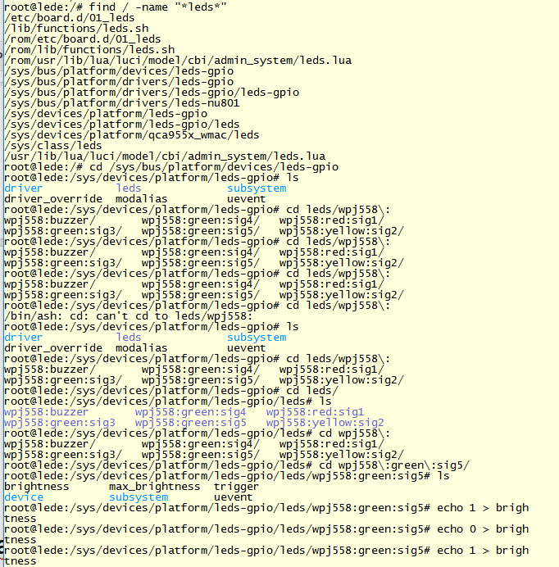

# WPJ531 LED configuration vs GPIO

# PWR LED : no gpio connect   **WAN LED : QCA9531 A59 pin/GPIO13** **LAN LED : QCA9531 B50 pin/GPIO11** **RSSI1 LED : QCA9531 A58 pin/GPIO12    RSSI2 LED : QCA9531 A77 pin/GPIO14** **RSSI3 LED : QCA9531 B67 pin/GPIO15    RSSI4 LED : QCA9531 A78 pin/GPIO16**

# //generate backup config file via telnet

sysupgrade --create-backup - 2>/dev/null 1>/www/backup.tar.gz

download backup file at http://192.168.1.1/backup.tar.gz

# //Check GPIO Pin value 1/0

In loader mode: diag gpio 38 0

In loader mode : diag gpio 41 0

# //To set the chainmask in 1x1 :

iwpriv wifi0 rxchainmask 0x01

iwpriv wifi0 txchainmask 0x01

## //To set the chainmasks in 2x2

iwpriv wifi0 rxchainmask 0x03

iwpriv wifi0 txchainmask 0x03

**//To set the chainmasks in 2x2(LEDE/OpenWRT)**

wireless.radio0.txantenna='3'

wireless.radio0.rxantenna='3'

## //get chainmask value

iwpriv wifi0 get_txchainmask

iwpriv wifi0 get_rxchainmask

## //set the txchaimask/rx to operate in specific chain 0, 1, 2, 3

Chain 0: iwpriv wifiN txchainmask 0x01

Chain 1: iwpriv wifiN txchainmask 0x02

Chain 2: iwpriv wifiN txchainmask 0x04

Chain 3: iwpriv wifiN txchainmask 0x08

---Monitoring mode---

# QSDK //to create monitor mode

brctl delif br-lan ath0

ifconfig ath0 192.168.3.2

wlanconfig ath0 destroy

wlanconfig ath0 create wlandev wifi0 wlanmode monitor

ifconfig ath0 up

# //to capture tcpdump pcaplog

tcpdump -i ath0 -w /tmp/log_file41.pcapng

# Check whether LTE module able detected

**cd sys/kernel/debug/usb**

**cat devices**

# //While

while true; do wlanconfig ath1 list sta; sleep 1; done

# //device ID

In the /dev/mtdblock0 at 0x2e050

MMJ344: 11 f6 06 90 11 f6 06 90 00 00 00 03 00 00 00 00

MPS344: 11 f6 06 87 11 f6 06 87 00 00 00 00 00 00 00 00

687 is WPJ344, 690 is WPJ344-A.

Wle600vx和wle900vx的device id 是0x003c。

WLE650V5 0x56

WLE1000V5 0x40

WLE1216V5 0x46

WLE900VX 003C

# //execute command in /etc/rc.local everytime reboot

cd /etc

find ./ -name "*local*"

vi rc.local

# //Sh

Cd /mnt

Ls

Sh xx.sh ath1

Tmp log

/mnt#

./check_rx_tx_rate.sh

# Setup WPA2-EAP enterprise network

*login password = 1234

*root password = abcd1234

1. First, setup radius server.

On linux PC, sudo apt-get install freeradius

1. The directory of radius server will appear here:

Cd /etc/freeradius/3.0

1. Include AP information inside the clients.conf

Client 192.168.1.1 {

secret = test1234 //when setup AP, should use this secret !!

shortname = TestRadius //any words, I will put it same as SSID

}

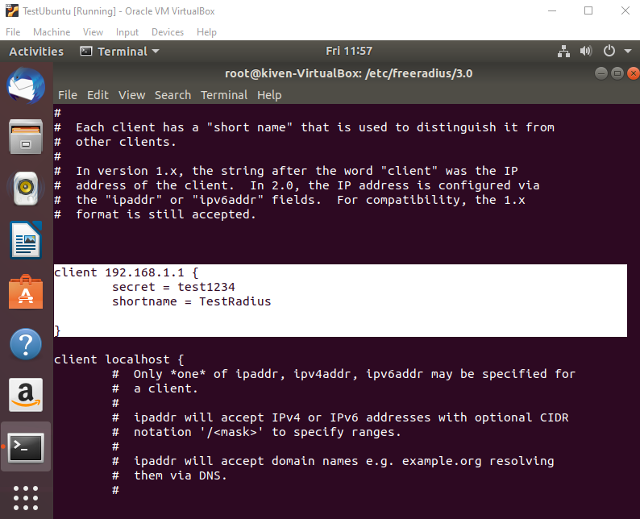

1. The radius IP address should be eth0 interface of your Linux PC.

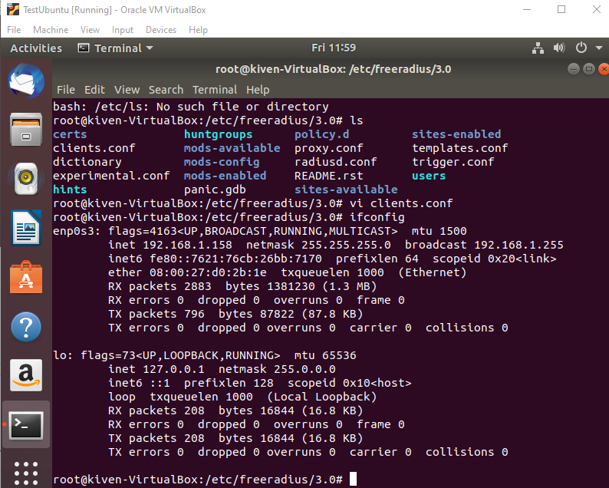

Go to setup Username for allow client device connect. In this directory : Cd /etc/freeradius/3.0/mods-config/files . edit **authorize** file -> vi authorize

1. Add in the username and password for client.

**user1 Cleartext-password :=”testing”**

//username=user1, password= testing.

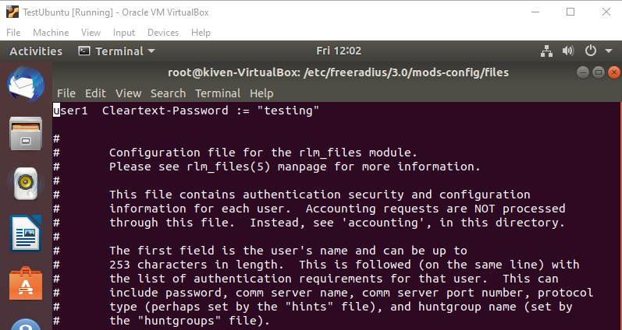

1. On luci interface, setup something’s like this :

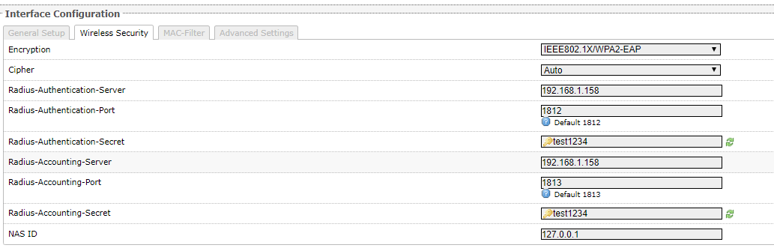

1. Start Radius server : systemctl start freeradius
2. Check status : systemctl status freeradius

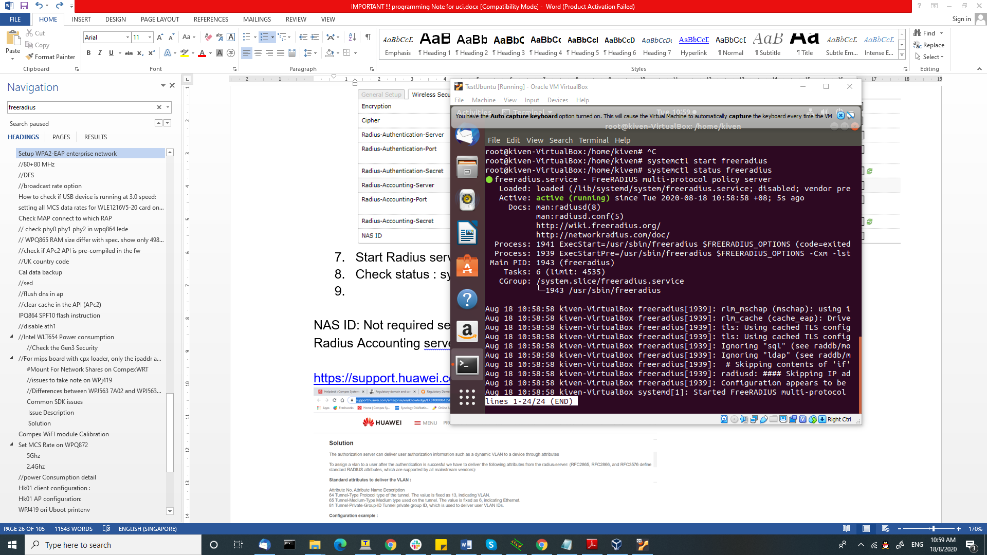

NAS ID: Not required set

Radius Accounting server : Not required too. Except you got the server

<https://support.huawei.com/enterprise/en/knowledge/EKB1000061256>

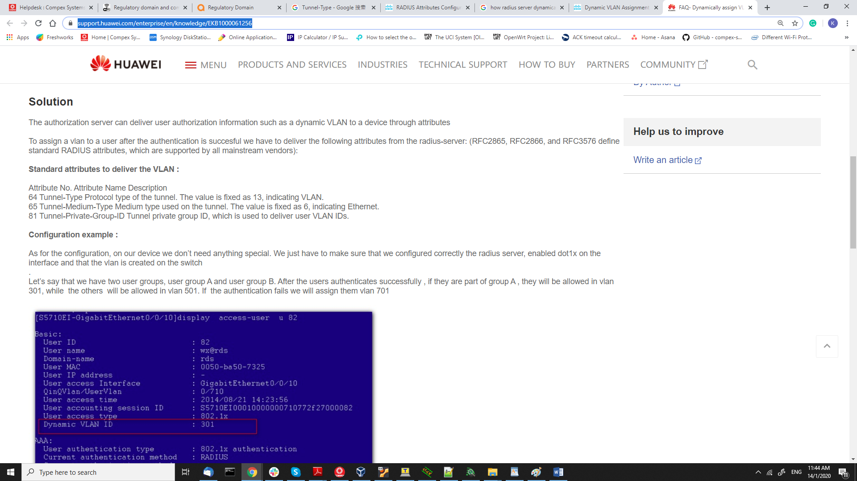

* FOR EAP-TlS

1. Edit the file under the etc/freeradius/3.0/mods-enabled -> **eap** file
2. Modify the **default_eap type = tls**

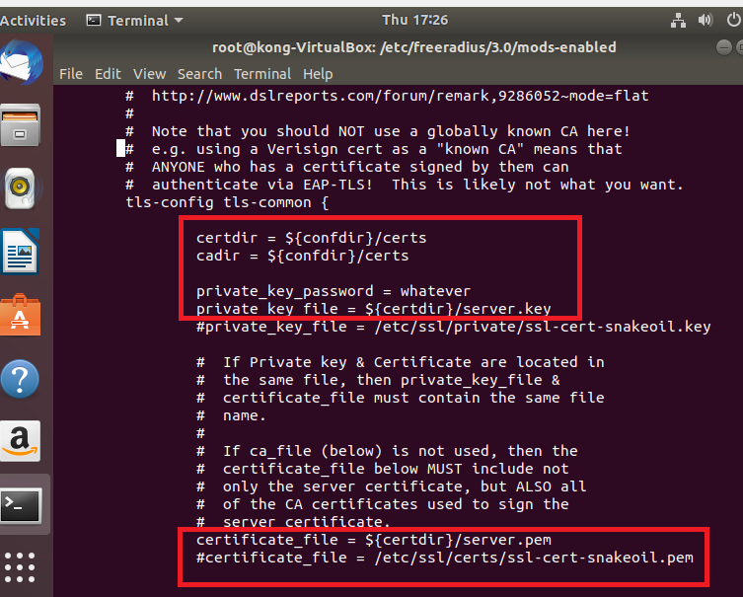

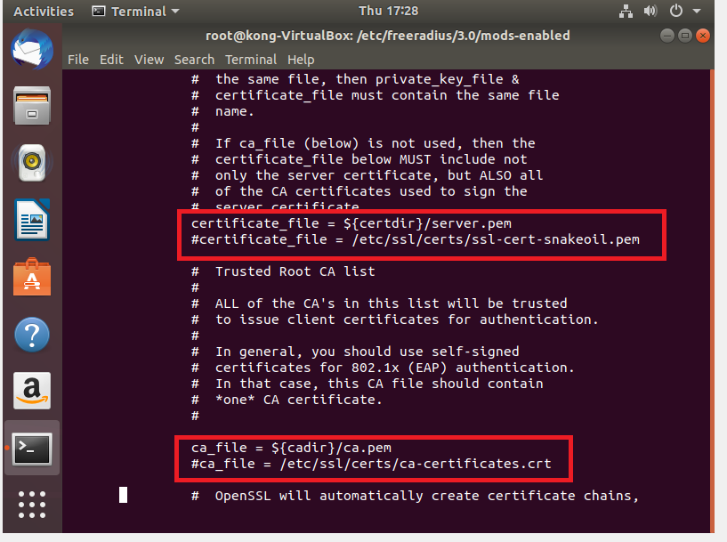

1. Generate certificate ?

Go to /etc/freeradius/3.0/certs/

* make

1. You will generate following files

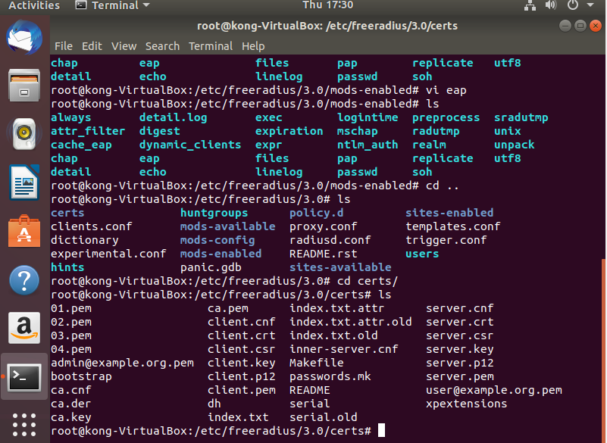

* Path to Private Key = client.key
* Ca-certificate = ca.pem
* Path to Client-Certificate = client.pem

# //80+80 MHz

Two method to determine whether the radio supports 80+80 and VHT160.

1) use hwcap from iwinfo:

(hwcap & 0x100000) != 0 means VHT160 supported

(hwcap & 0x200000) != 0 means VHT80_80supported

2) use

Looks for text strings "11AC_VHT160", "11AC_VHT80_80"

UCI configs:

1) VHT160 mode:

wireless.wifi1.channel=36

wireless.wifi1.htmode=HT160

2) VHT80_80 mode:

wireless.wifi1.channel=36

wireless.wifi1.htmode=HT80_80

wireless.@wifi-iface[1].cfreq2=106

From the output of "wlanconfig ath1 list chan"

Channel 36 : 5180 Mhz 11na C CU V VU V80- 42 V160- 50 Channel 120 : 5600 Mhz 11na C CL V VL V80-122 V160-114

Channel 40 : 5200 Mhz 11na C CL V VL V80- 42 V160- 50 Channel 124 : 5620 Mhz 11na C CU V VU V80-122 V160-114

Channel 44 : 5220 Mhz 11na C CU V VU V80- 42 V160- 50 Channel 128 : 5640 Mhz 11na C CL V VL V80-122 V160-114

Channel 48 : 5240 Mhz 11na C CL V VL V80- 42 V160- 50 Channel 132 : 5660 Mhz 11na C CU V VU V80-138

Channel 52 : 5260 Mhz 11na C CU V VU V80- 58 V160- 50 Channel 136 : 5680 Mhz 11na C CL V VL V80-138

Channel 56 : 5280 Mhz 11na C CL V VL V80- 58 V160- 50 Channel 140 : 5700 Mhz 11na C CU V VU V80-138

Channel 60 : 5300 Mhz 11na C CU V VU V80- 58 V160- 50 Channel 144 : 5720 Mhz 11na C CL V VL V80-138

Channel 64 : 5320 Mhz 11na C CL V VL V80- 58 V160- 50 Channel 149 : 5745 Mhz 11na C CU V VU V80-155

Channel 100 : 5500 Mhz 11na C CU V VU V80-106 V160-114 Channel 153 : 5765 Mhz 11na C CL V VL V80-155

Channel 104 : 5520 Mhz 11na C CL V VL V80-106 V160-114 Channel 157 : 5785 Mhz 11na C CU V VU V80-155

Channel 108 : 5540 Mhz 11na C CU V VU V80-106 V160-114 Channel 161 : 5805 Mhz 11na C CL V VL V80-155

Channel 112 : 5560 Mhz 11na C CL V VL V80-106 V160-114 Channel 165 : 5825 Mhz 11na C V

Channel 116 : 5580 Mhz 11na C CU V VU V80-122 V160-114

The channels list from iwinfo has added two fields, chan80 and chan160, corresponding to the table above,

e.g for Channel 36, chan80=42 and chan160=50, while for Channel 165, both fields not exist.

For HT160, only channels with V160 can be used, the value in chan160 is not important,

wireless.wifi1.channel must be set to 36, 40 etc, not 50.

For HT80_80, wireless.wifi1.channel should be set to 36, 40 etc, not 42, but the

wireless.@wifi-iface[1].cfreq2 must be set to the number behind V80-, eg 106, not 100, 104 etc.

wireless.@wifi-iface[1].cfreq2 must be greater than wireless.wifi1.channel.

The separation between first and second bands of HT80 must be greater than 80MHz, so if

wireless.wifi1.channel is one of (36, 40, 48, 52), then the valid cfreq2 is one of (106, 122, 138, 155). Must not the same band ! (UNII-2 cannot pair with UNII-2a)

58 cannot be used because the separation is 80Mhz.

Example:

1. Can we set like this?

wireless.wifi1.channel=144

wireless.@wifi-iface[1].cfreq2=155

I still see 1.733Gbps

Yes, the center frequency of this ch132-144 V80 band is 138,

the separation is (155-138) * 5 = 85Mhz which is greater than 80Mhz.

The QCA9984 can only support NSS 2 when in VHT80+80 or VHT160 mode,

so the max rate is still 1.733

1. wireless.wifi1.channel can be set to auto, cfreq2 can be set to auto or omiited.

# Don't have setting on web page. If possible, try

# 802.11ac 11ACVHT80+80 operating mode

uci set wireless.wifi0.hwmode=11ac

uci set wireless.wifi0.htmode=HT80_80

uci set wireless.wifi0.channel=40

# Don't use the 80MHz number: uci set wireless.wifi0.channel=42

# Use the 80MHz number: 155

uci set wireless.@wifi-iface[0].cfreq2=155

uci set wireless.wifi0.txpower='18'

uci commit wireless

wifi

sleep 3

iwpriv ath0 get_nss

iwpriv ath0 nss 2

Remove the setting if not using HT80_80

uci set [wireless.@wifi-iface[0].cfreq2](mailto:wireless.@wifi-iface[0].cfreq2)=""

**Set 80_80 Second Channel mode with iwpriv and iwconfig**

//iwpriv to set second channel

iwpriv ath0 cfreq2 106 or 5530

//iwpriv to check current second channel

Iwpriv ath0 get_cfreq2

//then only change the primary channel

Iwconfig ath0 channel 36

# //DFS

iwpriv wifi1 setCountryID 203

iwpriv wifi1 setCountry CZ

uci set wireless.@wifi-iface[1].cfreq2=106

uci set wireless.wifi1.htmode=HT80_80

uci set wireless.wifi1.channel=36

uci commit wireless

wifi up; wifi down

//debug level

radartool -i wifi1 dfsdebug 0x00000100

radartool -i wifi1 dfsdebug 0x00000200

radartool -i wifi1 dfsdebug 0x00000400

radartool -i wifi1 dfsdebug 0x00000800

radartool -i wifi1 dfsdebug 0x00001000

radartool -i wifi1 dfsdebug 0x00002000

radartool -i wifi1 dfsdebug 0x00004000

radartool -i wifi1 dfsdebug 0x00008000

radartool -i wifi1 enable

radartool -i wifi1 bangradar

radartool -I wifi1 ignorecac 1

//sta

iwpriv wifi1 staDFSEnable 1

radartool -i wifi1 shownolhistory

radartool -i wifi1 setnol 140

//set channel

wifi down

uci set wireless.wifi1.country=203

uci set wireless.wifi1.channel=36

uci commit wireless

wifi

iwconfig ath1 channel 100

iwconfig ath0 channel 11

iwconfig ath1

另此命令可将切换到dfs channel的等待时间从60秒缩短到10秒

iwpriv ath1 set_cactimeout 10

之前的这个指令我们都是用在串口的。

//先设一个DFS Channel

Iwconfig ath1 channel 52

然后实行以下：

radartool commands:

root@OpenWrt:/# radartool -i wifi1 dfsdebug 0x00000100

[ 72.727247] dfs_control debug level now = 0x100

root@OpenWrt:/#

root@OpenWrt:/# radartool -i wifi1 dfsdebug 0x00008000

[ 82.578289] dfs_control debug level now = 0x8000

root@OpenWrt:/# radartool -i wifi1 enable

[ 142.530674] dfs_control enable detects, ignore_dfs 0

run bangradar when in dfs channel 52, and channel changed to 153

root@OpenWrt:/# radartool -i wifi1 bangradar

root@OpenWrt:/# [ 271.111623] Radar found on channel 52 (5260 MHz)

[ 271.115400] ol_if_dfs_clist_update: called, cmd=1, nollist=ca27cd80, nentries=4

[ 271.123688] Changing to HT80 non-DFS channel 153 (5765 MHz)

[ 271.685153] OL vap_start +

[ 271.686945] VDEV RESTART

[ 271.689433] OL vap_start -

[ 271.692299] ol_ath_VA_set_param: Now supported MGMT RATE is 6000(kbps) and rate code: 0x3

[ 271.874888] ol_vdev_start_resp_ev for vap 0 (cbcb2000)

[ 271.879106] send_wmm_update_cmd_non_tlv:

[ 271.883605] su bfee 1 mu bfee 0 su bfer 1 mu bfer 1 impl bf 0 sounding dim 1

[ 271.890028] send_vdev_up_cmd_non_tlv for vap 0

[ 271.894439] __ieee80211_smart_ant_init: Smart Antenna is not supported

[ 273.182093] [wifi1] FWLOG: [284865] RESMGR_OCS_GEN_PERIODIC_NOA ( 0x0 )

[ 273.187700] [wifi1] FWLOG: [284865] RESMGR_OCS_GEN_PERIODIC_NOA ( 0x0 )

[ 273.194301] [wifi1] FWLOG: [284865] vap-0 VDEV_MGR_VDEV_START ( 0x1685, 0x2, 0x0, 0x0 )

[ 273.202284] [wifi1] FWLOG: [284865] WAL channel change freq=5765, mode=10 flags=0 rx_ok=1 tx_ok=1

[ 273.211132] [wifi1] FWLOG: [285055] UNKNOWN 14:20 ( 0x0 )

[ 274.181222] [wifi1] FWLOG: [286394] VDEV_MGR_HP_START_TIME ( 0x0, 0x1685, 0xe3a3001 )

[ 274.188044] [wifi1] FWLOG: [286394] RESMGR_OCS_GEN_PERIODIC_NOA ( 0x1 )

[ 274.194642] [wifi1] FWLOG: [286394] RESMGR_OCS_GEN_PERIODIC_NOA ( 0x0 )

[ 274.201236] [wifi1] FWLOG: [286394] VDEV_MGR_AP_TBTT_CONFIG ( 0x0, 0x1685, 0x0, 0x0 )

root@OpenWrt:/# radartool -i wifi1 ignorecac 1

[ 304.222753] dfs_control ignore cac = 0xffffffff

---------------------------------------------------------------------------------------------------------------

**//My experiment on radartool**

//Configure existing 5G Channel to any DFS Channel, exp: Channel 52。

**Iwconfig ath1 channel 52**

//Set country code :

**iwpriv wifi1 setCountry CZ**

//restart WIFI

**wifi**

//debug level

**radartool -i wifi1 dfsdebug 0x00000200**

//activated radar detection system

**radartool -I wifi0 enable**

//execute bangradar command

**radartool -i wifi0 bangradar**

-----------------------------------------------------------------------------------------------------------------------

# //broadcast rate option

1. QCA driver support this command, e.g.:

iwpriv ath0 bcast_rate 54000

to change the broadcast rate to 54mpbs.

The rate is in kbps, and not all rates are supported.

2. For ath9k/ath10k, not sure whether the broadcast rate

can be changed or not.

//RSSI

Athstats -i wifi1 |egrep rssi

Iwpriv wifi1 get_txchainmask

# How to check if USB device is running at 3.0 speed:

Plug a USB3.0 flash drive to the USB port,

run this command at the console:

cat /sys/kernel/debug/usb/devices

Look for the info for flash drive, the brand name should be

there, check the speed, if speed is 5000, it is USB3

Tested using DK04, the flash drive can run at USB3 speed.

Other boards not tested.

//

opkg list-installed | grep usb

# setting all MCS data rates for WLE1216V5-20 card on WPQ864 board

For VHT rates,

use the combinations of vhtmcs and nss commands:

iwpriv ath1 vhtmcs <mcs>

iwpriv ath1 nss <nss>

valid number for mcs is 0-9

valid number for nss is 1-4

example:

iwpriv ath1 vhtmcs 5

iwpriv ath1 nss 2

For 11na, 11ng rates, use set11NRates command:

commands:

nss=1

MCS 0: iwpriv ath1 set11NRates 0x80808080

MCS 1: iwpriv ath1 set11NRates 0x81818181

MCS 2: iwpriv ath1 set11NRates 0x82828282

MCS 3: iwpriv ath1 set11NRates 0x83838383

MCS 4: iwpriv ath1 set11NRates 0x84848484

MCS 5: iwpriv ath1 set11NRates 0x85858585

MCS 6: iwpriv ath1 set11NRates 0x86868686

MCS 7: iwpriv ath1 set11NRates 0x87878787

nss=2

MCS 0: iwpriv ath1 set11NRates 0x88888888

MCS 1: iwpriv ath1 set11NRates 0x89898989

MCS 2: iwpriv ath1 set11NRates 0x8a8a8a8a

MCS 3: iwpriv ath1 set11NRates 0x8b8b8b8b

MCS 4: iwpriv ath1 set11NRates 0x8c8c8c8c

MCS 5: iwpriv ath1 set11NRates 0x8d8d8d8d

MCS 6: iwpriv ath1 set11NRates 0x8e8e8e8e

MCS 7: iwpriv ath1 set11NRates 0x8f8f8f8f

nss=3

MCS 0: iwpriv ath1 set11NRates 0x90909090

MCS 1: iwpriv ath1 set11NRates 0x91919191

MCS 2: iwpriv ath1 set11NRates 0x92929292

MCS 3: iwpriv ath1 set11NRates 0x93939393

MCS 4: iwpriv ath1 set11NRates 0x94949494

MCS 5: iwpriv ath1 set11NRates 0x95959595

MCS 6: iwpriv ath1 set11NRates 0x96969696

MCS 7: iwpriv ath1 set11NRates 0x97979797

nss=4

MCS 0: iwpriv ath1 set11NRates 0x98989898

MCS 1: iwpriv ath1 set11NRates 0x99999999

MCS 2: iwpriv ath1 set11NRates 0x9A9A9A9A

MCS 3: iwpriv ath1 set11NRates 0x9B9B9B9B

MCS 4: iwpriv ath1 set11NRates 0x9C9C9C9C

MCS 5: iwpriv ath1 set11NRates 0x9D9D9D9D

MCS 6: iwpriv ath1 set11NRates 0x9E9E9E9E

MCS 7: iwpriv ath1 set11NRates 0x9F9F9F9F

For 11a, 11g rates, use set11NRates command:

commands:

6 Mbps: iwpriv ath1 set11NRates 0x0b0b0b0b

9 Mbps: iwpriv ath1 set11NRates 0x0f0f0f0f

12 Mbps: iwpriv ath1 set11NRates 0x0a0a0a0a

18 Mbps: iwpriv ath1 set11NRates 0x0e0e0e0e

24 Mbps: iwpriv ath1 set11NRates 0x09090909

36 Mbps: iwpriv ath1 set11NRates 0x0d0d0d0d

48 Mbps: iwpriv ath1 set11NRates 0x08080808

54 Mbps: iwpriv ath1 set11NRates 0x0c0c0c0c

UCI config for setting 11b rates:

uci set wireless.wifi0.hwmode='11b'

uci set wireless.@wifi-iface[0].set11NRates=0x1b1b1b1b

uci set wireless.@wifi-iface[0].set11NRetries=0x04040404

uci commit wireless

1mbps: 0x1b1b1b1b

2mbps: 0x1a1a1a1a

5.5 mbps: 0x19191919

11 mbps: 0x18181818

//Check for 11N VHT

iwpriv ath0 get_vht_11ng // 0 disable

# Check MAP connect to which RAP

cat /tmp/meshgwl.tmp

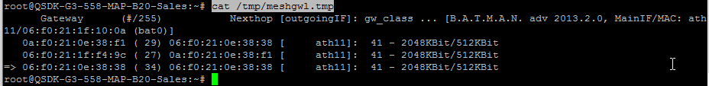

# // check phy0 phy1 phy2 in wpq864 lede

Cd /sys/class/ieee80211

Ls

# // WPQ865 RAM size differ with spec. show only 498Mb, but not 1GB

After using nand-ipq806x-single.img for WPQ864/WPQ865, RAM only show 491Mb, but not 1GB.

To solve it, flash the cdt.bin file on the board. (cdt file -> tech support info -> WPQ865 RAM )

# Run smeminfo, make sure DDRCONFIG is as follow

4: 0:DDRCONFIG 0x0000ffff 0x540000 0x120000

# Run u-boot command:

tftpboot 0x42000000 AP161-cdt.bin

ipq_nand sbl

nand erase 0x540000 0x120000

nand write 0x42000000 0x540000 0x800

reset

# //check if APc2 API is pre-compiled in the fw

Winscp to the board

Goto /usr/lib/lua/luci

Check every cpx_xxxx.lua file.

If it is able to open using insomnia app, that means the API is not precompiled.

# //UK country code

**For Normal UK Country code:**

CH36 to CH64: Max EIRP is 23dBm.

CH100 to CH144: Max EIRP should be 30dBm.

CH149 to CH165: Max EIRP should be 23dBm (no-licensed)

**For Band B:**

CH100 to CH144: Max EIRP 30dBm.

**For Band C:**

CH149 to CH165: Max EIRP 36dBm. (licensed)

# cal data backup

Caldata backup for HK01 boards.

Check the serial number and use the correct art.bin.

For new board, please backup the caldata before doing any test.

--------------------------------------------------------------------------------------------------

To backup the caldata for the board to art.bin using u-boot console command:

run "smeminfo", check the location of ART partition

For nor, it should be 0x2a0000

8: 0:ART 0x0000ffff 0x2a0000 0x40000

For norplusnand, it should be 0x5d0000

17: 0:ART 0x0000ffff 0x5d0000 0x40000

sf probe

sf read 0x44000000 0x2a0000 0x40000

--or--

sf read 0x44000000 0x5d0000 0x40000

setenv ipaddr 192.168.1.1 && setenv serverip 192.168.1.10

tftpput 0x44000000 0x40000 art.bin

--------------------------------------------------------------------------------------------------

To flash the art.bin using u-boot console command:

run "smeminfo", check the location of ART partition

For nor, it should be 0x2a0000

8: 0:ART 0x0000ffff 0x2a0000 0x40000

For norplusnand, it should be 0x5d0000

17: 0:ART 0x0000ffff 0x5d0000 0x40000

setenv ipaddr 192.168.1.1 && setenv serverip 192.168.1.10

tftpboot 0x44000000 art.bin

sf probe

sf erase 0x2d0000 +0x30000

sf write 0x44000000 0x2a0000 $filesize

--or--

sf erase 0x5d0000 +0x40000

sf write 0x44000000 0x5d0000 $filesize

# //sed

<http://www.grymoire.com/Unix/Sed.html#uh-62h>

sed -i -e 's/abcd/option disabled/g' /etc/config/wireless

//backup 419 cal data

7: 0:ART 0x0000ffff 0x170000 0x10000

sf probe

sf read 0x88000000 0x170000 0x10000

setenv ipaddr 192.168.1.1 && setenv serverip 192.168.1.10

tftpput 0x88000000 0x10000 art.bin

# //flush dns in ap

/etc/init.d/dnsmasq restart

# //clear cache in the API (APc2)

rm -r /tmp/luci-modulecache/

[root@local ~]# echo "2" > /proc/sys/net/ipv4/conf/eth1/force_igmp_version

[root@local ~]# cat /proc/sys/net/ipv4/conf/eth1/force_igmp_version

2

[root@local ~]# tcpdump -i eth1 igmp

tcpdump: verbose output suppressed, use -v or -vv for full protocol decode

listening on eth1, link-type EN10MB (Ethernet), capture size 96 bytes

20:42:22.411755 IP 192.168.0.200 > IGMP.MCAST.NET: igmp v3 report, 1 group record(s)

20:44:19.835355 IP 192.168.0.30 > ALL-SYSTEMS.MCAST.NET: igmp query v3

20:44:27.425615 IP 192.168.0.200 > IGMP.MCAST.NET: igmp v3 report, 1 group record(s)

CNMS需要FW里面有uconfig package才能被自动识别.

With firmware 2.4.x able to support Half/ Quarter Channel Spectrum, eg. 5/10MHz (802.11a+g) for on board radio card and WLE200VX only.

# IPQ864 SPF10 flash instruction

tftpboot 0x44000000 norplusnand-ipq806x-single.img  
***If using a NOR flash, use this command:  
sf probe  
Flash the image:  
imgaddr=0x44000000 && source $imgaddr:script

tftpboot 0x44000000 ipq806x-nor-apps.img

imgaddr=$fileaddr && source $imgaddr:script

# //disable ath1

uci set [wireless.@wifi-iface[1].disabled=0](mailto:wireless.@wifi-iface[1].disabled=0)

uci commit wireless

wifi

**//Web server**

Web server mode:http port: 80

Web server mode:https port: 443

# //Intel WLT654 Power consumption

3.3V = 5W

5V = 13.5W

**China Production Work Ticket.**

**Number of MAC addresses.**

**How can there be only one MAC address per board?/**

**Update:** The reason is that it is a PCBA / semi-finished board / onboard radio only.

**For CompexWRT firmware, we always have 4 MAC addresses per board.**

**For the 342, 344, 563 and 558 boards, the two Ethernet ports are connected to the same internal switch.**

**They actually only need 1 MAC address.**

**The CompexWRT firmware virtualizes the MAC address so that the two Ethernet ports have two MAC addresses.**

**For the 531 board, the two Ethernet ports are connected to the processor. Therefore, they must have 2 different MAC addresses.**

**Correction: If customer wants 1 MAC address per board, we give them as they wish.**

**The onboard radio actually has a different MAC address.**

**The card radio also has a different MAC address.**

**The CompexWRT firmware will override the onboard radio MAC address and the card radio MAC address.**

**Therefore, this accounts for the 4 MAC addresses used by CompexWRT.**

**The customer’s firmware can also be put on boards with Compex MAC addresses.**

**For the 342, 344, 563 and 558 boards, the customer can request for only 1 MAC address per board. Their firmware would use the radio’s native MAC address.**

**For the 531 board, it must have at least 2 MAC addresses.**

**Customer can request for 1 MAC address per board.**

**//LEDE Compiling Method**

Kindly use the following instructions to build your LEDE firmware.

1. Install all dependencies:

sudo apt-get install subversion g++ zlib1g-dev build-essential git python rsync man-db

sudo apt-get install libncurses5-dev gawk gettext unzip file libssl-dev wget zip

2. Clone the repository:

git clone https://github.com/lede-project/source

3. Change the directory:

cd source

4. Update and install packages:

./scripts/feeds update -a

./scripts/feeds install -a

5. make menuconfig

select information as below

Target System (Atheros AR7xxx/AR9xxx)

Subtarget (Generic)

Target Profile (Compex WPJ563)

Select other options like Compex WPJ342 if you want to compile WPJ342

Enable LuCI web management

LuCI —>

Collections —>

<*> luci

6. make

After the make process done, the firmware will be stored inside bin/targets/ar71xx/generic folder.

Please let me know if you got more query regarding to this build method, we would be happy to help you.

VAP Quantity: Max = 16 for each 2.4 and 5Ghz

**//For OTP Editing**

here is the instruction:

change the following Makefile :

qsdk/target/linux/ar71xx/image/Makefile

Change this line : cpxwrt_mtdlayout_16M=mtdparts=spi0.0:192k(u-boot)ro,1536k(kernel),14464k(rootfs),64k(otp)ro,64k(nvram),64k(art)ro,16000k@0x30000(firmware)

to: cpxwrt_mtdlayout_16M=mtdparts=spi0.0:192k(u-boot)ro,1536k(kernel),14464k(rootfs),64k(otp),64k(nvram),64k(art)ro,16000k@0x30000(firmware)

ro : means readonly parition, please remove ro for otp partition

Then run make command to build the firmware (edited)

2. How to read/write after firmware boot up

2.1. check partition number by running the command cat /proc/mtd

root@MimoAP:/# cat /proc/mtd

dev: size erasesize name

mtd0: 00030000 00010000 "u-boot"

mtd1: 00180000 00010000 "kernel"

mtd2: 00e20000 00010000 "rootfs"

mtd3: 003d0000 00010000 "rootfs_data"

mtd4: 00010000 00010000 "otp"

mtd5: 00010000 00010000 "nvram"

mtd6: 00010000 00010000 "art"

mtd7: 00fa0000 00010000 "firmware"

so we can see otp parition number is mtd4 (edited)

to erase partition: mtd erase /dev/mtd4

to read/write we can you cat command

cat /dev/mtd4 > /tmp/otp.bin to read content of otp parition to otp.bin file (edited)

we can write by command: cat file-to-write > /dev/mtd4

Done

**//Check WiFi Driver Version**

opkg list | grep wifi

**//Typical Configuration**

root@MimoAP:~# uci show wireless

wireless.wifi0=wifi-device

wireless.wifi0.type='qcawifi'

wireless.wifi0.channel='auto'

wireless.wifi0.macaddr='04:f0:21:36:89:cb'

wireless.wifi0.hwmode='11ng'

wireless.wifi0.htmode='HT40+'

wireless.wifi0.country='1001'

wireless.wifi0.antenna_gain='0'

wireless.wifi0.txpower='max'

wireless.wifi0.autoack='1'

wireless.wifi0.chainmask='7'

wireless.wifi0.anienablelua='1'

wireless.wifi0.dcsenablelua='0'

wireless.wifi0.bintval='1600'

wireless.@wifi-iface[0]=wifi-iface

wireless.@wifi-iface[0].device='wifi0'

wireless.@wifi-iface[0].network='lan'

wireless.@wifi-iface[0].mode='ap'

wireless.@wifi-iface[0].ssid='MimoSeries1'

wireless.@wifi-iface[0].encryption='none'

wireless.@wifi-iface[0].id_ssid='wifi0_1'

wireless.@wifi-iface[0].manrate='auto'

wireless.@wifi-iface[0].shortgi='1'

wireless.@wifi-iface[0].mcastenhance='2'

wireless.wifi1=wifi-device

wireless.wifi1.type='qcawifi'

wireless.wifi1.channel='auto'

wireless.wifi1.macaddr='04:f0:21:36:89:cc'

wireless.wifi1.hwmode='11ac'

wireless.wifi1.country='1001'

wireless.wifi1.antenna_gain='0'

wireless.wifi1.txpower='max'

wireless.wifi1.chainmask='7'

wireless.wifi1.anienablelua='1'

wireless.wifi1.dcsenablelua='0'

wireless.wifi1.htmode='HT80'

wireless.@wifi-iface[1]=wifi-iface

wireless.@wifi-iface[1].device='wifi1'

wireless.@wifi-iface[1].network='lan'

wireless.@wifi-iface[1].mode='ap'

wireless.@wifi-iface[1].encryption='none'

wireless.@wifi-iface[1].manrate='auto'

wireless.@wifi-iface[1].ssid='Testing'

wireless.@wifi-iface[1].shortgi='1'

wireless.@wifi-iface[1].mcastenhance='2'

wireless.wifi0=wifi-device

wireless.wifi0.type='qcawifi'

wireless.wifi0.macaddr='04:f0:21:36:9b:2a'

wireless.wifi0.hwmode='11ng'

wireless.wifi0.channel='1'

wireless.wifi0.htmode='HT40'

wireless.@wifi-iface[0]=wifi-iface

wireless.@wifi-iface[0].device='wifi0'

wireless.@wifi-iface[0].network='lan'

wireless.@wifi-iface[0].mode='ap'

wireless.@wifi-iface[0].ssid='MimoSeries1'

wireless.@wifi-iface[0].encryption='none'

wireless.@wifi-iface[0].disablecoext='1'

wireless.@wifi-iface[0].vht_11ng='1'

wireless.wifi1=wifi-device

wireless.wifi1.type='qcawifi'

wireless.wifi1.macaddr='04:f0:21:36:9b:29'

wireless.wifi1.hwmode='11ac'

wireless.wifi1.channel='36'

wireless.wifi1.htmode='HT80'

wireless.@wifi-iface[1]=wifi-iface

wireless.@wifi-iface[1].device='wifi1'

wireless.@wifi-iface[1].network='lan'

wireless.@wifi-iface[1].mode='ap'

wireless.@wifi-iface[1].ssid='MimoSeries2'

wireless.@wifi-iface[1].encryption='none'

wireless.@wifi-iface[1].disablecoext='1'

wireless.@wifi-iface[1].vht_11ng='1'

**//强制HT40在11ng**

iwpriv ath0 disablecoext 0/1

**//Auto/Manual ACK Times out Setting/Check**

wireless.wifi0.autoack='1' ->enable auto ack_timeout

wireless.wifi0.distance=’400’ -> set distance (m), should be double of the distance

wireless.wifi0.bintval='1600' -> beacon interval

Iwpriv ath0 get_acktimeout -> iwpriv wifi0 get_acktimeout -> get acktimeout value

***On current 6.2.12 firmware, due to the board data need to modify, but source code not available, all the wave 1 WiFi module unable to support this feature. Recommend Wave 2 WiFi module.

**//WiFiSON Setup**

root@MimoAP:~# uci show wireless

wireless.wifi0=wifi-device

wireless.wifi0.type='qcawifi'

wireless.wifi0.channel='auto'

wireless.wifi0.macaddr='04:f0:21:36:9a:f2'

wireless.wifi0.hwmode='11ng'

wireless.wifi0.htmode='HT40'

wireless.wifi0.disabled='0'

wireless.wifi0.qwrap_dbdc_enable='0'

wireless.wifi0.dbdc_enable='0'

wireless.wifi0.independent_channel_set='0'

wireless.@wifi-iface[0]=wifi-iface

wireless.@wifi-iface[0].device='wifi0'

wireless.@wifi-iface[0].network='lan'

wireless.@wifi-iface[0].mode='ap'

wireless.@wifi-iface[0].ssid='Compex_558'

wireless.@wifi-iface[0].disablecoext='1'

wireless.@wifi-iface[0].encryption='psk2'

wireless.@wifi-iface[0].key='nicenice'

wireless.@wifi-iface[0].backhaul_ap='1'

wireless.@wifi-iface[0].wps_pbc='1'

wireless.@wifi-iface[0].wps_pbc_start_time='0'

wireless.@wifi-iface[0].wps_pbc_duration='120'

wireless.@wifi-iface[0].disabled='0'

wireless.@wifi-iface[0].wds='1'

wireless.@wifi-iface[0].qwrap_ap='0'

wireless.@wifi-iface[0].blockdfschan='0'

wireless.@wifi-iface[0].rrm='1'

wireless.@wifi-iface[0].extap='0'

wireless.@wifi-iface[0].athnewind='0'

wireless.@wifi-iface[0].wps_pbc_noclone='1'

wireless.@wifi-iface[0].wps_pbc_enable='0'

wireless.@wifi-iface[0].vht_11ng=''\'''\'''\'''\'''\'''\'''\'''\'''\'''\'''\'''\'''\''1'\'''\'''\'''\'''\'''\'''\'''\'''\''.independent_channel_set=0'\'''\'''\''.independent_channel_set=0'\''.independent_channel_set=0'

wireless.@wifi-iface[0].root_distance='0'

wireless.wifi1=wifi-device

wireless.wifi1.type='qcawifi'

wireless.wifi1.channel='auto'

wireless.wifi1.macaddr='04:f0:21:36:9a:f1'

wireless.wifi1.hwmode='11ac'

wireless.wifi1.htmode='HT80'

wireless.wifi1.disabled='0'

wireless.wifi1.qwrap_enable='0'

wireless.wifi1.dbdc_enable='0'

wireless.@wifi-iface[1]=wifi-iface

wireless.@wifi-iface[1].device='wifi1'

wireless.@wifi-iface[1].network='lan'

wireless.@wifi-iface[1].mode='ap'

wireless.@wifi-iface[1].ssid='Compex_558'

wireless.@wifi-iface[1].disablecoext='1'

wireless.@wifi-iface[1].encryption='psk2'

wireless.@wifi-iface[1].key='nicenice'

wireless.@wifi-iface[1].backhaul_ap='1'

wireless.@wifi-iface[1].wps_pbc='1'

wireless.@wifi-iface[1].wps_pbc_start_time='0'

wireless.@wifi-iface[1].wps_pbc_duration='120'

wireless.@wifi-iface[1].disabled='0'

wireless.@wifi-iface[1].wds='1'

wireless.@wifi-iface[1].qwrap_ap='0'

wireless.@wifi-iface[1].blockdfschan='0'

wireless.@wifi-iface[1].rrm='1'

wireless.@wifi-iface[1].extap='0'

wireless.@wifi-iface[1].athnewind='0'

wireless.@wifi-iface[1].wps_pbc_noclone='1'

wireless.@wifi-iface[1].wps_pbc_enable='0'

wireless.@wifi-iface[1].vht_11ng=''\'''\'''\'''\'''\'''\'''\'''\'''\'''\'''\'''\'''\''1'\'''\'''\'''\'''\'''\'''\'''\'''\''.independent_channel_set=0'\'''\'''\''.independent_channel_set=0'\''.independent_channel_set=0'

wireless.@wifi-iface[1].root_distance='0'

wireless.@wifi-iface[2]=wifi-iface

wireless.@wifi-iface[2].device='wifi0'

wireless.@wifi-iface[2].network='lan'

wireless.@wifi-iface[2].ssid='Compex_558'

wireless.@wifi-iface[2].wps_pbc='1'

wireless.@wifi-iface[2].wps_pbc_start_time='0'

wireless.@wifi-iface[2].wps_pbc_duration='120'

wireless.@wifi-iface[2].encryption='psk2'

wireless.@wifi-iface[2].key='nicenice'

wireless.@wifi-iface[2].mode='sta'

wireless.@wifi-iface[2].wds='1'

wireless.@wifi-iface[2].extap='0'

wireless.@wifi-iface[2].athnewind='0'

wireless.@wifi-iface[2].wps_pbc_noclone='1'

wireless.@wifi-iface[2].wps_pbc_enable='0'

wireless.@wifi-iface[2].bssid='00:00:00:00:00:00'

wireless.@wifi-iface[2].disabled='1'

wireless.@wifi-iface[2].re_scalingfactor='0'

wireless.@wifi-iface[2].root_distance='0'

wireless.@wifi-iface[3]=wifi-iface

wireless.@wifi-iface[3].device='wifi1'

wireless.@wifi-iface[3].network='lan'

wireless.@wifi-iface[3].ssid='Compex_558'

wireless.@wifi-iface[3].wps_pbc='1'

wireless.@wifi-iface[3].wps_pbc_start_time='0'

wireless.@wifi-iface[3].wps_pbc_duration='120'

wireless.@wifi-iface[3].encryption='psk2'

wireless.@wifi-iface[3].key='nicenice'

wireless.@wifi-iface[3].mode='sta'

wireless.@wifi-iface[3].wds='1'

wireless.@wifi-iface[3].extap='0'

wireless.@wifi-iface[3].athnewind='0'

wireless.@wifi-iface[3].wps_pbc_noclone='1'

wireless.@wifi-iface[3].wps_pbc_enable='0'

wireless.@wifi-iface[3].disabled='1'

wireless.@wifi-iface[3].re_scalingfactor='0'

wireless.@wifi-iface[3].root_distance='0'

wireless.qcawifi=qcawifi

wireless.qcawifi.wps_pbc_overwrite_ap_settings_all='1'

wireless.qcawifi.wps_pbc_extender_enhance='0'

**//WiFiSON Setup - CAP**

root@MimoAP:~# uci show repacd

repacd.repacd=config

repacd.repacd.ManagedNetwork='lan'

repacd.repacd.DeviceType='RE'

repacd.repacd.DefaultREMode='qwrap'

repacd.repacd.BlockDFSChannels='0'

repacd.repacd.EnableSON='1'

repacd.repacd.NetworkGuest='guest'

repacd.repacd.EnableEthernetMonitoring='0'

repacd.repacd.Enable='1'

repacd.repacd.GatewayConnectedMode='CAP'

repacd.repacd.ConfigREMode='son'

repacd.repacd.LinkCheckDelay='2'

repacd.repacd.ManageMCSD='0'

repacd.repacd.TrafficSeparationEnabled='0'

repacd.repacd.NetworkGuestBackhaulInterface='2.4G'

repacd.repacd.EnableSteering='1'

repacd.repacd.Role='CAP'

repacd.WiFiLink=WiFiLink

repacd.WiFiLink.MinAssocCheckAutoMode='5'

repacd.WiFiLink.MinAssocCheckPostWPS='5'

repacd.WiFiLink.MinAssocCheckPostBSSIDConfig='5'

repacd.WiFiLink.WPSTimeout='180'

repacd.WiFiLink.AssociationTimeout='300'

repacd.WiFiLink.RSSINumMeasurements='5'

repacd.WiFiLink.RSSIThresholdFar='-75'

repacd.WiFiLink.RSSIThresholdNear='-60'

repacd.WiFiLink.RSSIThresholdMin='-75'

repacd.WiFiLink.RSSIThresholdPrefer2GBackhaul='-100'

repacd.WiFiLink.2GBackhaulSwitchDownTime='10'

repacd.WiFiLink.MaxMeasuringStateAttempts='3'

repacd.WiFiLink.DaisyChain='1'

repacd.WiFiLink.RateNumMeasurements='30'

repacd.WiFiLink.RateThresholdMin5GInPercent='40'

repacd.WiFiLink.RateThresholdMax5GInPercent='70'

repacd.WiFiLink.RateThresholdPrefer2GBackhaulInPercent='5'

repacd.WiFiLink.5GBackhaulBadlinkTimeout='60'

repacd.WiFiLink.BSSIDAssociationTimeout='90'

repacd.WiFiLink.RateScalingFactor='70'

repacd.WiFiLink.5GBackhaulEvalTimeShort='1800'

repacd.WiFiLink.5GBackhaulEvalTimeLong='7200'

repacd.WiFiLink.2GBackhaulEvalTime='1800'

repacd.WiFiLink.PreferCAPSNRThreshold5G='0'

repacd.WiFiLink.MoveFromCAPSNRHysteresis5G='2'

repacd.WiFiLink.2GIndependentChannelSelectionEnable='0'

repacd.WiFiLink.2GIndependentChannelSelectionRssiLevel='-70'

repacd.WiFiLink.2GIndependentChannelSelectionTotalRssiCounter='10'

repacd.WiFiLink.2GIndependentChannelSelectionRssiDebug='0'

repacd.WiFiLink.2GIndependentChannelSelectionStartRssiCheckTime='60'

repacd.WiFiLink.ManageVAPInd='0'

repacd.WiFiLink.BSSIDResolveState='resolving'

repacd.PLCLink=PLCLink

repacd.PLCLink.PLCBackhaulEvalTime='1800'

repacd.BackhaulMgr=BackhaulMgr

repacd.BackhaulMgr.SelectOneBackHaulInterfaceInDaisy='0'

repacd.BackhaulMgr.BackHaulMgrRateNumMeasurements='10'

repacd.BackhaulMgr.PLCLinkThresholdto2G='60'

repacd.BackhaulMgr.SwitchInterfaceAfterCAPPingTimeouts='10'

repacd.FrontHaulMgr=FrontHaulMgr

repacd.FrontHaulMgr.ManageFrontAndBackHaulsIndependently='0'

repacd.FrontHaulMgr.FrontHaulMgrTimeout='300'

repacd.Reset=LEDState

repacd.Reset.Name_1='led_0'

repacd.Reset.Trigger_1='none'

repacd.Reset.Brightness_1='0'

repacd.Reset.Name_2='led_1'

repacd.Reset.Trigger_2='none'

repacd.Reset.Brightness_2='0'

repacd.NotAssociated=LEDState

repacd.NotAssociated.Name_1='led_0'

repacd.NotAssociated.Trigger_1='timer'

repacd.NotAssociated.Brightness_1='1'

repacd.NotAssociated.DelayOn_1='500'

repacd.NotAssociated.DelayOff_1='500'

repacd.NotAssociated.Name_2='led_1'

repacd.NotAssociated.Trigger_2='none'

repacd.NotAssociated.Brightness_2='0'

repacd.AutoConfigInProgress=LEDState

repacd.AutoConfigInProgress.Name_1='led_0'

repacd.AutoConfigInProgress.Trigger_1='timer'

repacd.AutoConfigInProgress.Brightness_1='1'

repacd.AutoConfigInProgress.DelayOn_1='250'

repacd.AutoConfigInProgress.DelayOff_1='250'

repacd.AutoConfigInProgress.Name_2='led_1'

repacd.AutoConfigInProgress.Trigger_2='none'

repacd.AutoConfigInProgress.Brightness_2='0'

repacd.Measuring=LEDState

repacd.Measuring.Name_1='led_0'

repacd.Measuring.Trigger_1='timer'

repacd.Measuring.Brightness_1='1'

repacd.Measuring.DelayOn_1='250'

repacd.Measuring.DelayOff_1='250'

repacd.Measuring.Name_2='led_1'

repacd.Measuring.Trigger_2='timer'

repacd.Measuring.Brightness_2='1'

repacd.Measuring.DelayOn_2='250'

repacd.Measuring.DelayOff_2='250'

repacd.WPSTimeout=LEDState

repacd.WPSTimeout.Name_1='led_0'

repacd.WPSTimeout.Trigger_1='timer'

repacd.WPSTimeout.Brightness_1='1'

repacd.WPSTimeout.DelayOn_1='2000'

repacd.WPSTimeout.DelayOff_1='1000'

repacd.WPSTimeout.Name_2='led_1'

repacd.WPSTimeout.Trigger_2='none'

repacd.WPSTimeout.Brightness_2='0'

repacd.AssocTimeout=LEDState

repacd.AssocTimeout.Name_1='led_0'

repacd.AssocTimeout.Trigger_1='timer'

repacd.AssocTimeout.Brightness_1='1'

repacd.AssocTimeout.DelayOn_1='5000'

repacd.AssocTimeout.DelayOff_1='1000'

repacd.AssocTimeout.Name_2='led_1'

repacd.AssocTimeout.Trigger_2='none'

repacd.AssocTimeout.Brightness_2='0'

repacd.RE_MoveCloser=LEDState

repacd.RE_MoveCloser.Name_1='led_0'

repacd.RE_MoveCloser.Trigger_1='none'

repacd.RE_MoveCloser.Brightness_1='1'

repacd.RE_MoveCloser.Name_2='led_1'

repacd.RE_MoveCloser.Trigger_2='none'

repacd.RE_MoveCloser.Brightness_2='0'

repacd.RE_MoveFarther=LEDState

repacd.RE_MoveFarther.Name_1='led_0'

repacd.RE_MoveFarther.Trigger_1='none'

repacd.RE_MoveFarther.Brightness_1='0'

repacd.RE_MoveFarther.Name_2='led_1'

repacd.RE_MoveFarther.Trigger_2='none'

repacd.RE_MoveFarther.Brightness_2='1'

repacd.RE_LocationSuitable=LEDState

repacd.RE_LocationSuitable.Name_1='led_0'

repacd.RE_LocationSuitable.Trigger_1='none'

repacd.RE_LocationSuitable.Brightness_1='1'

repacd.RE_LocationSuitable.Name_2='led_1'

repacd.RE_LocationSuitable.Trigger_2='none'

repacd.RE_LocationSuitable.Brightness_2='1'

repacd.InCAPMode=LEDState

repacd.InCAPMode.Name_1='led_0'

repacd.InCAPMode.Trigger_1='none'

repacd.InCAPMode.Brightness_1='1'

repacd.InCAPMode.Name_2='led_1'

repacd.InCAPMode.Trigger_2='none'

repacd.InCAPMode.Brightness_2='1'

repacd.CL_LinkSufficient=LEDState

repacd.CL_LinkSufficient.Name_1='led_0'

repacd.CL_LinkSufficient.Trigger_1='none'

repacd.CL_LinkSufficient.Brightness_1='1'

repacd.CL_LinkSufficient.Name_2='led_1'

repacd.CL_LinkSufficient.Trigger_2='none'

repacd.CL_LinkSufficient.Brightness_2='0'

repacd.CL_LinkInadequate=LEDState

repacd.CL_LinkInadequate.Name_1='led_0'

repacd.CL_LinkInadequate.Trigger_1='none'

repacd.CL_LinkInadequate.Brightness_1='0'

repacd.CL_LinkInadequate.Name_2='led_1'

repacd.CL_LinkInadequate.Trigger_2='none'

repacd.CL_LinkInadequate.Brightness_2='1'

repacd.CL_ActingAsRE=LEDState

repacd.CL_ActingAsRE.Name_1='led_0'

repacd.CL_ActingAsRE.Trigger_1='none'

repacd.CL_ActingAsRE.Brightness_1='1'

repacd.CL_ActingAsRE.Name_2='led_1'

repacd.CL_ActingAsRE.Trigger_2='none'

repacd.CL_ActingAsRE.Brightness_2='1'

**//CPU temperature check on 428/864**

thermaltool –i wifiN –get

cat /sys/class/net/wifi1/thermal/temp

**//Read out flash contents using running firmware**

**现在我懂的有几个方法，for nor的， 一个就是用xvi32把rootfs_data从img里面提出来然后再用linux里的unsquashfs来解。还有一个是用linux里的binwalk来查询地址还有内容(比较user friendly)，再用unsquashfs来解你需要的部分。还有一个比较简单就是用7-zip或者winrar直接解，不过这个只有少数firmware支持这个方法。**

**nand的file system是用UBIFS的，我和同事查询一下再让你知道。**

Examples below are from SPF5.3 nor+nand firmware on DK03.

login as root user and run "cat /proc/mtd"

root@OpenWrt:/# cat /proc/mtd

mtd0: 00040000 00010000 "0:SBL1"

mtd1: 00020000 00010000 "0:MIBIB"

mtd2: 00060000 00010000 "0:QSEE"

mtd3: 00010000 00010000 "0:CDT"

mtd4: 00010000 00010000 "0:DDRPARAMS"

mtd5: 00010000 00010000 "0:APPSBLENV"

mtd6: 00080000 00010000 "0:APPSBL"

mtd7: 00010000 00010000 "0:ART"

mtd8: 04000000 00020000 "rootfs"

mtd9: 003e0000 0001f000 "kernel"

mtd10: 00f04000 0001f000 "ubi_rootfs"

mtd11: 02a05000 0001f000 "rootfs_data"

mtd4 is not used by the firmware, mtd5 is data for u-boot,

mtd7 contains calibration data and will be different for every board,

mtd8 consists of all NAND, mtd11 contains modifications to the system file systems, so will be different for every board.

No need to compare these partitions.

mtd0, mtd1,mtd2,mtd3,mtd6,mtd9,mtd10 should be same across all boards with same software version, and

should be compared.

read out a partition and transfer to host:

cd /tmp

cat /dev/mtd9 > kernel1.bin

tftp -p -l kernel1.bin 192.168.1.10

on another board:

cd /tmp

cat /dev/mtd9 > kernel2.bin

tftp -p -l kernel2.bin 192.168.1.10

compare on Windows:

fc /b kernel1.bin kernel2.bin

**//snmpd check**

ps -w | grep snmpd

**//Ethernet Status**

cat /sys/class/net/eth1/voperstate

**//Monitor mode for ath10k fw**

Monitor mode already supported in ath10k fw itself.

Example I want to monitor our Compex_558 5Ghz network connection.. (Ch100: 5500Mhz, in 80Mhz Channel width = Ch106: 5530Mhz)

With the following commands:

ip link set wlan1 down

iw wlan1 set type monitor

ip link set wlan1 up

iw wlan0 set freq 5500 80 5530

then now the radio card had been in monitor mode and you can capture with the following command.

sudo tcpdump -i wlp2s0 -n -w wireless.cap

Ctrl-C to stop the capture, then view with Wireshark.

**//Flash loader**

Flash loader in WPJ342, 344, 558 and 563.

run lu(For “tuboot.bin” only)

Or

tftpboot 0x80600000 uboot.bin

erase 0x9fff0000 +0x10000

cp.b 0x80600000 0x9fff0000 0x10000

**//Limit the host ip to 10.10.0.1/2 only.**

# This file is interpreted as shell script.

# Put your custom iptables rules here, they will

# be executed with each firewall (re-)start.

# Internal uci firewall chains are flushed and recreated on reload, so

# put custom rules into the root chains e.g. INPUT or FORWARD or into the

# special user chains, e.g. input_wan_rule or postrouting_lan_rule.

# Custom AZIMUT rules

iptables -I INPUT 1 -p tcp -s 10.10.0.0/30 --dport 80 -j ACCEPT

iptables -I INPUT 2 -p tcp -s 10.10.0.0/30 --dport 22 -j ACCEPT

iptables -I INPUT 3 -p tcp -s 0.0.0.0/0 --dport 80 -j DROP

iptables -I INPUT 4 -p tcp -s 0.0.0.0/0 --dport 22 -j DROP

**//iperf3 command**

iperf3 -c 192.168.1.24 -P 10 -t 20 -i 1

**//Background ACS Scan UCI Configuration**

wireless.wifi0.acs_bkscanen='1'

wireless.wifi0.acs_ctrlflags='1'

wireless.wifi0.acs_scanintvl='60'

**//802.11n Only UCI Configuration**

wireless.@wifi-iface[1].puren='1'

**// WPQ872 restart Bluetooth**

/etc/init.d/qca-iot restart

**//Becareful !!! WPJ419 GEN make file different**

**Symptom:**

**[   27.893785] ath_tx99: Version 2.0  
[   27.893785] Copyright (c) 2010 Atheros Communications, Inc, All Rights Reserved  
[   27.950805] ath_dev: Copyright (c) 2001-2007 Atheros Communications, Inc, All Rights Reserved  
[   28.919713] qdf_fs_read[66], Open File /tmp/wifix.caldata SUCCESS!!file system magic:16914836super blocksize:4096inode 3087file size:12064qdf_fs_read[86]: caldata data size mismatch, fsize=12064, cal_size=2112  
[   28.947696] ath10k_ahb: probe of a000000.wifi failed with error -5  
[   28.964524] ath10k_ahb: probe of a800000.wifi failed with error -5**

**Solution**: Try on CompexWRTV6.0.8

**//Switch/power down the Compex module when it is not in use (in our router configuration).**

We have used following procedure to switch off:

remove device from PCIe bus, echo 1 > /sys/bus/pci/devices/0000:01:00.0/remove

switch WiFi module power off

And to switch WiFi module on:

switch WiFi module power on

scan PCIe bus, echo 1 > /sys/class/pci_bus/0000:01/rescan

**//Check the USB devices command**

root@MimoAP:/sys/kernel/debug/usb# cat devices

Sierra EM7455 using IPEX MHF4 antenna.

**//TDMA(qboost)(Only Wave 2 Radio Card able to support)**

iwpriv wifiX qboost_enable <1| 0>

**//Enable and Disable the Wi-Fi in Network Manager**

nmcli radio wifi off

nmcli radio wifi on

**//Commands to show the ICCID read from the Sim card:**

TTYDEV="/dev/ttyUSB0"

echo ATE0 > $TTYDEV

cat < $TTYDEV & echo "AT^ICCID?" > $TTYDEV

killall cat

The sim slot select is through a GPIO which is shared with the rssi2 led.

If the value is 0 first sim slot (near USB port) is selected.

To use the other sim slot,

SIMSEL=/sys/class/leds/rssi2/brightness

echo 1 > $SIMSEL

echo "AT+CFUN=1,1" > $TTYDEV

# wait for the message "usb 3-1: GSM modem (1-port) converter now attached to ttyUSB0"

# then run the get ICCID commands again.

**For enable the Ch12 and 13 in ath10k**

I found the file /usr/src/linux-3.10.17-gentoo/drivers/net/wireless/ath/regd.c responsible for the initial limitations of the card.

I made a change on line 569:

Code:

if (reg->country_code == CTRY_DEFAULT &&

regdmn == CTRY_DEFAULT) {

printk(KERN_DEBUG "ath: EEPROM indicates default "

"country code should be used\n");

reg->country_code = CTRY_UNITED_STATES;

}

from United States to Germany:

Code:

reg->country_code = CTRY_GERMANY;

Then, sudo make modules_install

Now I'm able to use the channels 12 and 13, as wished.

//Check sim card info

root@MimoAP:~# ls -l /dev/cdc-wdm*

crw-r--r-- 1 root root 180, 176 Oct 26 02:48 /dev/cdc-wdm0

crw-r--r-- 1 root root 180, 177 Oct 26 02:48 /dev/cdc-wdm1

crw-r--r-- 1 root root 180, 178 Oct 26 02:48 /dev/cdc-wdm2

root@MimoAP:~# umbim -n -d /dev/cdc-wdm0 subscriber

ERROR: mbim message timeout

root@MimoAP:~#

root@MimoAP:~# umbim -n -d /dev/cdc-wdm1 subscriber

[ 270.624408] cdc_wdm 3-1:1.8: wdm_int_callback - 0 bytes

ERROR: mbim message timeout

root@MimoAP:~# umbim -n -d /dev/cdc-wdm2 subscriber

readystate: 0001 - initialized

simiccid: 8935301150210781769

subscriberid: 272017013984235

root@MimoAP:~# umbim -n -d /dev/cdc-wdm0 subscriber

ERROR: mbim message timeout

root@MimoAP:~# umbim -n -d /dev/cdc-wdm1 subscriber

ERROR: mbim message timeout

root@MimoAP:~# umbim -n -d /dev/cdc-wdm2 subscriber

readystate: 0001 - initialized

simiccid: 8935301150210781769

subscriberid: 272017013984235

root@MimoAP:~#

Test firmware supporting MBIM as WAN.

\\Prelease\ROUTER\WPJ428\compexwrt\v5.1.14_b180831-sierra-test\openwrt-ipq806x-wpj428-squashfs-factory.img

Please check.

How to use:

Switch the WAN protocol to "MBIM" (Mobile Broadband Interface Model )

Select the device (usually /dev/cdc-wdm0)

Other settings are optional.

logread|grep -i mbim

**Scan network:**

iw dev ath0 scan

## //Check the Gen3 Security

For v6.x,

wifi down && wifi unload && rm /tmp/wifix.caldata

wifi

For v2.x:

cd /lib/modules/3.3.8

grep -H -m 1 -o jSyMM3Ymckw6PJjb umac.ko ath_hal.ko

For v3.x:

cd /lib/modules/3.3.8

grep -H -m 1 -o jSyMM3Ymckw6PJjb qca_ol.ko ath_hal.ko

The string should be found in the ko files.

//WSD377 Driver and Linux Kernel info

Please kindly refer to the following link:

https://wiki.compex.com.sg/wiki/WSD377_EVK_Hardware_Manual

For the WSD377 driver, can you try it with the v3.13 kernel? Please download the compiled driver from the following link:

[https://1drv.ms/u/s!AtrwcXgCD0I 0hNd5l6QYSKii2WpAQg](https://1drv.ms/u/s!AtrwcXgCD0I0hNd5l6QYSKii2WpAQg)

//Example of Setup for Mac Filtering

wireless.wifi1=wifi-device

wireless.wifi1.type='qcawifi'

wireless.wifi1.channel='auto'

wireless.wifi1.macaddr='04:f0:21:36:89:d0'

wireless.wifi1.hwmode='11ac'

wireless.wifi1.country='1001'

wireless.wifi1.htmode='HT80'

wireless.wifi1.antenna_gain='0'

wireless.wifi1.txpower='max'

wireless.wifi1.chainmask='7'

wireless.wifi1.anienablelua='1'

wireless.wifi1.dcsenablelua='0'

wireless.@wifi-iface[1]=wifi-iface

wireless.@wifi-iface[1].device='wifi1'

wireless.@wifi-iface[1].network='lan'

wireless.@wifi-iface[1].mode='ap'

wireless.@wifi-iface[1].encryption='none'

wireless.@wifi-iface[1].manrate='auto'

wireless.@wifi-iface[1].ssid='Test'

wireless.@wifi-iface[1].shortgi='1'

wireless.@wifi-iface[1].mcastenhance='2'

wireless.@wifi-iface[1].macpolicy='allow'

[wireless.@wifi-iface[1].maclist='48:4B:AA:69:96:C0'](mailto:wireless.@wifi-iface[1].maclist='48:4B:AA:69:96:C0')

"iwpriv ath1 maccmd 1" for "Allow listed only and "iwpriv ath1 maccmd 2" for "Allow all except listed"

iwpriv ath0 get_maccmd //checking

The dns server is in /tmp/resolv.conf.auto

root@MimoAP:/tmp# cat resolv.conf.auto

# Interface lan

nameserver 8.8.8.8

In openwrt default configuration, the AP act as a dns cache server too,

the dns server in resolv.conf.auto is used if the enquired host is not in the cache.

The DHCP dns server option should be in:

Interfaces - LAN -> DHCP Server -> Advanced Settings -> DHCP-Options

Define additional DHCP options, for example "6,192.168.2.1,192.168.2.2" which advertises different DNS servers to clients.

It is not user-friendly.

root@Basement South:~# nslookup google.com

Server: 127.0.0.1

Address 1: 127.0.0.1 localhost

enum ieee80211_phymode {

IEEE80211_MODE_AUTO = 0, /* autoselect */

IEEE80211_MODE_11A = 1, /* 5GHz, OFDM */

IEEE80211_MODE_11B = 2, /* 2GHz, CCK */

IEEE80211_MODE_11G = 3, /* 2GHz, OFDM */

IEEE80211_MODE_FH = 4, /* 2GHz, GFSK */

IEEE80211_MODE_TURBO_A = 5, /* 5GHz, OFDM, 2x clock dynamic turbo */

IEEE80211_MODE_TURBO_G = 6, /* 2GHz, OFDM, 2x clock dynamic turbo */

IEEE80211_MODE_11NA_HT20 = 7, /* 5Ghz, HT20 */

IEEE80211_MODE_11NG_HT20 = 8, /* 2Ghz, HT20 */

IEEE80211_MODE_11NA_HT40PLUS = 9, /* 5Ghz, HT40 (ext ch +1) */

IEEE80211_MODE_11NA_HT40MINUS = 10, /* 5Ghz, HT40 (ext ch -1) */

IEEE80211_MODE_11NG_HT40PLUS = 11, /* 2Ghz, HT40 (ext ch +1) */

IEEE80211_MODE_11NG_HT40MINUS = 12, /* 2Ghz, HT40 (ext ch -1) */

IEEE80211_MODE_11NG_HT40 = 13, /* 2Ghz, Auto HT40 */

IEEE80211_MODE_11NA_HT40 = 14, /* 5Ghz, Auto HT40 */

IEEE80211_MODE_11AC_VHT20 = 15, /* 5Ghz, VHT20 */

IEEE80211_MODE_11AC_VHT40PLUS = 16, /* 5Ghz, VHT40 (Ext ch +1) */

IEEE80211_MODE_11AC_VHT40MINUS = 17, /* 5Ghz VHT40 (Ext ch -1) */

IEEE80211_MODE_11AC_VHT40 = 18, /* 5Ghz, VHT40 */

IEEE80211_MODE_11AC_VHT80 = 19, /* 5Ghz, VHT80 */

IEEE80211_MODE_11AC_VHT160 = 20, /* 5Ghz, VHT160 */

IEEE80211_MODE_11AC_VHT80_80 = 21, /* 5Ghz, VHT80_80 */

};

**Customer From Hospitality**

Requirement:

LAN: interface needs to be DHCP by default.

DHCP CLIENT enabled by default on LAN interface

WAN6: interface needs removed.

WAN: interface needs disabled

Bring up on boot setting: Unchecked as default.

Ath0:

Default channel width: 20MHz

Transmit Power: 14dBm

Country Code: United States (840, I believe)

Ath1:

Default channel width: 20MHz

Transmit Power: 18dBm

Country Code: United States (840, I believe)

System – Administration:

Allow root login with password: Default needs to be Checked.

Root password needs to be: Ite0tw@wk1&1ff

#Kernal Crashed happened due to partitioning:

In all cases it is necessary to set the following u-boot parameter to an

empty (whitespace) value, to ensure that the chosen bootargs of the dts

isn't overwritten or set to bogus - not working - values:

(IPQ) # set bootargs " "

(IPQ) # set fsbootargs " "

(IPQ) # saveenv

# //For mips board with cpx loader, only the ipaddr and serverip env can be modified: commands: cpximg setenv ipaddr 192.168.1.5 cpximg setenv serverip 192.168.1.20 cpximg saveenv 1 1

//Wireless Isolation, sometimes called Client or AP Isolation

wireless.@wifi-iface[1].isolate=1

Wireless clients can’t ping to each others.

#How do I confirm 1000 Mbps link speed in DD-WRT?

swconfig dev switch0 show

#11n的问题

802.11n MCS rates can be larger than that. For example a 2x2

device can send with up to MCS 15.

The ath10k firmware encodes the higher MCS rates using the NSS field. The actual

calculation is not documented by QCA but it seems like the NSS field can be

mapped for HT rates to following MCS offsets:

* NSS 1: 0

* NSS 2: 8

* NSS 3: 16

* NSS 4: 24

This offset therefore has to be added for HT rates before they are stored

in the rate_info struct.

顾客使用的kernel并没有支持WMI_RATE_PREAMBLE_HT，而kernel4.14或至少4.10就有，所以只能支持到MCS7的。

## #Mount For Network Shares on CompexWRT

mkdir -p /mnt/usb

mount -t vfat /dev/sda1 /mnt/usb 🡨mount USB devices

mount -t exfat /dev/sda1 /mnt/usb

1. Listed out the available usb device by using command : df

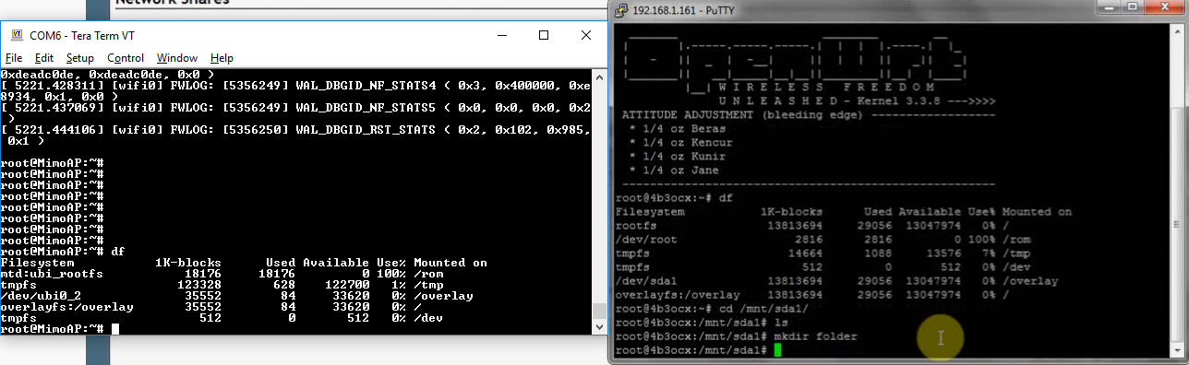

#Fast Roaming

802.11k, 802.11v and 802.11r are all standards designed to create a more seamless roaming experience for wireless clients.

With 802.11k, the AP can respond to Wi-Fi clients’ Neighbor Report request, let them understand the RF environment around them better. As a result, it helps them select a stronger signal, decrease the time used to scan the surrounding Wi-Fi, and have a better roaming.

With 802.11v, the AP will not only respond to Wi-Fi clients’ Neighbor Report request, but also evaluate the client connection quality, and direct the wireless clients to roam to be best AP which will provide a better WLAN experience, thus to balance the load among the APs.

With 802.11r, the time for wireless authentication will be reduced, it’s suitable for suitable for WPA2-PSK and WPA2-Enterprise encryption method.

#4G in SG

most recent 4G roll-out in Singapore involves only the LTE system, which stands for Long Term Evolution, or 3GPP Long Term Evolution for the Universal Mobile Telecommunications System (UMTS in short).

4G LTE Frequency Bands Covered by Mobile Operators:

M1: 1,800MHz & 2,600MHz

SingTel: 1,800MHz & 2,600MHz

StarHub: 1,800MHz

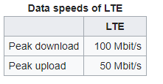

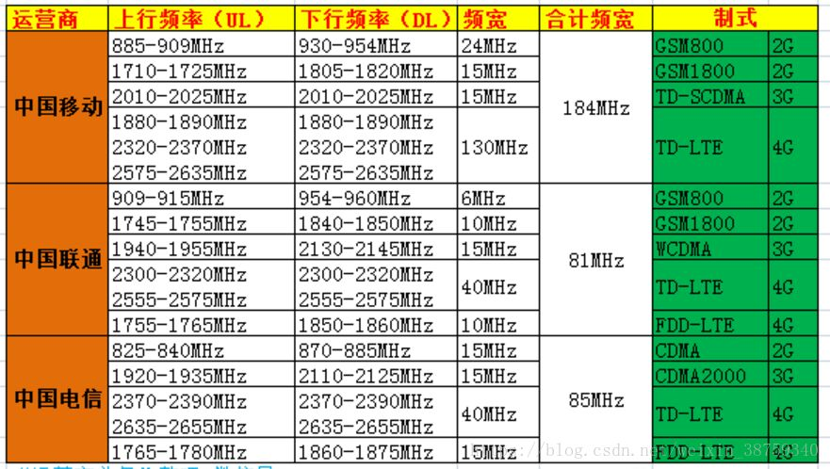

On WPJ563 firmware v6.1.10 with MU709, the following command can be used to put the modem

in mbim mode.

uci set system.@system[0].usbmodem=mbim

uci commit system

Thus no need to change bConfigurationValue manually.

More info on "umbim -n -d $device caps" command:

The dataclass field indicates what mode the modem can support:

Bit 0: MBIM_DATA_CLASS_GPRS

Bit 1: MBIM_DATA_CLASS_EDGE

Bit 2: MBIM_DATA_CLASS_UMTS

Bit 3: MBIM_DATA_CLASS_HSDPA

Bit 4: MBIM_DATA_CLASS_HSUPA

Bit 5: MBIM_DATA_CLASS_LTE

e.g. for MU709 dataclass: 8000001F

So this card can support up to HSUPA, and no LTE

"umbim -n -t 5 -d $device registration" command that shows successful connection:

nwerror: 0000 - unknown

registerstate: 0003 - home

registermode: 0001 - automatic

availabledataclasses: 8000001C - (null)

currentcellularclass: 0001 - gsm

provider_id: 52503

provider_name: SGP-M1

roamingtext: (null)

registrationflag: 0002

Optional dataclass for registration command: preferlte preferumts lte umts gsm

Normally this can be left blank.

Other command:

umbim -n -t 8 -d $device signal

- show rssi

umbim -n -t 9 -d $device config

- show ip address, dns etc assigned by telco

echo 3 > /sys/bus/usb/devices/3-1/bConfigurationValue

device=/dev/cdc-wdm2

umbim -n -d $device caps

umbim -n -t 3 -d $device pinstate

umbim -n -t 4 -d $device subscriber

umbim -n -t 5 -d $device registration lte

umbim -n -t 6 -d $device attach

umbim -n -t 7 -d $device connect

**#Jumbo Frame Supported**

The WPQ86x/WPJ41x firmware already supports jumbo frame.

The command to change:

ip link set mtu 9000 dev eth5 //maximum on 419 -> 9000

ip link show dev eth1

No need to change the switch setting as the Ethernet driver did that already, to check:

swconfig dev switch0 get max_frame_size

#Check for MTU size on window – cmd

* **netsh interface ipv4 show subinterface**

verify : ping my.test.host -f -l 8972

**Note** there is an overhead of 28 bytes for the ICMP headers, so the MTU is 28 bytes larger than the figure you establish through the method above. So to check for MTU of 9000, you actually need to set your ping packet size to 9000-28 = 8972.

## //issues to take note on WPj419

On WPJ7A02 model, due to the Gen Make file is different on the hardware perspective, some of the customer may face after flash the latest firmware, WiFi interface is missing.

Solution: May try advise customer to flash the old firmware, v6.0.8 first, then see what is the output. Usually this issues required RMA to China to do some hardware modification. But shipping fees should bear by customer if device OOW.

## //Differences between WPJ563 7A02 and WPJ563 7A03

Ntg much changes. Just 7A03 has one more 防雷 feature.（Lighting arrester）

## Common SDK issues

Uqmi package missing with error logs below:

make[3]: Entering directory '/home/indra/compex_v16_1_16/qsdk/package/network/utils/uqmi'

mkdir -p /home/indra/compex_v16_1_16/qsdk/dl

echo "Checking out files from the git repository..."; mkdir -p /home/indra/compex_v16_1_16/qsdk/tmp/dl && cd /home/indra/compex_v16_1_16/qsdk/tmp/dl && rm -rf uqmi-2016-12-19-8ceeab69 && [ \! -d uqmi-2016-12-19-8ceeab69 ] &&         GIT_NAME=$(echo /project/uqmi.git | sed -e s:.*/::g -e s/.git$//g); [ -n ""git://codeaurora.org/quic/qsdk/"" ] && git clone  "git://codeaurora.org/quic/qsdk/"$GIT_NAME uqmi-2016-12-19-8ceeab69 --recursive && (cd uqmi-2016-12-19-8ceeab69 && git remote -v && git checkout 8ceeab690d8c6f1e3afbd4bcaee7bc2ba3fbe165) || (rm -rf uqmi-2016-12-19-8ceeab69 &&  git clone /project/uqmi.git uqmi-2016-12-19-8ceeab69 --recursive && (cd uqmi-2016-12-19-8ceeab69 && git remote -v && git checkout 8ceeab690d8c6f1e3afbd4bcaee7bc2ba3fbe165 || (git fetch origin 8ceeab690d8c6f1e3afbd4bcaee7bc2ba3fbe165 && git checkout FETCH_HEAD && git submodule update))) && echo "Packing checkout..." && rm -rf uqmi-2016-12-19-8ceeab69/.git &&     tar c uqmi-2016-12-19-8ceeab69 | xz -zc > /home/indra/compex_v16_1_16/qsdk/tmp/dl/uqmi-2016-12-19-8ceeab69.tar.xz && mv /home/indra/compex_v16_1_16/qsdk/tmp/dl/uqmi-2016-12-19-8ceeab69.tar.xz /home/indra/compex_v16_1_16/qsdk/dl/ && rm -rf uqmi-2016-12-19-8ceeab69;

Checking out files from the git repository...

Cloning into 'uqmi-2016-12-19-8ceeab69'...

fatal: remote error: access denied or repository not exported: /quic/qsdk/uqmi

fatal: repository '/project/uqmi.git' does not exist

Makefile:50: recipe for target '/home/indra/compex_v16_1_16/qsdk/dl/uqmi-2016-12-19-8ceeab69.tar.xz' failed

make[3]: *** [/home/indra/compex_v16_1_16/qsdk/dl/uqmi-2016-12-19-8ceeab69.tar.xz] Error 128

make[3]: Leaving directory '/home/indra/compex_v16_1_16/qsdk/package/network/utils/uqmi'

package/Makefile:191: recipe for target 'package/network/utils/uqmi/compile' failed

make[2]: *** [package/network/utils/uqmi/compile] Error 2

make[2]: Leaving directory '/home/indra/compex_v16_1_16/qsdk'

package/Makefile:188: recipe for target '/home/indra/compex_v16_1_16/qsdk/staging_dir/target-arm_cortex-a7_uClibc-1.0.14_eabi/stamp/.package_compile' failed

make[1]: *** [/home/indra/compex_v16_1_16/qsdk/staging_dir/target-arm_cortex-a7_uClibc-1.0.14_eabi/stamp/.package_compile] Error 2

make[1]: Leaving directory '/home/indra/compex_v16_1_16/qsdk'

/home/indra/compex_v16_1_16/qsdk/include/toplevel.mk:186: recipe for target 'world' failed

make: *** [world] Error 2

Solution: **You Error logs mainly come from uqmi-2016-12-19-8ceeab69.tar.xz file unable to download during your compilation process. Can you try to copy the uqmi-2016-12-19-8ceeab69.tar.xz attached to /home/indra/compex_v16_1_16/qsdk/dl/ directory and recompile your SDK using Make V=s again?**

**HT40+/HT40- differences**

## Issue Description

What Are the Differences Between HT20 and HT40, How Is the 11n 40 MHz Channel Is Partitioned, and What Are the Meanings of Plus and Minus?

## https://support.huawei.com/view/pages/main/images/transparent.gif Solution

The channel bandwidth in HT20 mode is 20 MHz, and the channel bandwidth in HT40 mode is 40 MHz. Two neighboring 20 MHz channels are bundled to form a 40 MHz channel. One channel functions as the main channel, and the other as the auxiliary channel. The main channel sends Beacon packets and data packets, and the auxiliary channel sends other packets. When the HT40 mode is used in the 2.4 GHz frequency band, there is only one non-overlapping channel. Therefore, you are not advised to use the HT40 mode in the 2.4 GHz frequency band.  
  
Two neighboring 20 MHz channels are bundled to form a 40 MHz channel. If the center frequency of the main 20 MHz channel is higher than that of the auxiliary channel, 40MHz-plus is displayed; otherwise, 40MHz-minus is displayed. For example, if the center frequency 149 and the center frequency 153 reside on two 20 MHz channels, 149plus indicates that the two 20 MHz channels are bundled to form a 40 MHz channel.

//Board schematic

Request from Compex Sales Representative.

//Qustion: USB type on our Board.

//Answer: by default, all our board PCIE is using USB2.0, but support the module that operate on USB3.0 with backward compatible USB2.0. Only M.2 Slot support USB3.

# Compex WiFI module Calibration

Run the FTM mode with these commands.

**For QCA_Networking_2017.SPF.8.0:**

rmmod qca_ol //unload existing driver

insmod qca_ol soc_probe_module_load=1 fbc_enabled=1 hw_mode_id=1 testmode=1 cfg80211_config=1

//load factory test mode driver

**For QCA_Networking_2019.SPF.9.0 or later release:**

rmmod wifi_3_0

rmmod wifi_2_0

rmmod qca_ol

insmod qca_ol testmode=1

insmod wifi_3_0

insmod wifi_2_0

**//boot RAM image**

tftpboot LC-initramfs-prod-lx6400.itb

bootm

# Set MCS Rate on WPQ872

## 5Ghz

**Please look through 5Ghz belong to ath1 or ath0 / wifi0 or wifi1. For WPQ872, 5Ghz located on ath0 or wifi0

Fixed only Chain 1 to operate:

Command: iwpriv wifi0 txchainmask 0x01

####################################################

For 11A mode

Command: iwpriv ath0 mode 11A -> Set 11A mode in 5Ghz

Set Rate :

6 Mbps: iwpriv ath0 set11NRates 0x0b0b0b0b

9 Mbps: iwpriv ath0 set11NRates 0x0f0f0f0f

12 Mbps: iwpriv ath0 set11NRates 0x0a0a0a0a

18 Mbps: iwpriv ath0 set11NRates 0x0e0e0e0e

24 Mbps: iwpriv ath0 set11NRates 0x09090909

36 Mbps: iwpriv ath0 set11NRates 0x0d0d0d0d

48 Mbps: iwpriv ath0 set11NRates 0x08080808

54 Mbps: iwpriv ath0 set11NRates 0x0c0c0c0c

####################################################

For 11ac 20Mhz (VHT20)

Command: iwpriv ath0 mode 11ACVHT20

Set rate :

MCS 0: iwpriv ath0 vhtmcs 0

MCS 1: iwpriv ath0 vhtmcs 1

MCS 2: iwpriv ath0 vhtmcs 2

MCS 3: iwpriv ath0 vhtmcs 3

MCS 4: iwpriv ath0 vhtmcs 4

MCS 5: iwpriv ath0 vhtmcs 5

MCS 6: iwpriv ath0 vhtmcs 6

MCS 7: iwpriv ath0 vhtmcs 7

MCS 8: iwpriv ath0 vhtmcs 8 //Max bitrate: 86.67Mbps For 1 Chain only

####################################################

For 11ac 40Mhz (VHT40)

Command: iwpriv athN mode 11ACVHT40PLUS

Set Rate:

MCS 0: iwpriv ath0 vhtmcs 0

MCS 1: iwpriv ath0 vhtmcs 1

MCS 2: iwpriv ath0 vhtmcs 2

MCS 3: iwpriv ath0 vhtmcs 3

MCS 4: iwpriv ath0 vhtmcs 4

MCS 5: iwpriv ath0 vhtmcs 5

MCS 6: iwpriv ath0 vhtmcs 6

MCS 7: iwpriv ath0 vhtmcs 7

MCS 8: iwpriv ath0 vhtmcs 8

MCS 9: iwpriv ath0 vhtmcs 9 //Max bitrate: 200Mbps For 1 Chain only

####################################################

For 11ac 80Mhz (VHT80)

Command: iwpriv ath0 mode 11ACVHT80

Set Rate:

MCS 0: iwpriv ath0 vhtmcs 0

MCS 1: iwpriv ath0 vhtmcs 1

MCS 2: iwpriv ath0 vhtmcs 2

MCS 3: iwpriv ath0 vhtmcs 3

MCS 4: iwpriv ath0 vhtmcs 4

MCS 5: iwpriv ath0 vhtmcs 5

MCS 6: iwpriv ath0 vhtmcs 6

MCS 7: iwpriv ath0 vhtmcs 7

MCS 8: iwpriv ath0 vhtmcs 8

MCS 9: iwpriv ath0 vhtmcs 9 //Max bitrate: 433.33Mbps For 1 Chain only

####################################################

For 11ac 80_80Mhz (VHT80_80)

Command:

i. Command: uci set wireless.wifi0.hwmode='11ac'

ii. Command: uci set wireless.@wifi-iface[0].cfreq2=106

iii.Command: uci set wireless.wifi0.htmode=HT80_80

iv. Command: uci set wireless.wifi0.channel=36

v. Command: uci commit wireless

vi. Command: wifi

Set Rate:

MCS 0: iwpriv ath0 vhtmcs 0

MCS 1: iwpriv ath0 vhtmcs 1

MCS 2: iwpriv ath0 vhtmcs 2

MCS 3: iwpriv ath0 vhtmcs 3

MCS 4: iwpriv ath0 vhtmcs 4

MCS 5: iwpriv ath0 vhtmcs 5

MCS 6: iwpriv ath0 vhtmcs 6

MCS 7: iwpriv ath0 vhtmcs 7

MCS 8: iwpriv ath0 vhtmcs 8

MCS 9: iwpriv ath0 vhtmcs 9 //Max bitrate: 2166.7Mbps For 4 Chain only

####################################################

**For 11ax mode, please set the shortgi to 800ns

Command: iwpriv ath0 shortgi 0

Fixed only Chain 1 to operate:

Command: iwpriv wifi0 txchainmask 0x01

For 11ax 20Mhz (HE20Mhz)

Command: iwpriv ath0 mode 11AHE20

Set Rate:

MCS 0: iwpriv ath0 he_mcs 0

MCS 1: iwpriv ath0 he_mcs 1

MCS 2: iwpriv ath0 he_mcs 2

MCS 3: iwpriv ath0 he_mcs 3

MCS 4: iwpriv ath0 he_mcs 4

MCS 5: iwpriv ath0 he_mcs 5

MCS 6: iwpriv ath0 he_mcs 6

MCS 7: iwpriv ath0 he_mcs 7

MCS 8: iwpriv ath0 he_mcs 8

MCS 9: iwpriv ath0 he_mcs 9

MCS 10: iwpriv ath0 he_mcs 10

MCS 11: iwpriv ath0 he_mcs 11 //Maximum bitrate: 143.4 Mbps For 1 chain only

##########################################################

For 11ax 40Mhz (HE40Mhz)

Command: iwpriv ath0 mode 11AHE40PLUS

Set Rate:

MCS0: iwpriv ath0 he_mcs 0

MCS1: iwpriv ath0 he_mcs 1

MCS2: iwpriv ath0 he_mcs 2

MCS3: iwpriv ath0 he_mcs 3

MCS4: iwpriv ath0 he_mcs 4

MCS5: iwpriv ath0 he_mcs 5

MCS6: iwpriv ath0 he_mcs 6

MCS7: iwpriv ath0 he_mcs 7

MCS8: iwpriv ath0 he_mcs 8

MCS9: iwpriv ath0 he_mcs 9

MCS10: iwpriv ath0 he_mcs 10

MCS11: iwpriv ath0 he_mcs 11 //Maximum bitrate: 286.76 Mbps For 1 chain only

##########################################################

For 11ax 80Mhz (HE80Mhz)

Command: iwpriv ath0 mode 11AHE80

Set Rate:

MCS0: iwpriv ath0 he_mcs 0

MCS1: iwpriv ath0 he_mcs 1

MCS2: iwpriv ath0 he_mcs 2

MCS3: iwpriv ath0 he_mcs 3

MCS4: iwpriv ath0 he_mcs 4

MCS5: iwpriv ath0 he_mcs 5

MCS6: iwpriv ath0 he_mcs 6

MCS7: iwpriv ath0 he_mcs 7

MCS8: iwpriv ath0 he_mcs 8

MCS9: iwpriv ath0 he_mcs 9

MCS10: iwpriv ath0 he_mcs 10

MCS11: iwpriv ath0 he_mcs 11 //Maximum bitrate: 600.441Mbps For 1 chain only

##########################################################

For 11ax 160Mhz (HE160Mhz)

Command: iwpriv ath0 mode 11AHE160

Set Rate:

MCS0: iwpriv ath0 he_mcs 0

MCS1: iwpriv ath0 he_mcs 1

MCS2: iwpriv ath0 he_mcs 2

MCS3: iwpriv ath0 he_mcs 3

MCS4: iwpriv ath0 he_mcs 4

MCS5: iwpriv ath0 he_mcs 5

MCS6: iwpriv ath0 he_mcs 6

MCS7: iwpriv ath0 he_mcs 7

MCS8: iwpriv ath0 he_mcs 8

MCS9: iwpriv ath0 he_mcs 9

MCS10: iwpriv ath0 he_mcs 10

MCS11: iwpriv ath0 he_mcs 11 //Maximum bitrate: 2401.9Mbps For 4 chain

##########################################################

Iwpriv ath2 shortgi 0

## 2.4Ghz

2.4Ghz

**Please look through 2.4Ghz belong to ath0 or ath1 / wifi0 or wifi1. For WPQ872, 2.4Ghz located on ath1 or wifi1

Fixed only Chain 1 to operate:

Command: iwpriv wifi1 txchainmask 0x01

####################################################

For 11B mode

Command: iwpriv ath1 mode 11B -> Set for 11B mode in 2.4Ghz

Set Rate:

1 Mbps : iwpriv ath1 set11NRates 0x1b1b1b1b

2 Mbps : iwpriv ath1 set11NRates 0x1a1a1a1a

5.5 Mbps : iwpriv ath1 set11NRates 0x19191919

11 Mbps : iwpriv ath1 set11NRates 0x18181818

####################################################

For 11G mode

Command: iwpriv ath1 mode 11G -> Set 11G mode in 2.4Ghz

Set Rate :

6 Mbps: iwpriv ath1 set11NRates 0x0b0b0b0b

9 Mbps: iwpriv ath1 set11NRates 0x0f0f0f0f

12 Mbps: iwpriv ath1 set11NRates 0x0a0a0a0a

18 Mbps: iwpriv ath1 set11NRates 0x0e0e0e0e

24 Mbps: iwpriv ath1 set11NRates 0x09090909

36 Mbps: iwpriv ath1 set11NRates 0x0d0d0d0d

48 Mbps: iwpriv ath1 set11NRates 0x08080808

54 Mbps: iwpriv ath1 set11NRates 0x0c0c0c0c

####################################################

For 11n 20Mhz (HT20)

Command: iwpriv ath1 mode 11NGHT20

Set rate :

MCS 0: iwpriv ath1 set11NRates 0x80808080

MCS 1: iwpriv ath1 set11NRates 0x81818181

MCS 2: iwpriv ath1 set11NRates 0x82828282

MCS 3: iwpriv ath1 set11NRates 0x83838383

MCS 4: iwpriv ath1 set11NRates 0x84848484

MCS 5: iwpriv ath1 set11NRates 0x85858585

MCS 6: iwpriv ath1 set11NRates 0x86868686

MCS 7: iwpriv ath1 set11NRates 0x87878787

####################################################

For 11n 40Mhz (HT40)

Command: iwpriv ath1 mode 11NGHT40PLUS

Set Rate:

MCS 0: iwpriv ath1 set11NRates 0x80808080

MCS 1: iwpriv ath1 set11NRates 0x81818181

MCS 2: iwpriv ath1 set11NRates 0x82828282

MCS 3: iwpriv ath1 set11NRates 0x83838383

MCS 4: iwpriv ath1 set11NRates 0x84848484

MCS 5: iwpriv ath1 set11NRates 0x85858585

MCS 6: iwpriv ath1 set11NRates 0x86868686

MCS 7: iwpriv ath1 set11NRates 0x87878787

####################################################

**For 11ax mode, please set the shortgi to 800ns

Command: iwpriv ath1 shortgi 0

Fixed only Chain 1 to operate:

Command: iwpriv wifi1 txchainmask 0x01

For 11ax 20Mhz (HE20Mhz)

Command: iwpriv ath1 mode 11GHE20

Set Rate:

MCS0: iwpriv ath1 he_mcs 0

MCS1: iwpriv ath1 he_mcs 1

MCS2: iwpriv ath1 he_mcs 2

MCS3: iwpriv ath1 he_mcs 3

MCS4: iwpriv ath1 he_mcs 4

MCS5: iwpriv ath1 he_mcs 5

MCS6: iwpriv ath1 he_mcs 6

MCS7: iwpriv ath1 he_mcs 7

MCS8: iwpriv ath1 he_mcs 8

MCS9: iwpriv ath1 he_mcs 9

MCS10: iwpriv ath1 he_mcs 10

MCS11: iwpriv ath1 he_mcs 11 //Maximum bitrate: 573.5Mbps

##########################################################

For 11ax 40Mhz (HE40Mhz)

Command: iwpriv ath1 mode 11GHE40PLUS

Set Rate:

MCS0: iwpriv ath1 he_mcs 0

MCS1: iwpriv ath1 he_mcs 1

MCS2: iwpriv ath1 he_mcs 2

MCS3: iwpriv ath1 he_mcs 3

MCS4: iwpriv ath1 he_mcs 4

MCS5: iwpriv ath1 he_mcs 5

MCS6: iwpriv ath1 he_mcs 6

MCS7: iwpriv ath1 he_mcs 7

MCS8: iwpriv ath1 he_mcs 8

MCS9: iwpriv ath1 he_mcs 9

MCS10: iwpriv ath1 he_mcs 10

MCS11: iwpriv ath1 he_mcs 11 //Maximum bitrate: 1147.2Mbps

##########################################################

1216VX OpenWRT Change mode

# testing

# default is 5G, to use 2G

sed -i "s/dual_band=5/dual_band=2/" /etc/modules.d/ath10k

reboot

# go to the webui wireless setting, and set the correct mode

# back to 5G

sed -i "s/dual_band=2/dual_band=5/" /etc/modules.d/ath10k

reboot

# //power Consumption detail

|  |  |  |  |
| --- | --- | --- | --- |
| 型號 | 電壓V | 電流A | 瓦數W |
| WLE1216V2-20 | 3.3V | 2.02A | 6.68 |
| WLE1216V5-20 | 3.3V | 2.58A | 8.5 |
| WLE1216V5-23 | 3.3 V & 5V | ????? | 13W |

For WLE1216V5-23, the current measured is separate as:

I) For 3.3 V to allow module operate, current = 0.75A.

ii) For 5V, PA on the module to operate, current = 2.11A

The Total power consumption calculated, 13W= (3.3*0.75) + (5*2.11)

Microsoft server 2016 PC login password

Password: Abcd1234

Ubuntu PC:

Password: 1234

To root access: sudo su

# Hk01 client configuration :

root@OpenWrt:/# uci show wireless

wireless.wifi0=wifi-device

wireless.wifi0.type='qcawificfg80211'

wireless.wifi0.channel='auto'

wireless.wifi0.macaddr='04:f0:21:45:e7:d1'

wireless.wifi0.hwmode='11axa'

wireless.wifi0.disabled='0'

wireless.@wifi-iface[0]=wifi-iface

wireless.@wifi-iface[0].device='wifi0'

wireless.@wifi-iface[0].network='lan'

wireless.@wifi-iface[0].encryption='none'

wireless.@wifi-iface[0].ssid='hk015g'

wireless.@wifi-iface[0].mode='sta'

wireless.@wifi-iface[0].wds='1'

wireless.wifi1=wifi-device

wireless.wifi1.type='qcawificfg80211'

wireless.wifi1.channel='auto'

wireless.wifi1.macaddr='04:f0:21:45:e7:d2'

wireless.wifi1.hwmode='11axg'

wireless.wifi1.disabled='0'

wireless.@wifi-iface[1]=wifi-iface

wireless.@wifi-iface[1].device='wifi1'

wireless.@wifi-iface[1].network='lan'

wireless.@wifi-iface[1].mode='ap'

wireless.@wifi-iface[1].encryption='none'

[wireless.@wifi-iface[1].ssid='hk012g](mailto:wireless.@wifi-iface[1].ssid='hk012g)'

**\*\*extap or wds is necessary for client connection**

# Hk01 AP configuration:

root@OpenWrt:/etc# uci show wireless

wireless.wifi0=wifi-device

wireless.wifi0.type='qcawificfg80211'

wireless.wifi0.channel='auto'

wireless.wifi0.macaddr='04:f0:21:45:e7:d5'

wireless.wifi0.hwmode='11axa'

wireless.wifi0.disabled='0'

wireless.@wifi-iface[0]=wifi-iface

wireless.@wifi-iface[0].device='wifi0'

wireless.@wifi-iface[0].network='lan'

wireless.@wifi-iface[0].mode='ap'

wireless.@wifi-iface[0].encryption='none'

wireless.@wifi-iface[0].ssid='hk015g'

wireless.wifi1=wifi-device

wireless.wifi1.type='qcawificfg80211'

wireless.wifi1.channel='auto'

wireless.wifi1.macaddr='04:f0:21:45:e7:d6'

wireless.wifi1.hwmode='11axg'

wireless.wifi1.disabled='0'

wireless.@wifi-iface[1]=wifi-iface

wireless.@wifi-iface[1].device='wifi1'

wireless.@wifi-iface[1].network='lan'

wireless.@wifi-iface[1].mode='ap'

wireless.@wifi-iface[1].encryption='none'

[wireless.@wifi-iface[1].ssid='hk012g](mailto:wireless.@wifi-iface[1].ssid='hk012g)'

# WPJ419 ori Uboot printenv

(IPQ40xx) # printenv

baudrate=115200

bootcmd=bootipq

bootdelay=1

ethact=eth0

ethaddr=04:f0:21:48:f3:ef

flash_type=0

ipaddr=192.168.1.1

machid=8010401

serverip=192.168.1.10

stderr=serial

stdin=serial

WPj419 Mount SD card:

root@OpenWrt:/dev# mkdir /tmp/mount_point2

root@OpenWrt:/dev# mount -t vfat /dev/mmcblk0p1 / tmp/mount_point2

mmcblk0 mmcblk0p1

root@OpenWrt:/dev# mount -t vfat /dev/mmcblk0p1 /tmp/mount_point2/

root@OpenWrt:/dev# cd /tmp/

root@OpenWrt:/tmp# ls

TZ etc mount_point shm

board.json hosts overlay state

dhcp.leases lib resolv.conf sysinfo

dnsmasq.d lock resolv.conf.auto tmp

dropbear log run

root@OpenWrt:/tmp# ls

TZ etc mount_point shm

board.json hosts overlay state

dhcp.leases lib resolv.conf sysinfo

dnsmasq.d lock resolv.conf.auto tmp

dropbear log run

root@OpenWrt:/tmp# ls

TZ etc mount_point shm

board.json hosts overlay state

dhcp.leases lib resolv.conf sysinfo

dnsmasq.d lock resolv.conf.auto tmp

dropbear log run

root@OpenWrt:/tmp# cd mount_point/

root@OpenWrt:/tmp/mount_point# ls

System Volume Information test

root@OpenWrt:/tmp/mount_point# cd test/

root@OpenWrt:/tmp/mount_point/test# ls

asf.o ath_rate_atheros.o qca_ol.o

ath_dev.o ath_spectral.o qdf.o

ath_dfs.o hst_tx99.o smart_antenna.o

ath_hal.o mem_manager.o tm.o

ath_pktlog.o qca_da.o umac.o

root@OpenWrt:/tmp/mount_point/test#

For HK01:

root@OpenWrt:/# mkdir /tmp/mount_point

root@OpenWrt:/# mount -t ext4 /dev/mmcblk0p1 /tmp/mount_point/

root@OpenWrt:/# cd /tmp/mount_point/

root@OpenWrt:/tmp/mount_point# ls

lost+found

# SPF11 OFDMA and MU-MIMO

(1 for enable, 0 for disable, default is 1)

Uplink set Mu-Mimo command: **cfg80211tool ath0 he_ul_mimo 1**

Uplink get MU-mimo command: **cfg80211tool ath0 get_he_ul_mimo**

**iwpriv athX he_**

**ulmimo**

Uplink set OFDMA: **cfg80211tool ath0 he_ul_ofdma 1**

Uplink get OFDMA: **cfg80211tool ath0 get_he_ul_ofdma**

Downlink set OFDMA**: cfg80211tool ath0 he_dl_ofdma 1**

Downlink get OFDMA**: cfg80211tool ath0 get_he_dl_ofdma**

**//SPF61 setcountry code and country ID command :**iwpriv wifi0 setCountryID 250 //France

Iwpriv wifi0 getCountryID

Iwpriv wifi0 setCountry FR

Iwpriv wifi0 getCountry

**//SPF61 Antenna Gain**

iwpriv wifi0 antgain_2g 10

iwpriv wifi0 antgain_5g 10

**//OpenWRT change MAC address**

wireless.default_radio0.macaddr='0A:f0:21:33:44:cb'

wireless.default_radio0.ssid='Open55'

**or edit wireless interface : vi /etc/config/wireless**

config wifi-iface 'default_radio0'

option device 'radio0'

option network 'lan'

option mode 'ap'

option encryption 'none'

**option macaddr '0A:f0:21:33:44:cb'**

option ssid 'Open55'

# // HK01.2 Change 1 8x8 5Ghz Radio to 2 4x4 5Ghz Radio :

modify the file /ini/internal/global_i.ini

edit line 39, change from hw_mode_id=1 to hw_mode_id=4

modify the file /etc/init.d/wifi_fw_mount, change the line 55/95:

cd /lib/firmware/$arch && ln -sf WIFI_FW/*.* .

to:

cd /lib/firmware/$arch && ln -s WIFI_FW/*.* .

cd /lib/firmware/IPQ8074

ln -sf WIFI_FW/bdwlan.b215 bdwlan.bin

rm -rf /etc/config/wireless

reboot

# // HK01.2 Change 2 4x4 5Ghz Radio to 1 8x8 5Ghz Radio :

modify the file: vi /ini/internal/global_i.ini

edit line 39, change from hw_mode_id=4 to hw_mode_id=1

modify the file: vi /etc/init.d/wifi_fw_mount , change the line 55:

cd /lib/firmware/$arch && ln -s WIFI_FW/*.* .

to:

cd /lib/firmware/$arch && ln -sf WIFI_FW/*.* .

cd /lib/firmware/IPQ8074

ln -sf WIFI_FW/bdwlan.b215 bdwlan.bin

rm -rf /etc/config/wireless

reboot

root@OpenWrt:~# uci set wireless.wifi0.disabled='0'

root@OpenWrt:~# uci set wireless.wifi0.htmode='HT160'

root@OpenWrt:~# uci commit wireless

root@OpenWrt:~# wifi

Verify:

root@OpenWrt:~# iwconfig ath0

ath0 IEEE 802.11axa ESSID:"OpenWrt"

Mode:Master Frequency:5.6 GHz Access Point: 00:03:7F:12:D9:83

Bit Rate:4.8039 Gb/s Tx-Power:24 dBm

RTS thr:off Fragment thr:off

Encryption key:off

Power Management:off

Link Quality=0/94 Signal level=-92 dBm Noise level=-92 dBm

Rx invalid nwid:0 Rx invalid crypt:0 Rx invalid frag:0

Tx excessive retries:0 Invalid misc:0 Missed beacon:0

root@OpenWrt:~# iwpriv ath0 get_mode

ath0 get_mode:11AHE160

# //QCA6391 WINDOW Driver:

qca6390-win-1-0_qca_device_standalone-r00120.1_B200526.zip in study material folder

//linux bring up cmd

Edit the default configuration file “*hostapd.conf*” and save it on */data/misc/wifi/ folder* with hostapd in */vendor/bin/* folder.

insmod wlan_cnss_core_pcie.ko

insmod wlan.ko

ifconfig wlan0 up

ifconfig wlan1 up

ifconfig wlan0

root@MimoAP:/# ifconfig

wlan0 Link encap:Ethernet HWaddr 00:03:7F:26:58:51

UP BROADCAST MULTICAST MTU:1500 Metric:1

RX packets:0 errors:0 dropped:0 overruns:0 frame:0

TX packets:0 errors:0 dropped:0 overruns:0 carrier:0

collisions:0 txqueuelen:3000

RX bytes:0 (0.0 B) TX bytes:0 (0.0 B)

wlan1 Link encap:Ethernet HWaddr 00:03:7F:A8:58:51

UP BROADCAST MULTICAST MTU:1500 Metric:1

RX packets:0 errors:0 dropped:0 overruns:0 frame:0

TX packets:0 errors:0 dropped:0 overruns:0 carrier:0

collisions:0 txqueuelen:3000

RX bytes:0 (0.0 B) TX bytes:0 (0.0 B)

//Using winscp, copy the hosatpd file from PC to board directory: /usr/sbin

Wlan1 = 2.4G

Wlan0 = 5G

Then run:

hostapd /etc/hostapd.conf &

hostapd /etc/hostapd1.conf &

brctl addif br-lan wlan1

brctl addif br-lan wlan0

# //Window Server Radius Server 2016 Setup:

Vmbox password : Abcd1234

1. open Server Manager :

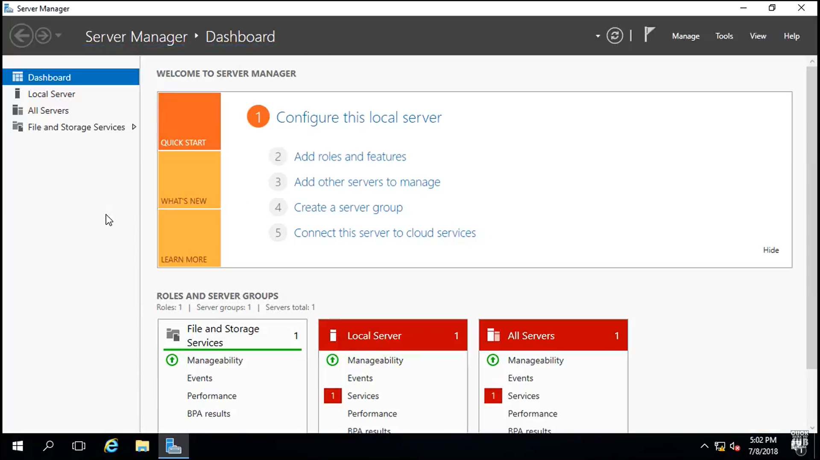

1. Add Roles an Features -> Next -> next-> Server Role -> choose ADDS-> next -> tick restart

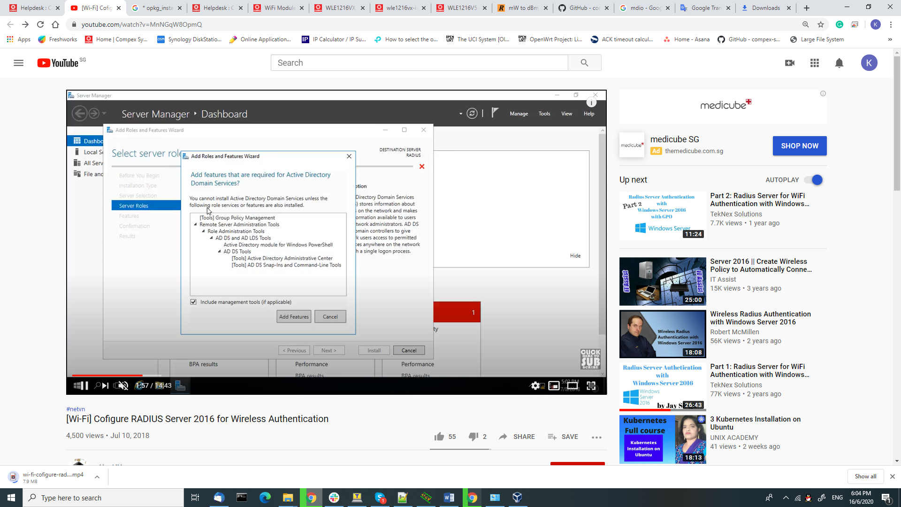

1. After installation done, go to ADDS page, click the flag on top

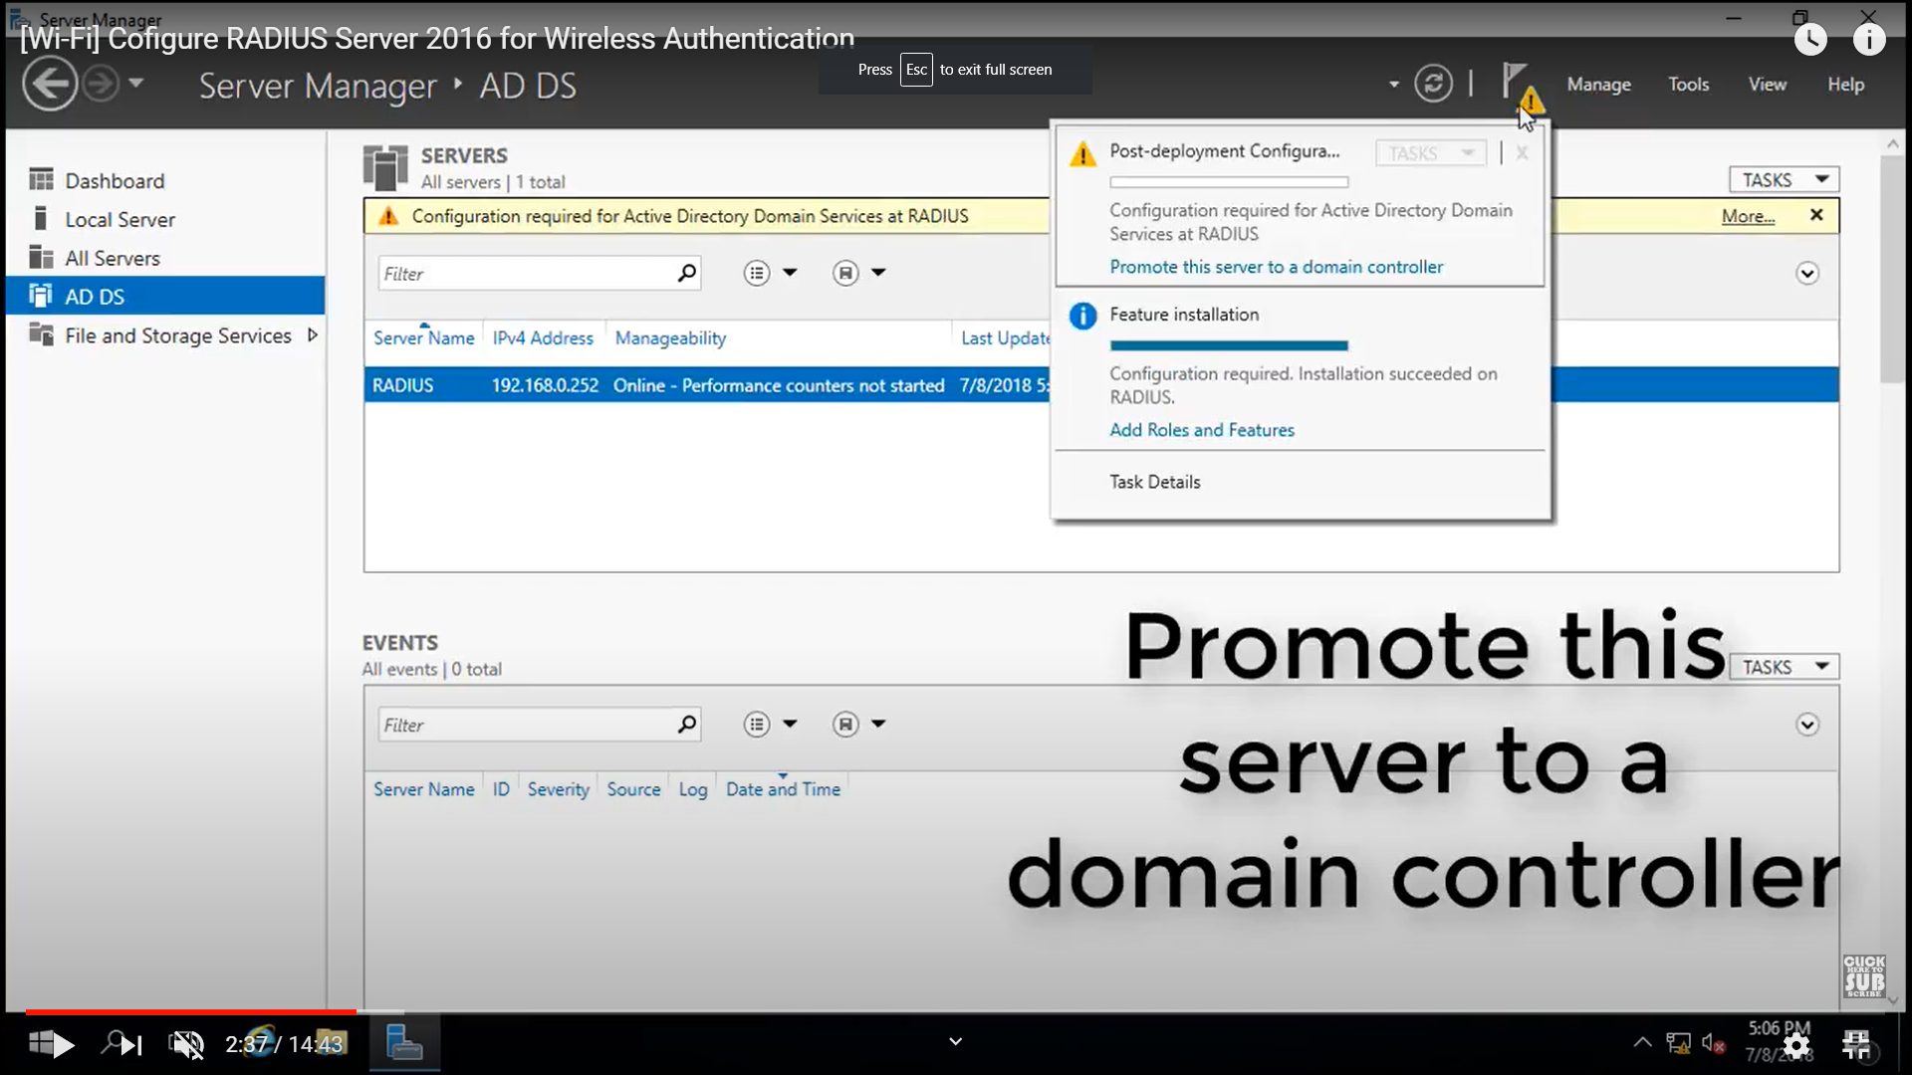

1. Add new forest, configured domain name:

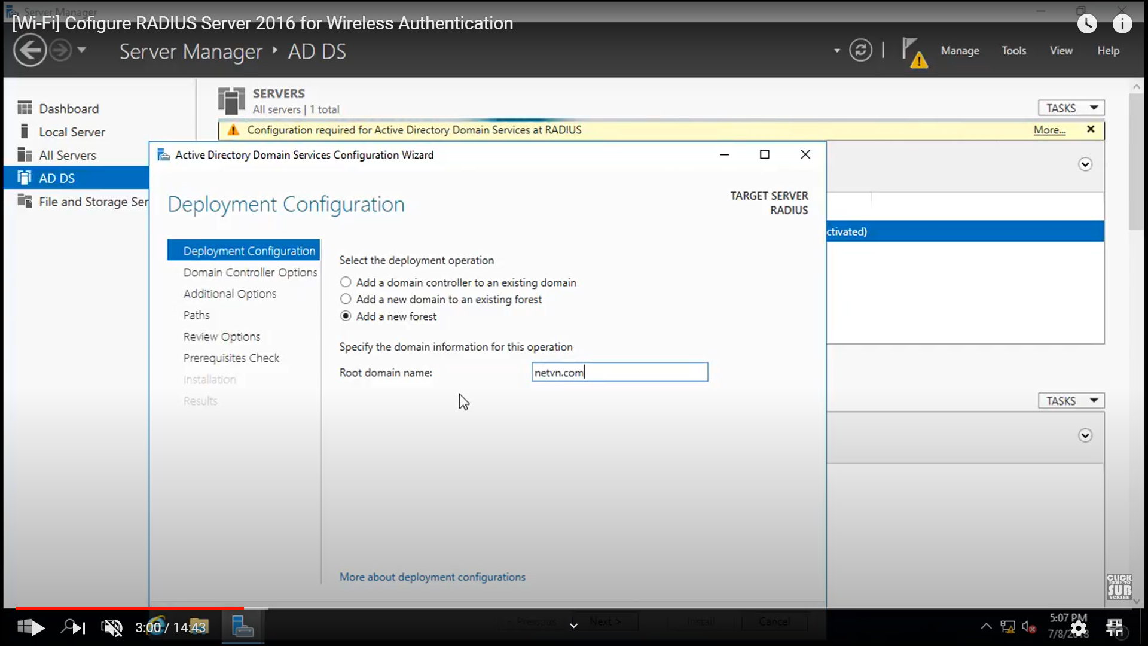

1. Setup as below: Setup Password. After this, this password will be the login password. Click next-> Netbios name -> next -> install

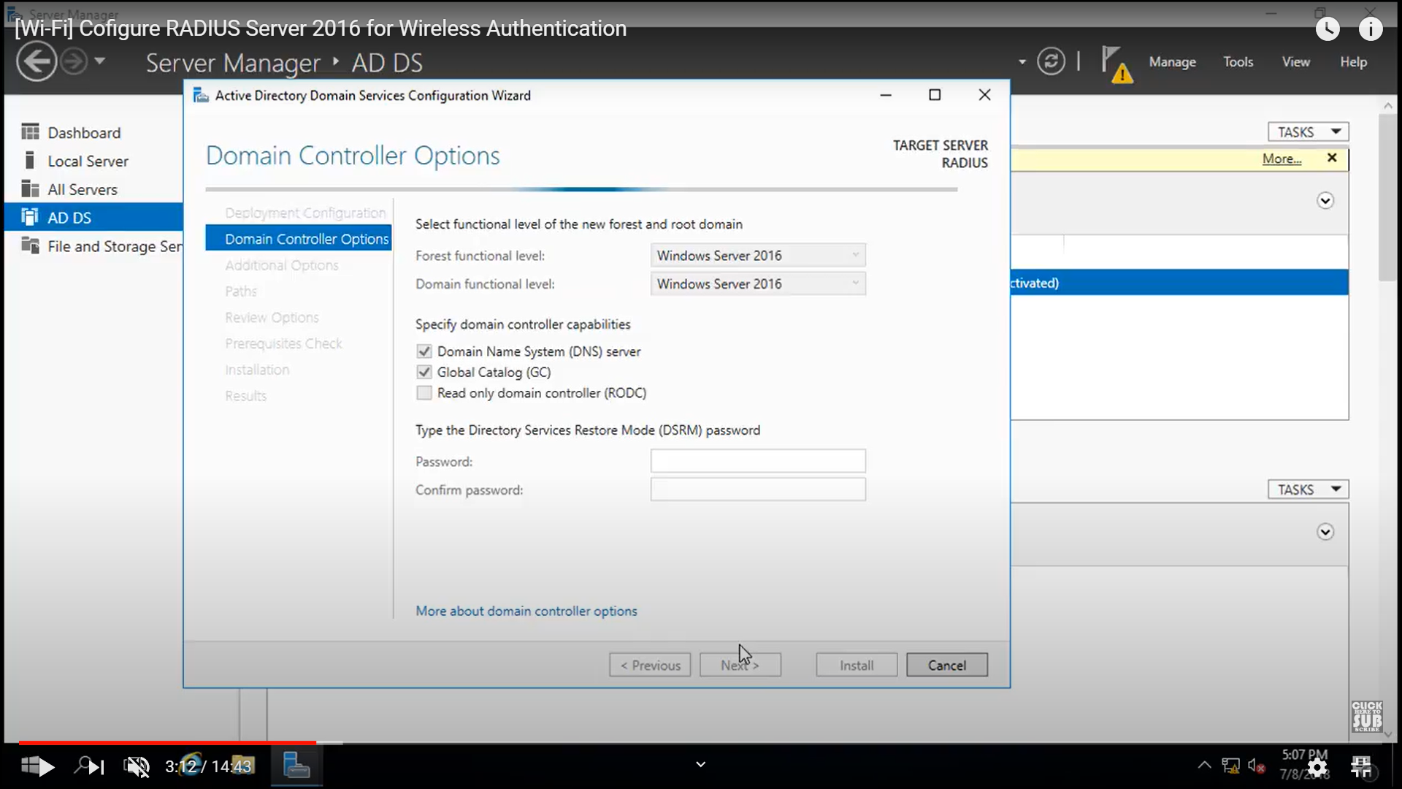

1. Installing CA -> Choose ADD role

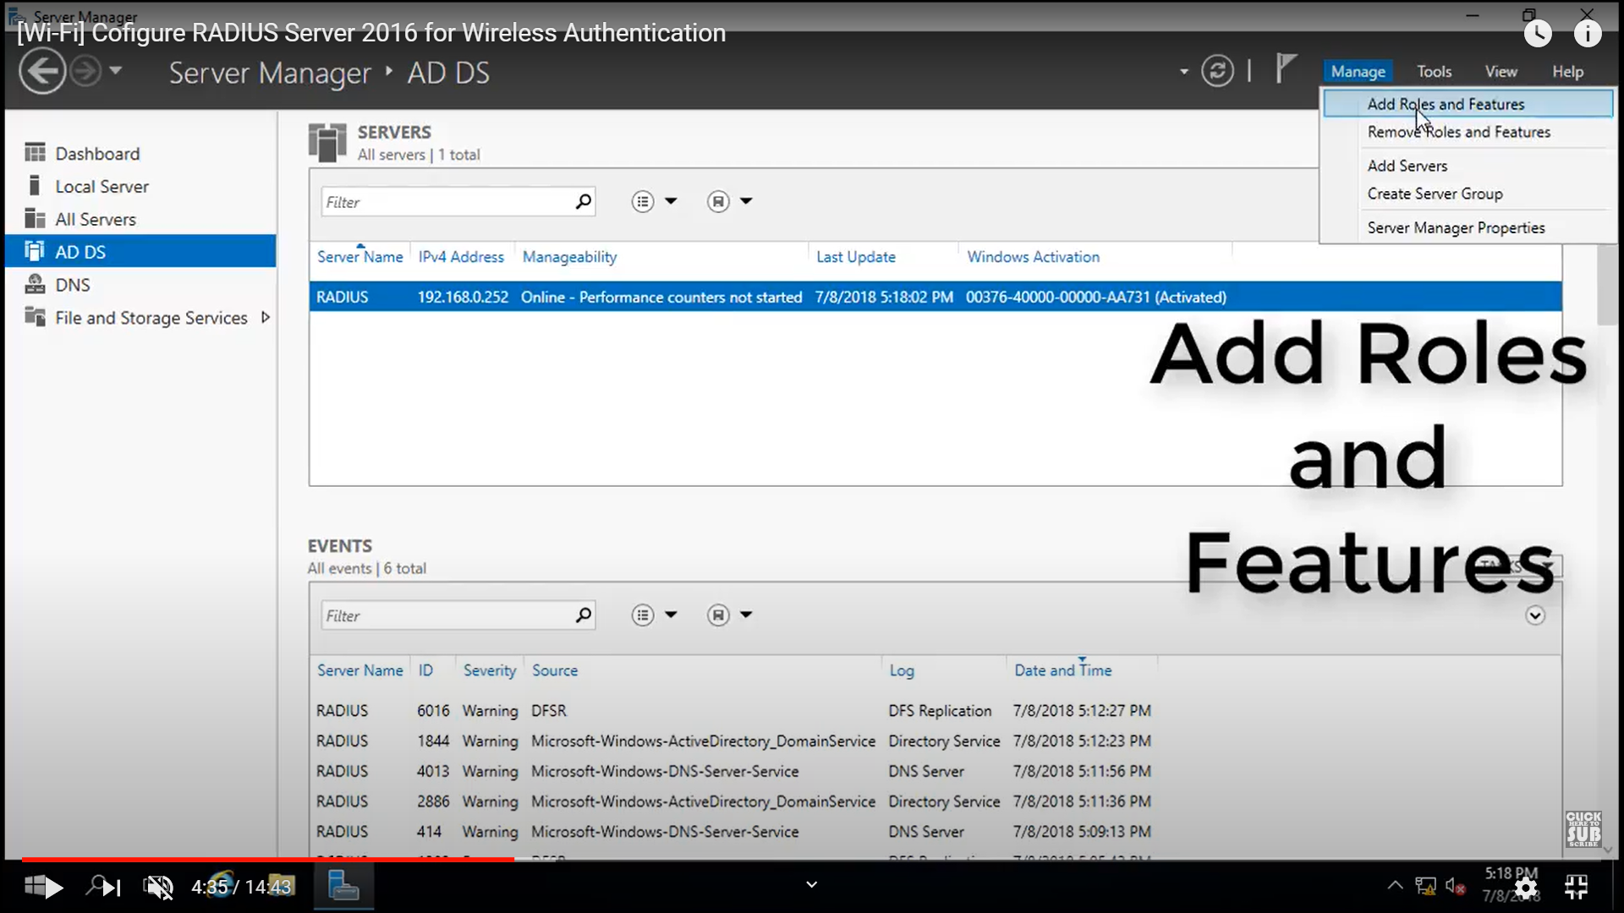

1. Choose ADCS -> Certificate Authority -> tick restart -> Finish

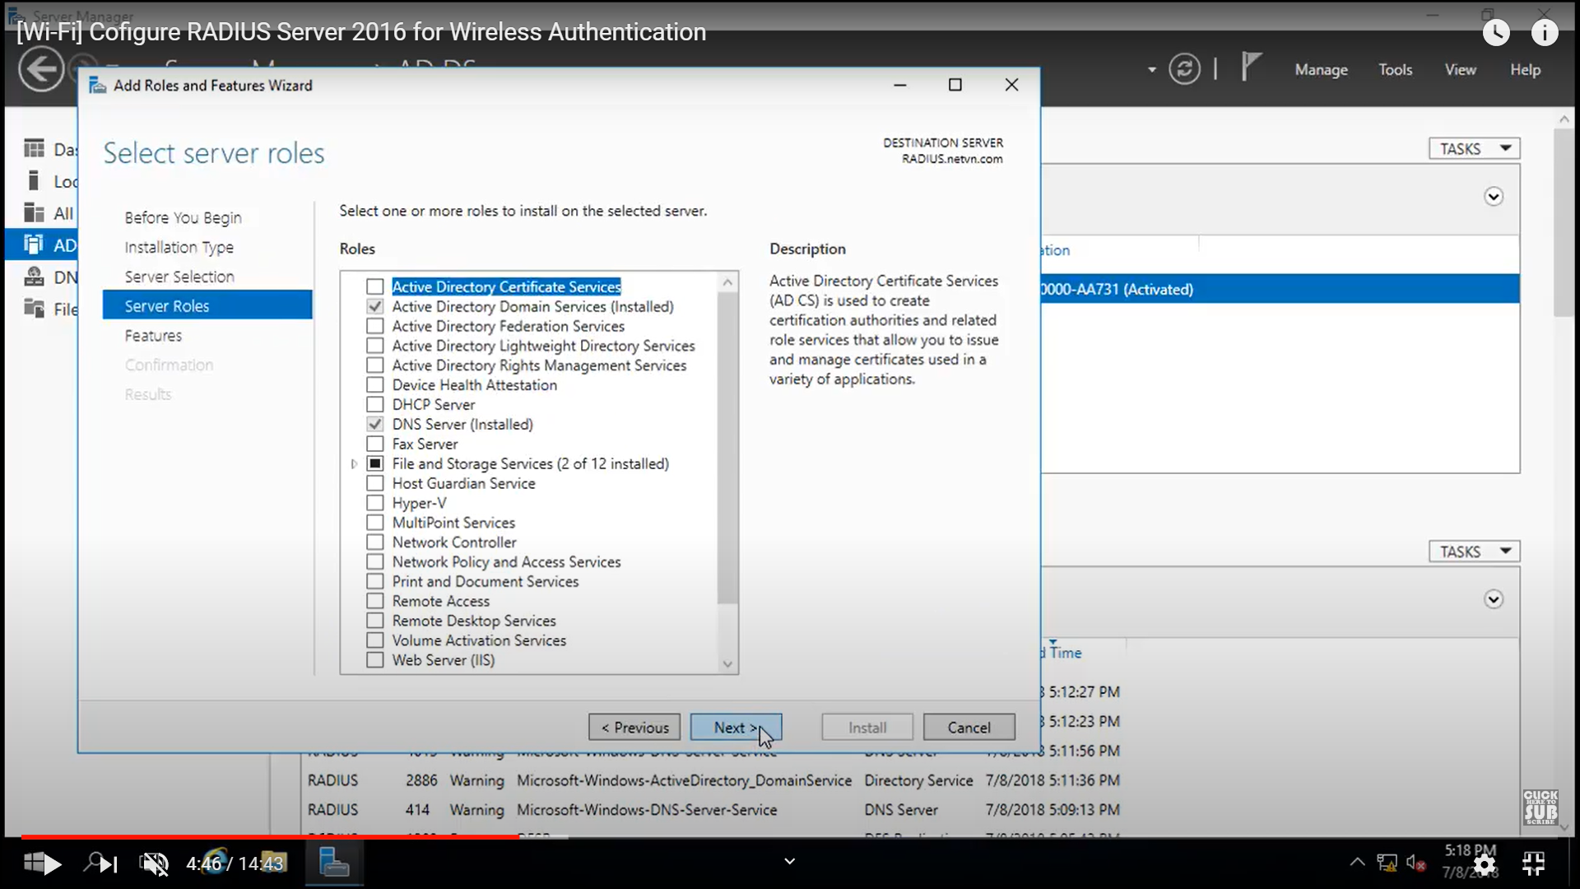

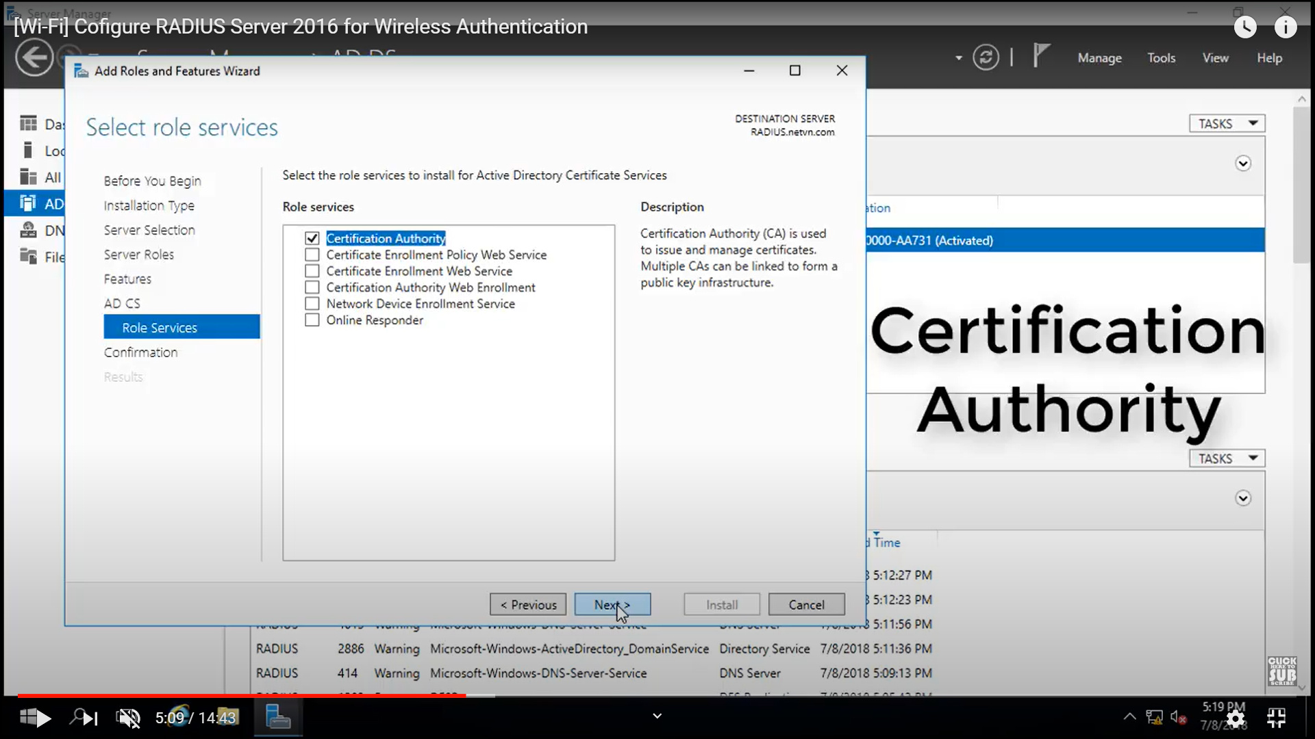

1. Click flag -> Configure ADCS -> Credential Authority -> Enteprise CA -> Root CA -> Create New private key -> SHA256 , 2048 -> validity (set period) -> next -> close

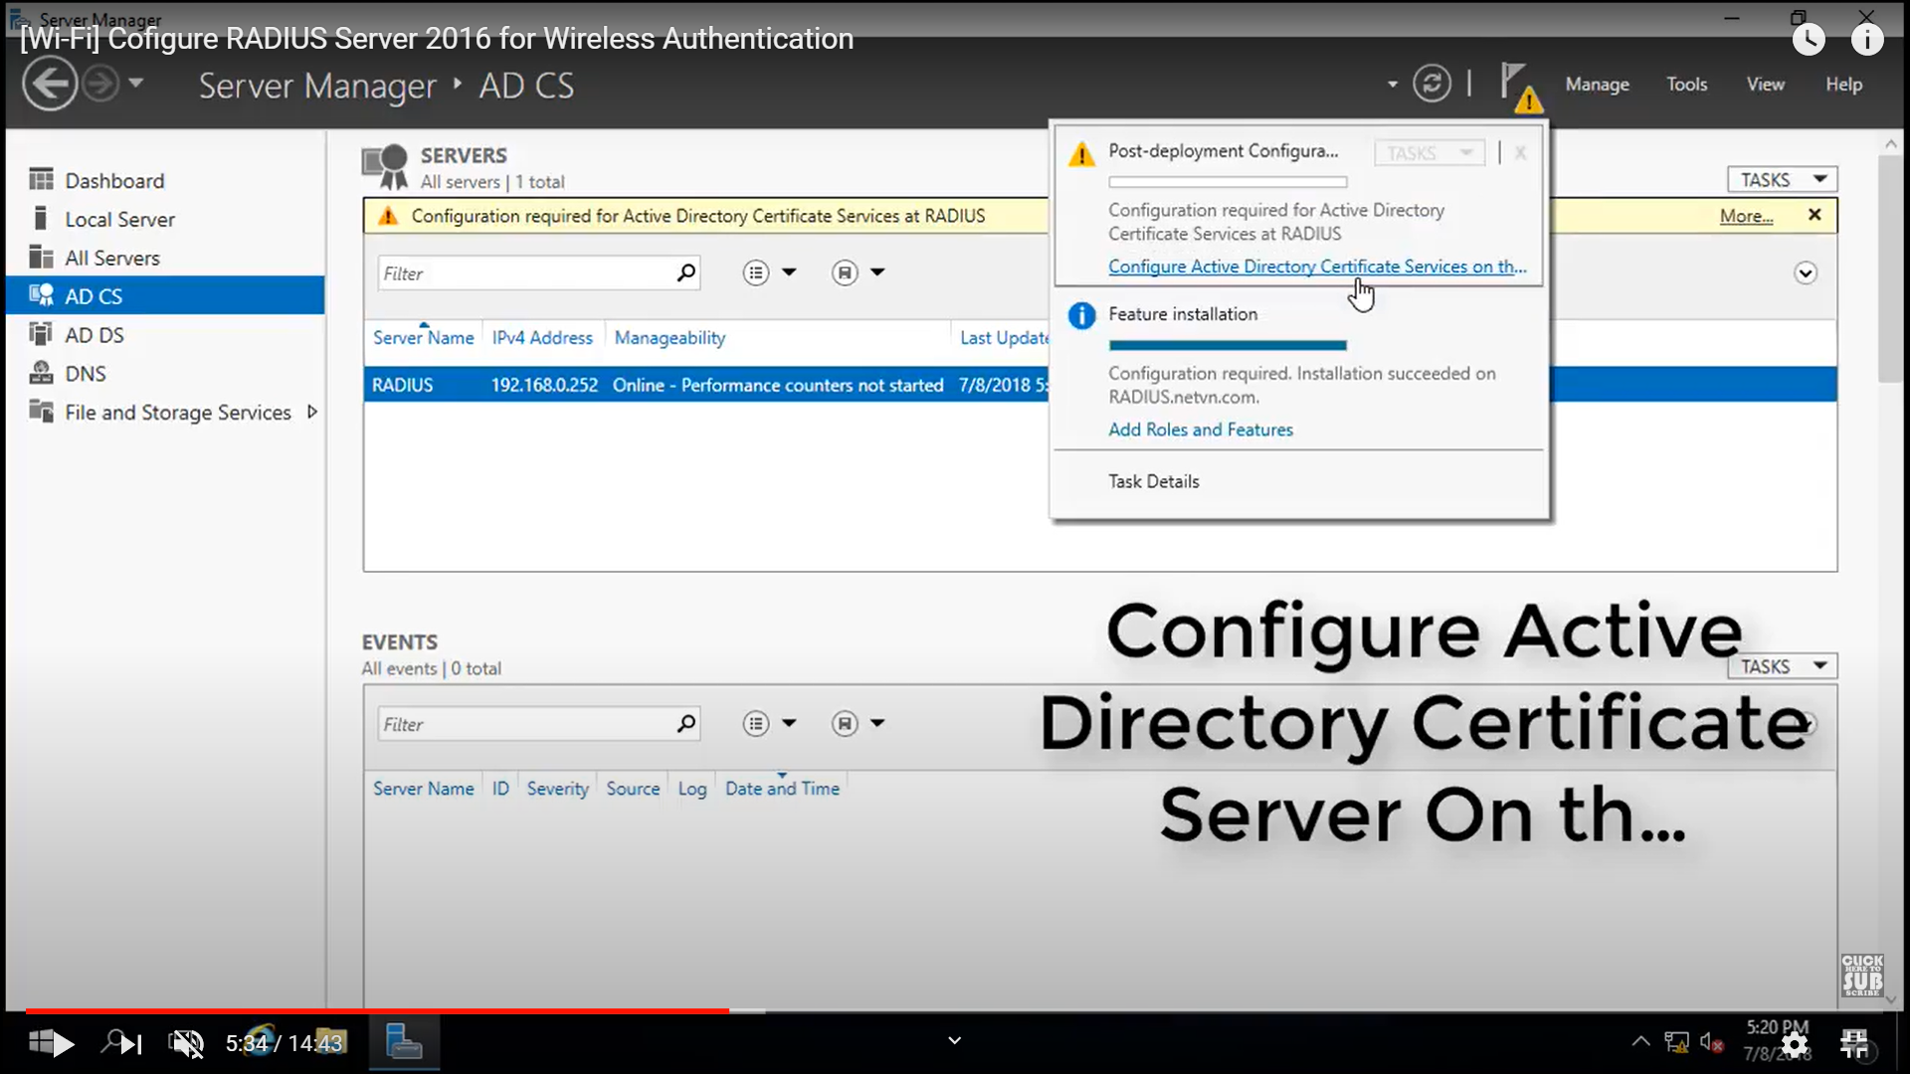 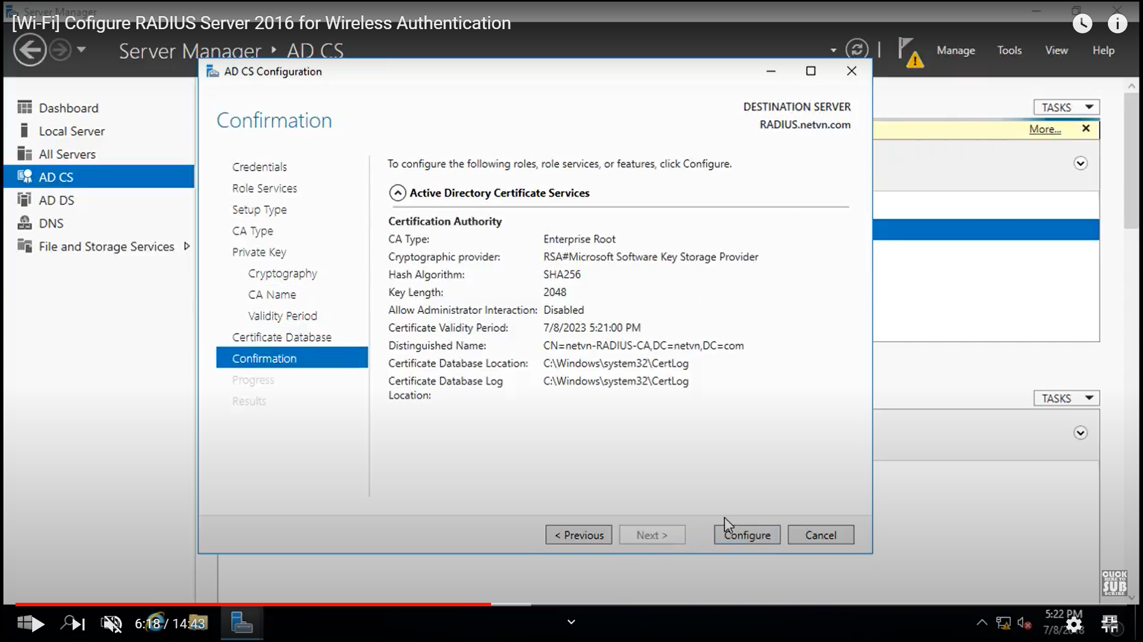

1. Installing and configured NAP (Network Policy and Access Services)
2. Add Role and feature

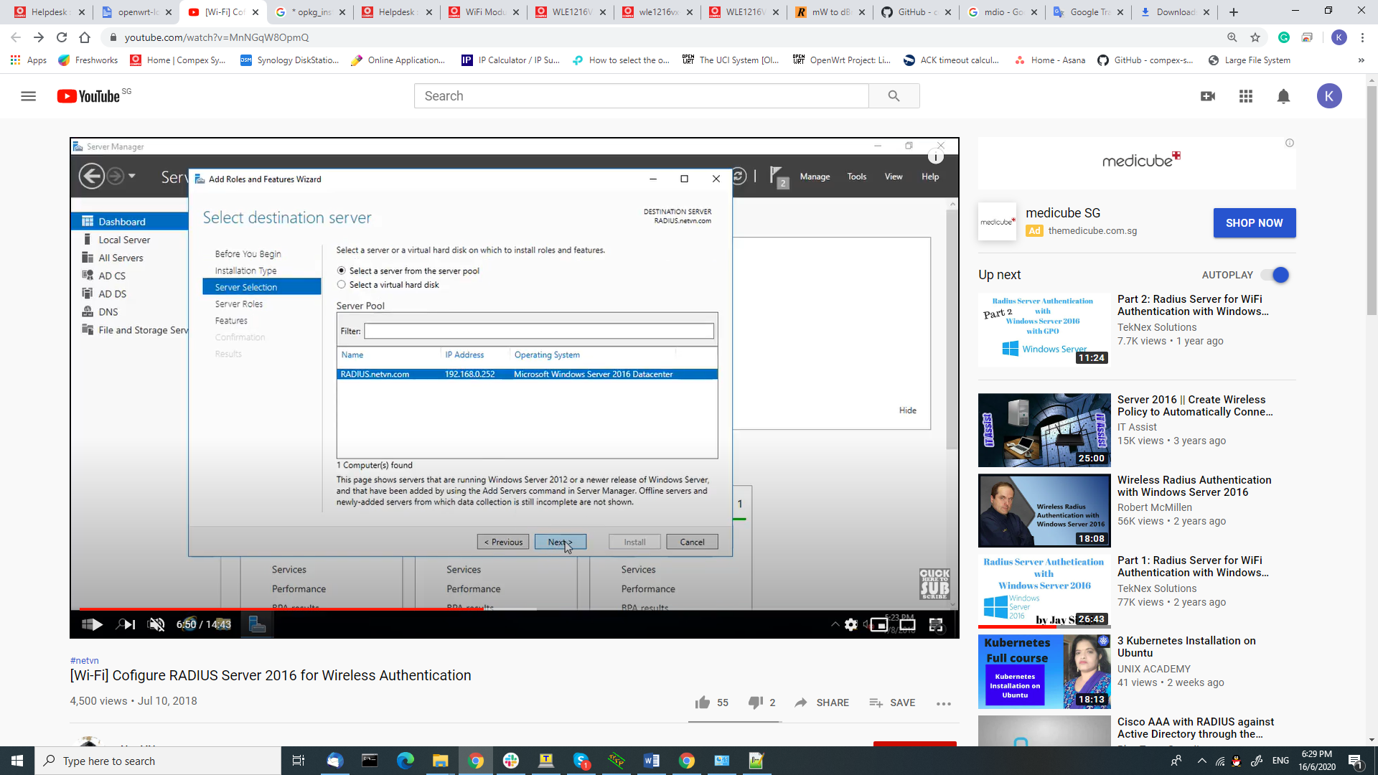

1. Choose NPS and Access Server -> next -> next -> install

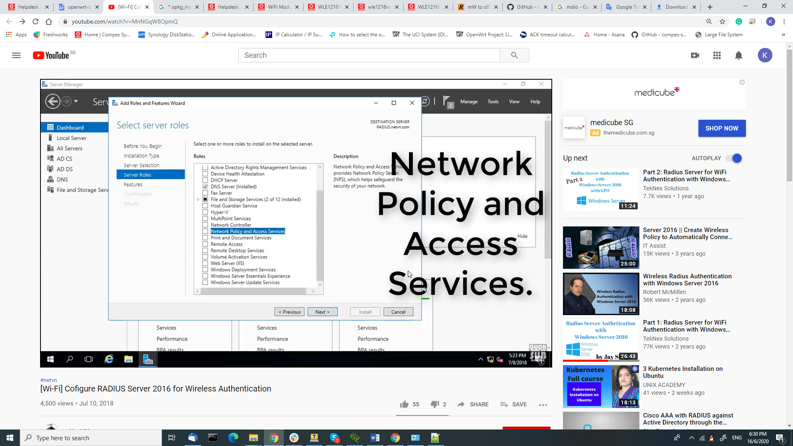

1. Setup Active Directory Users and computer. (Add authenticated client devices )

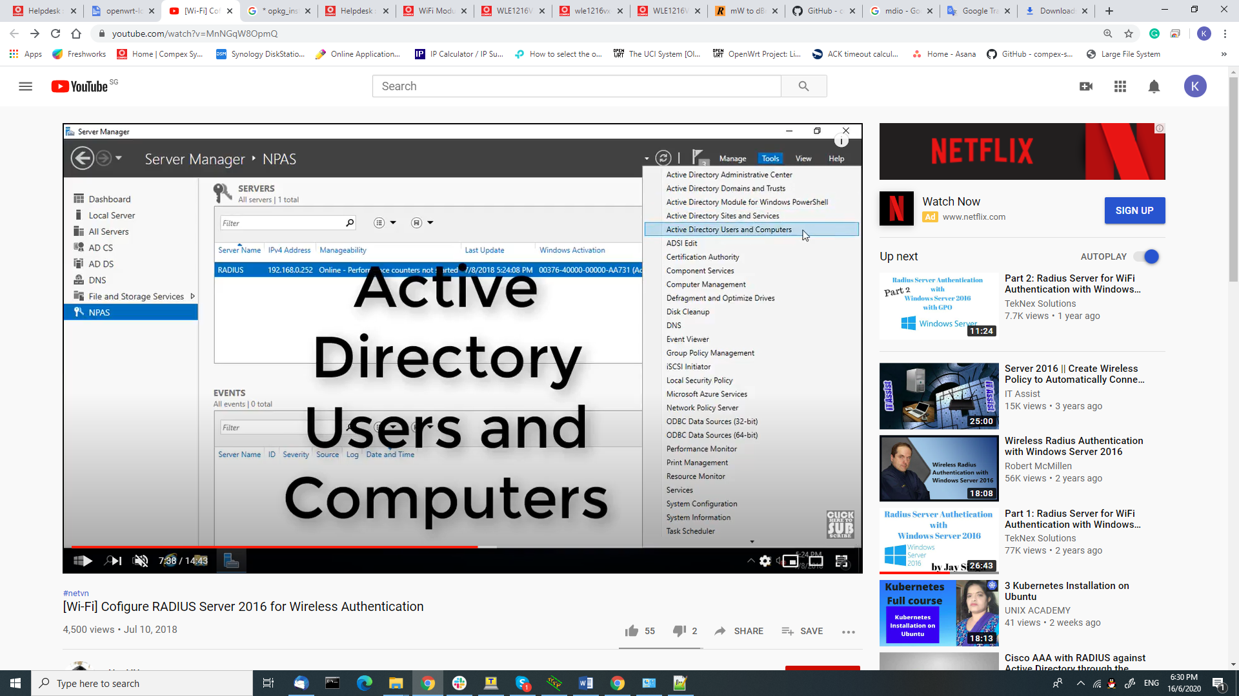

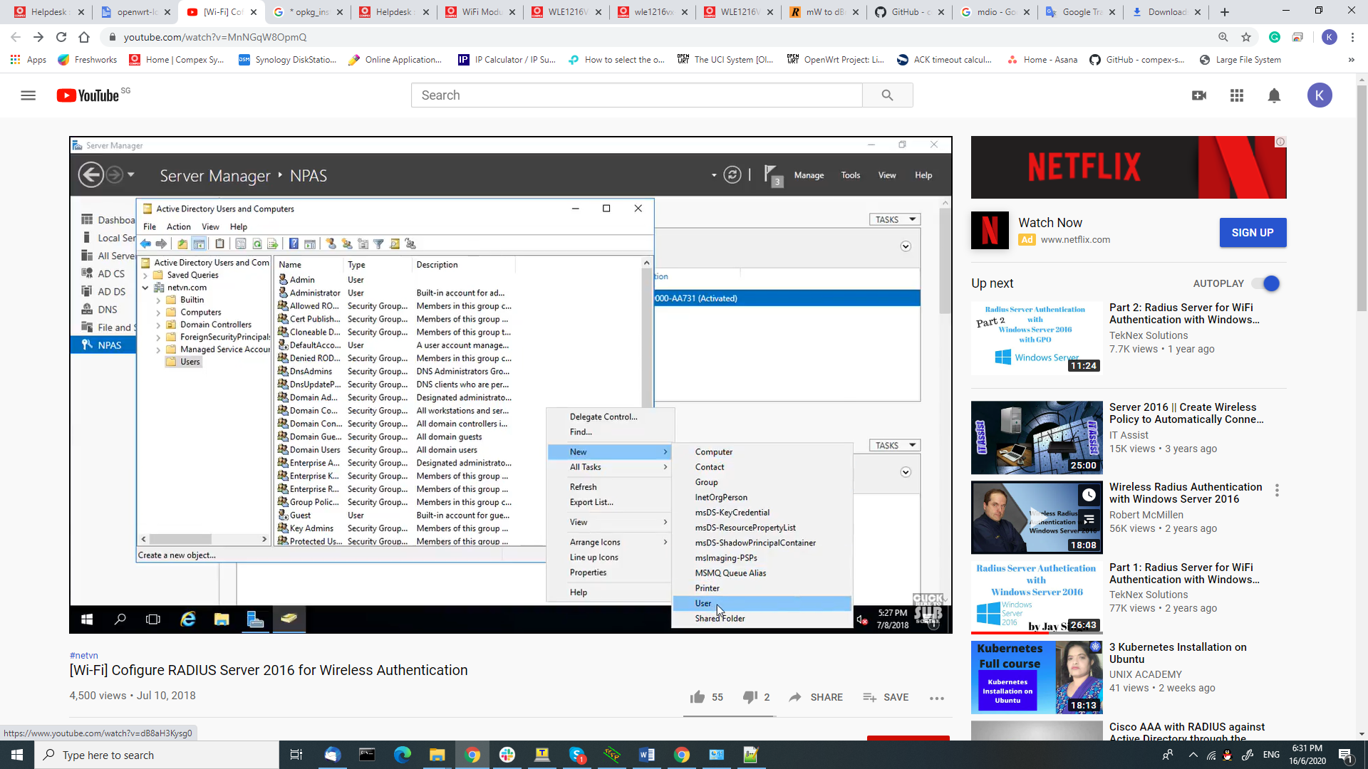

1. Click user and input the account information. -> password

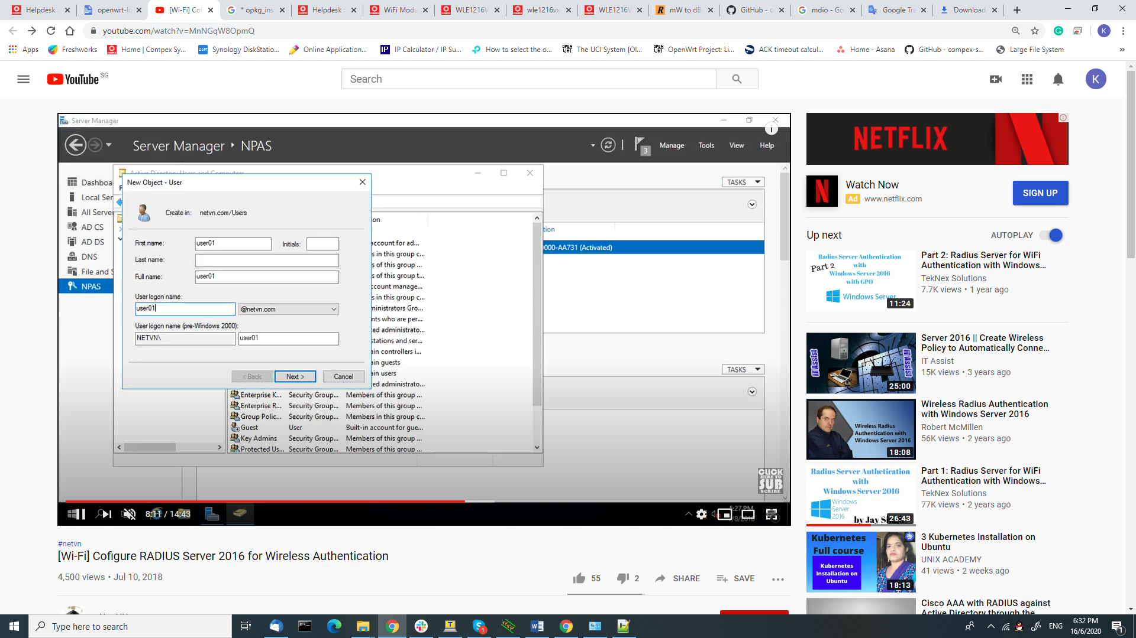

Enter password and tick the relevant. Click next

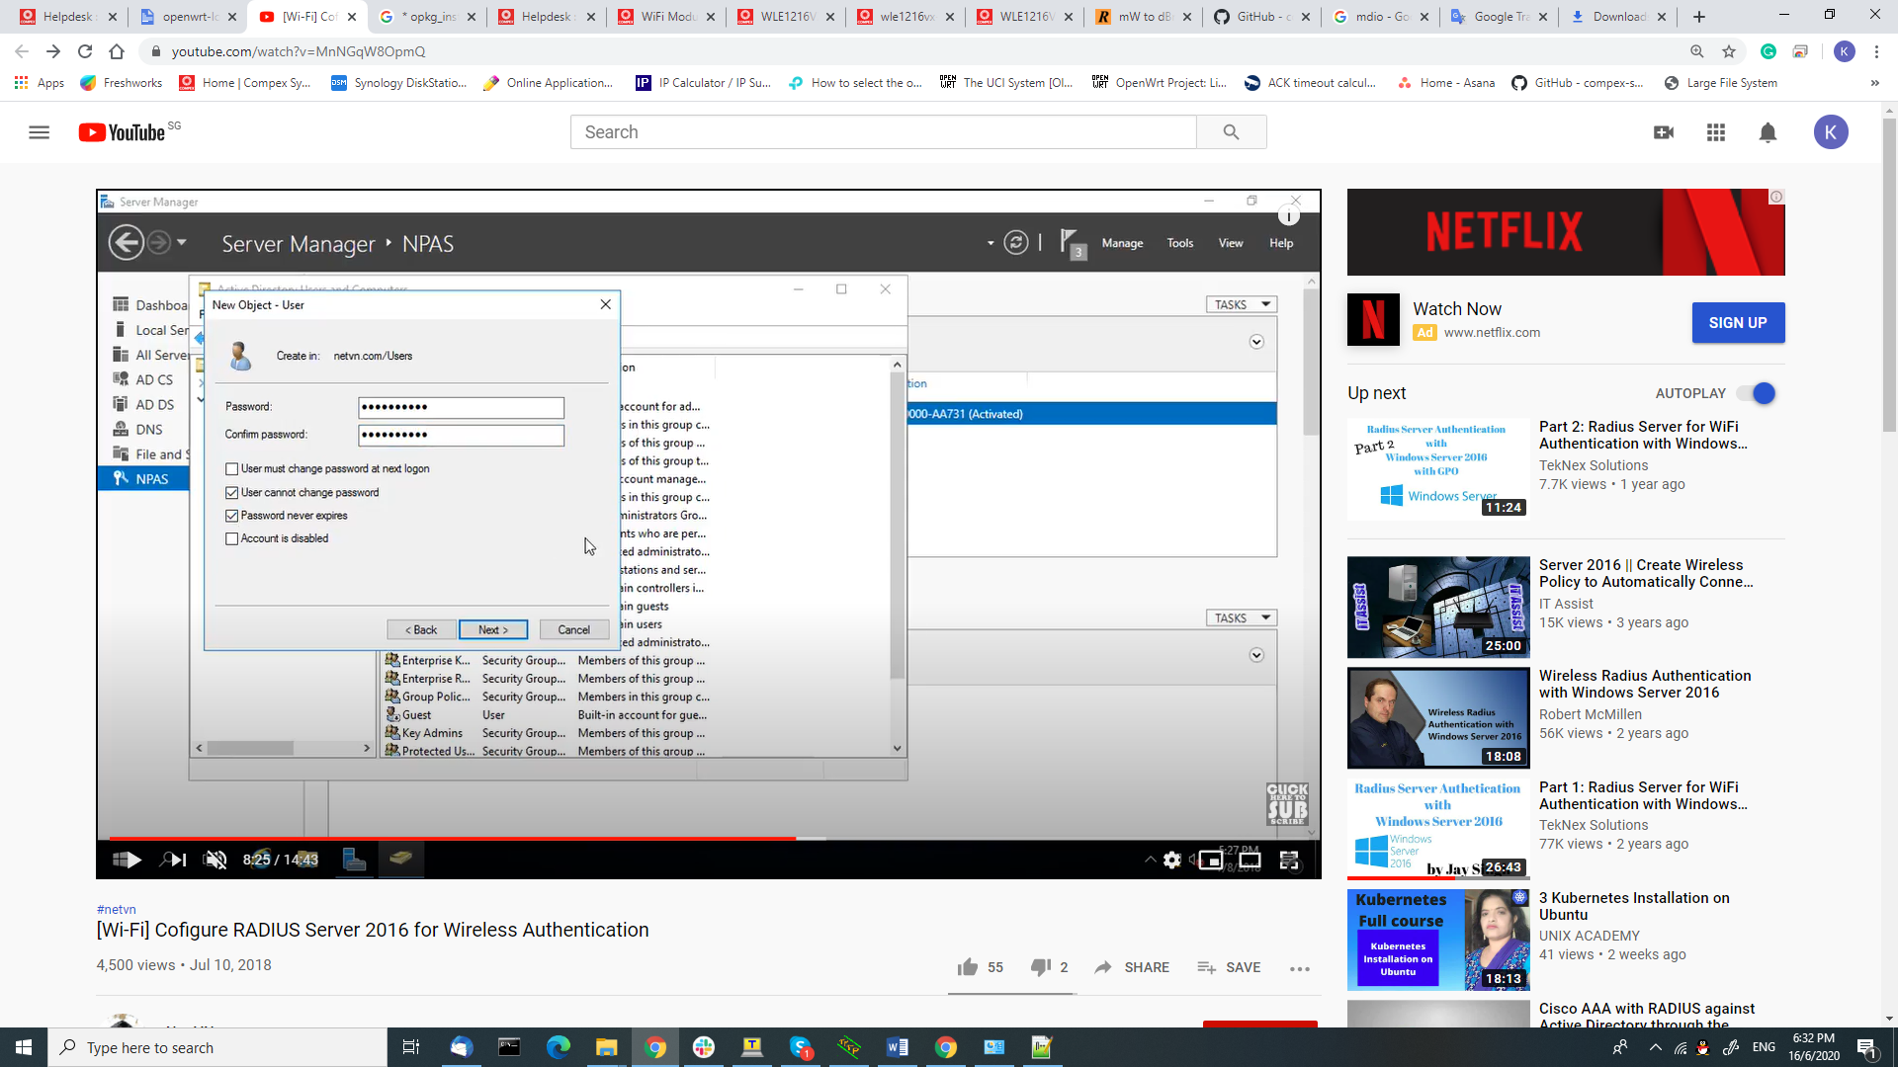

*Create a group to assign the User.

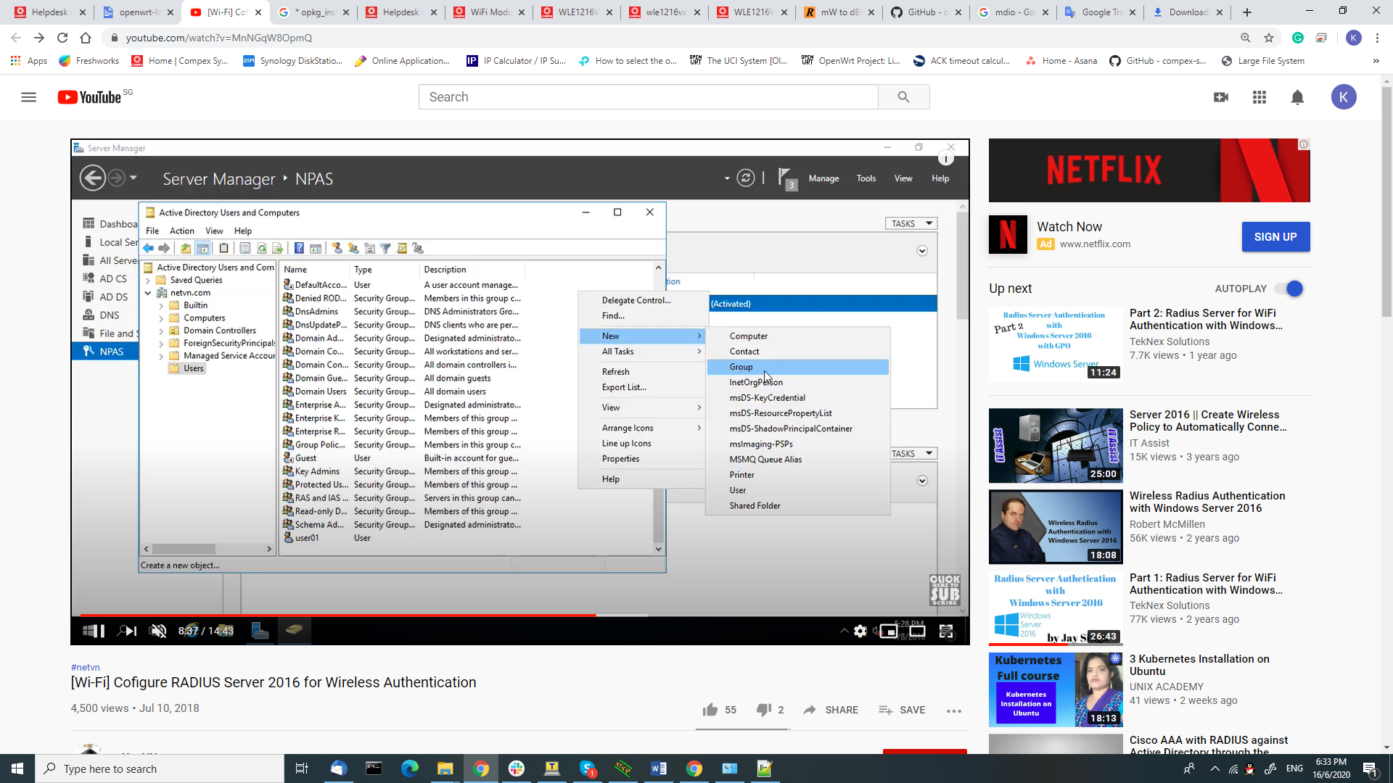

*Add to group.

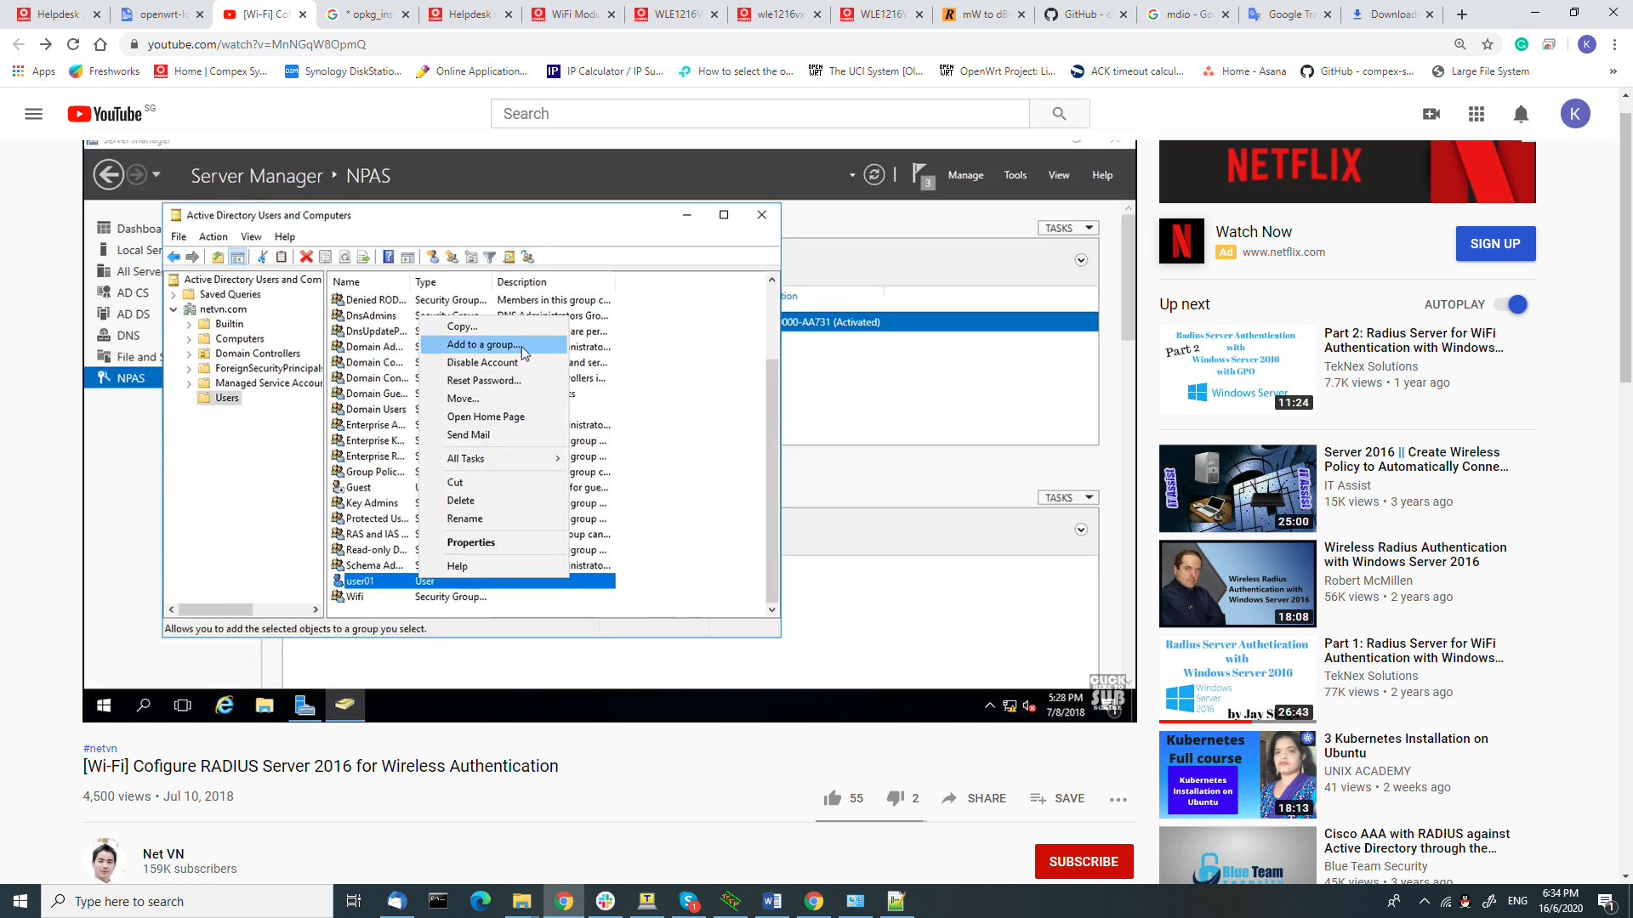

*Change the account properties. -> Allow Access

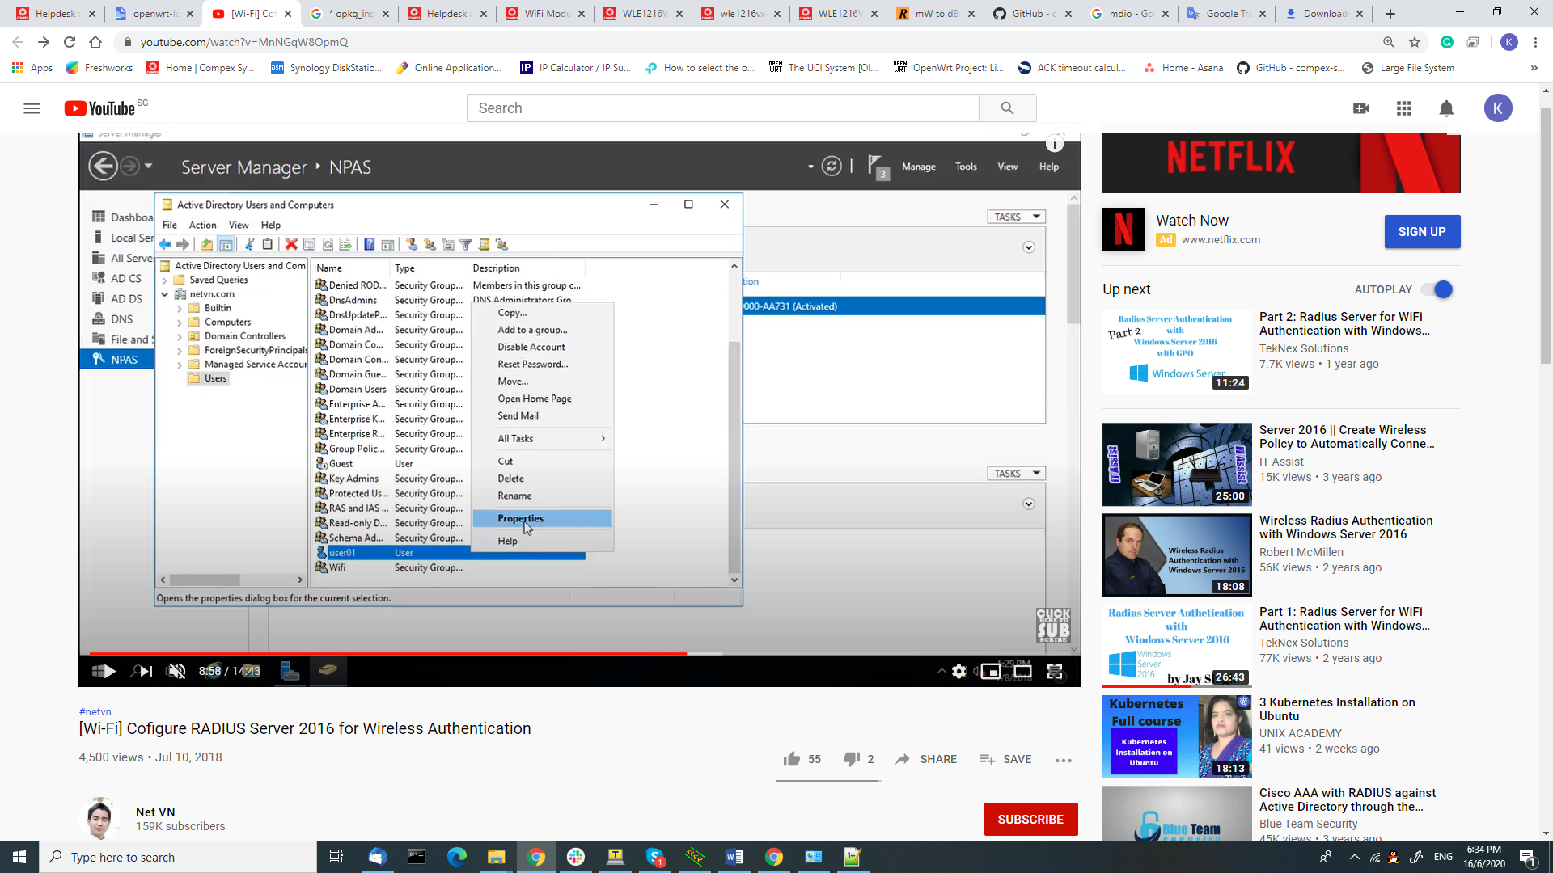

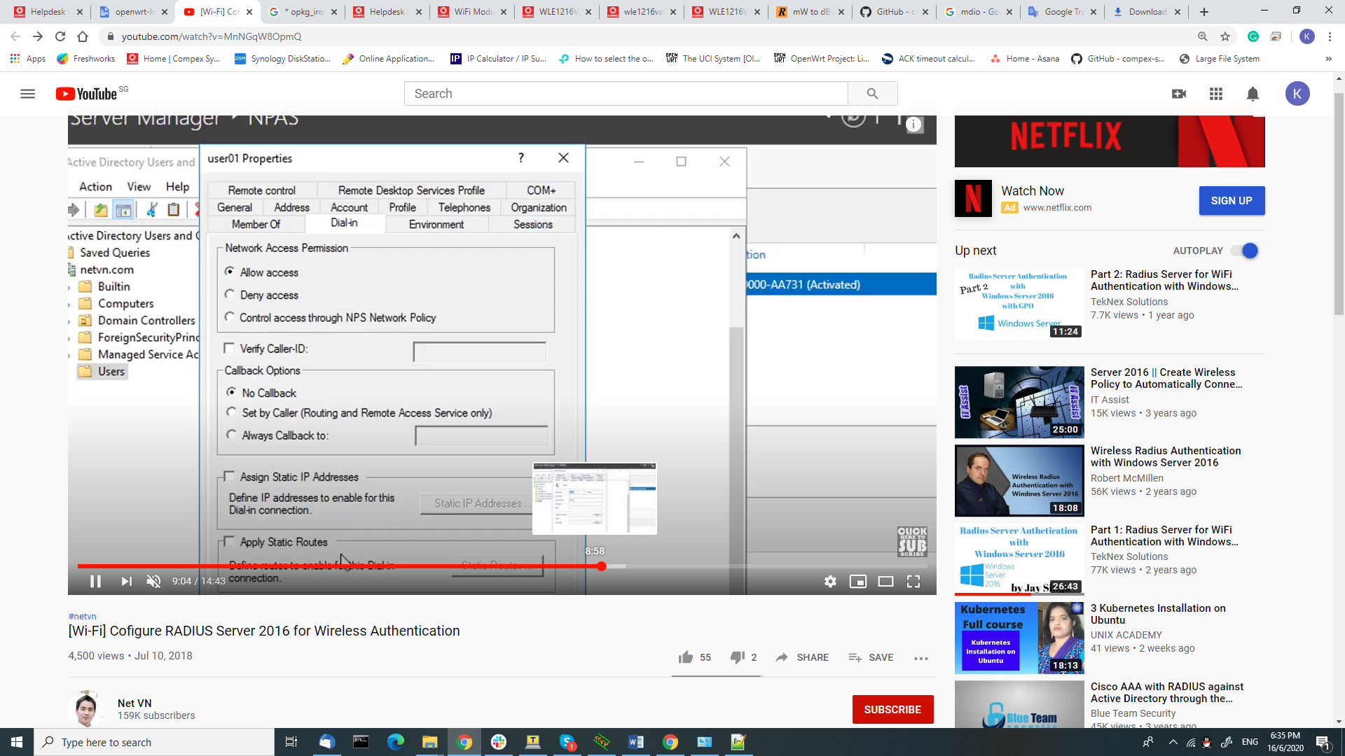

12. Click NPAS and setup the NPS.

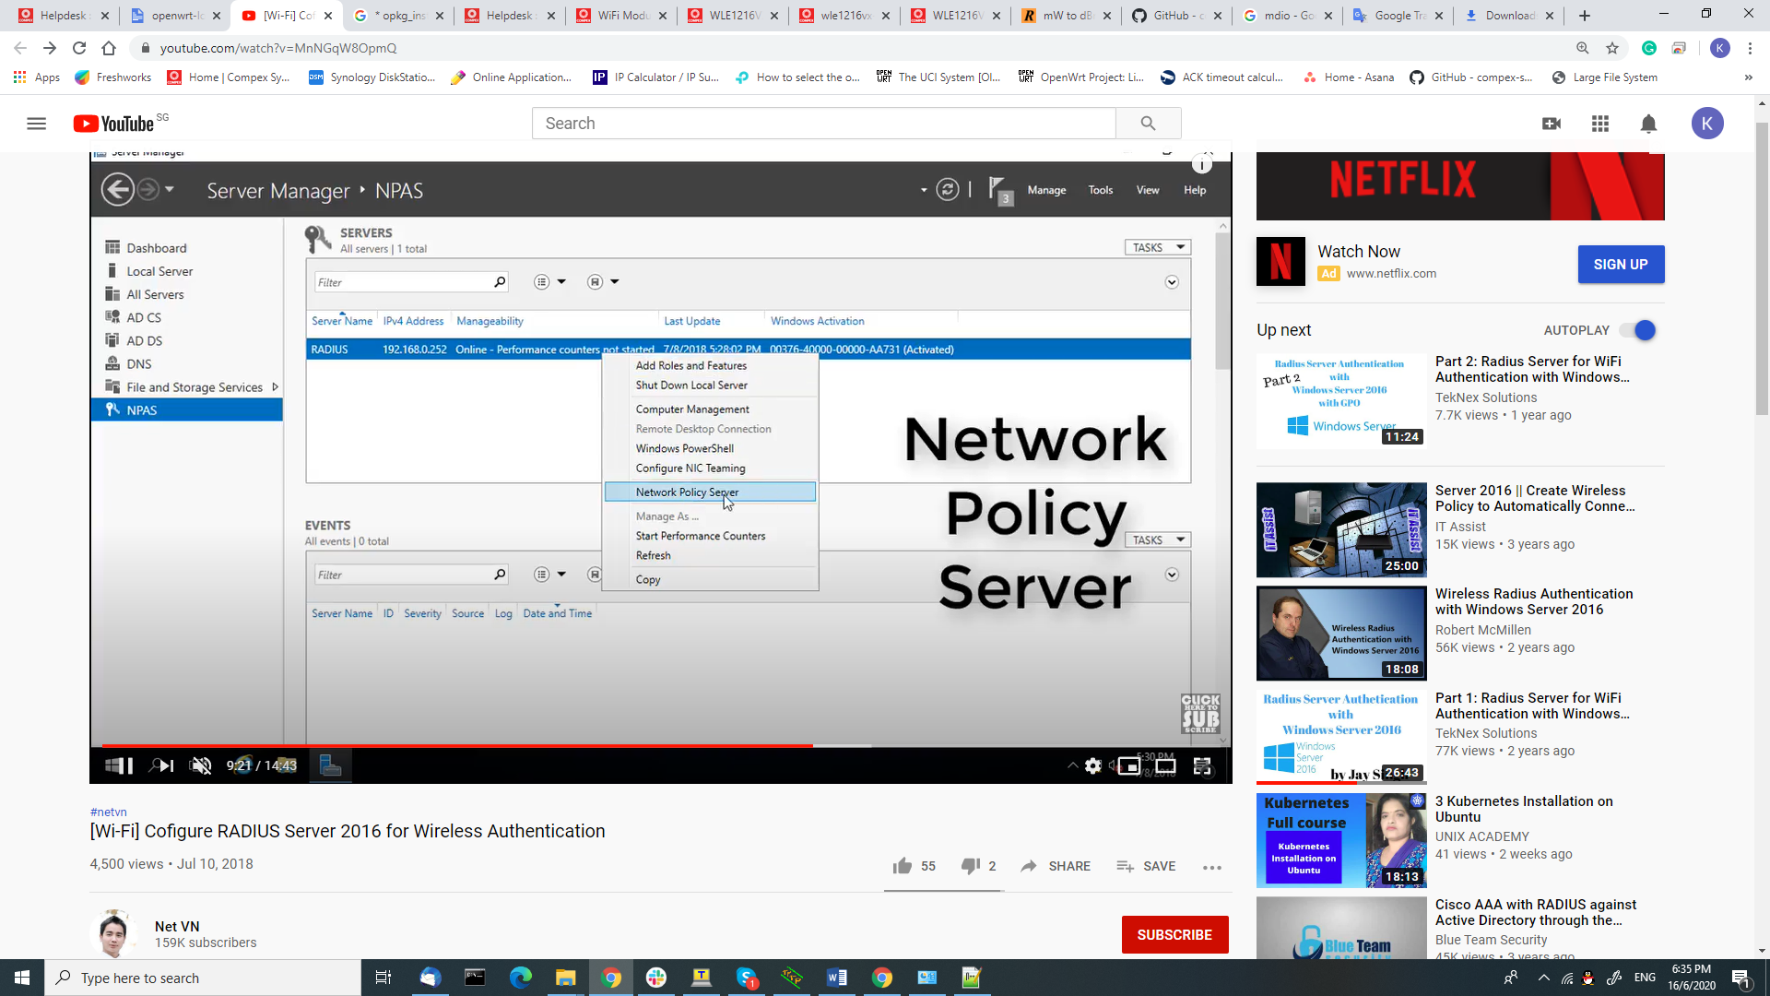

**Choose wireless authentication.

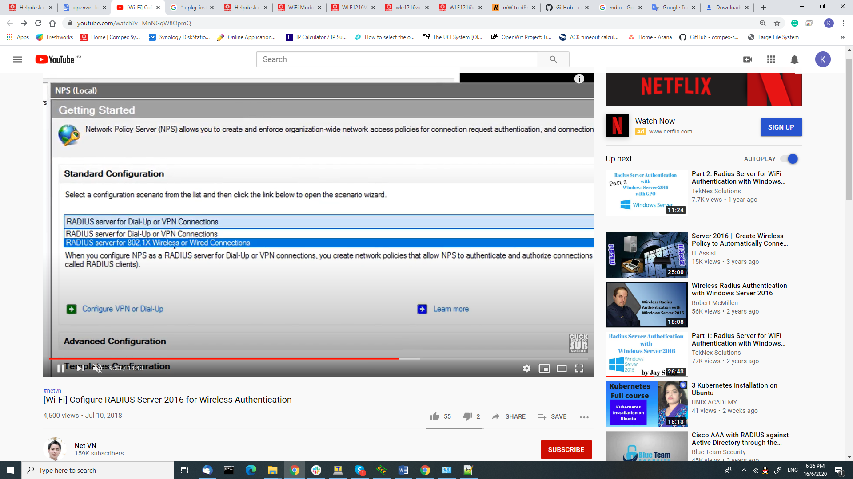

**Continue with create policy.

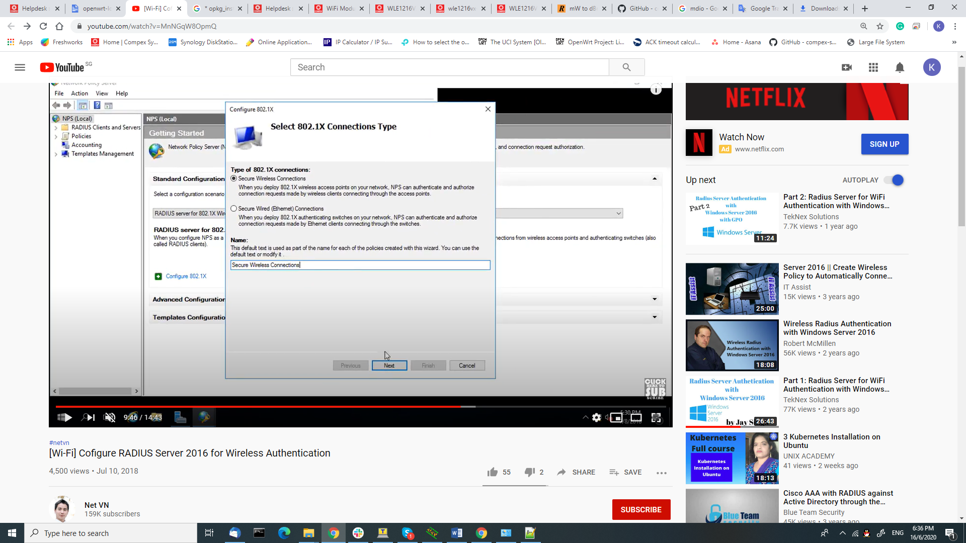

**create a shared secret to allow AP communicate with Radius Server.

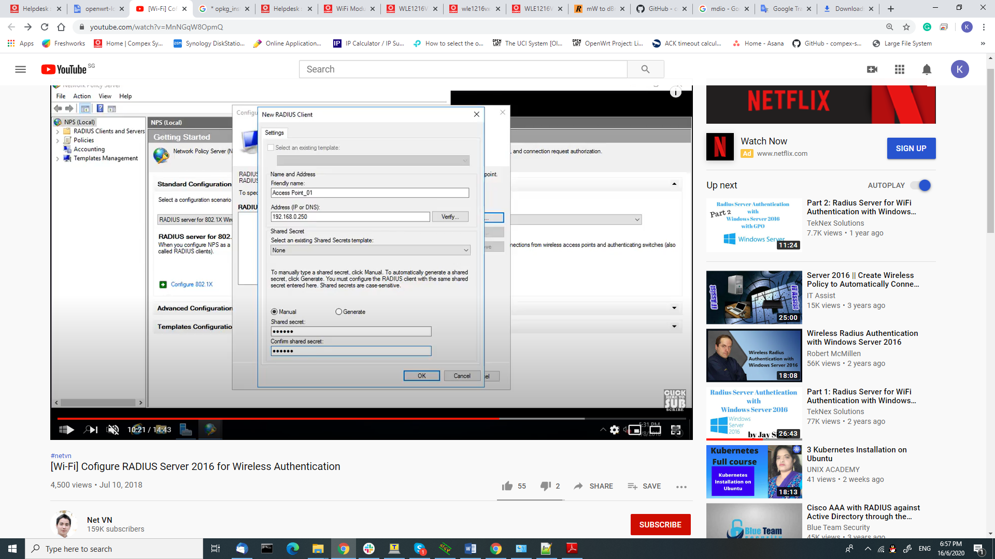

**Choose encryption type -> PEAP

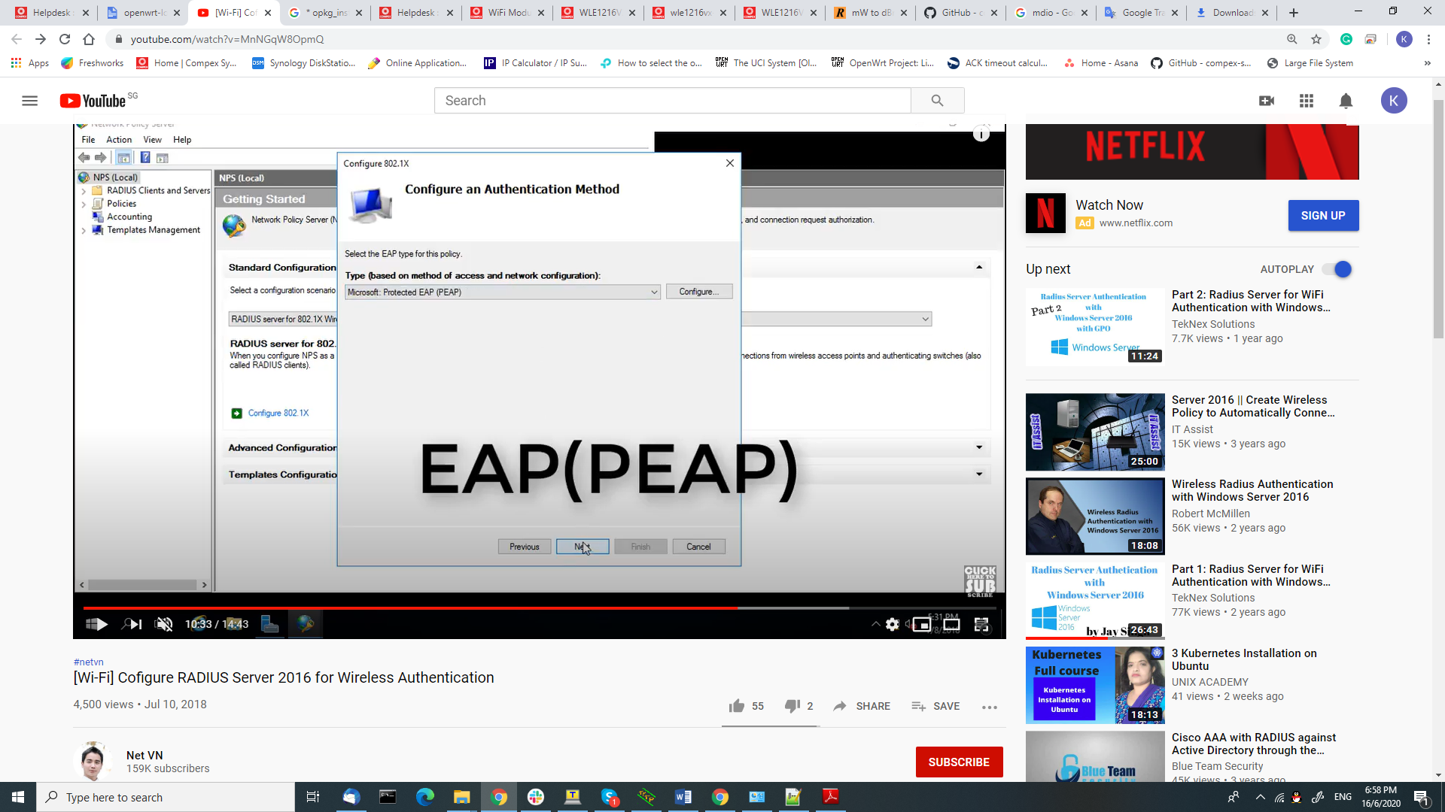

**Add group to this policy. Click Finish

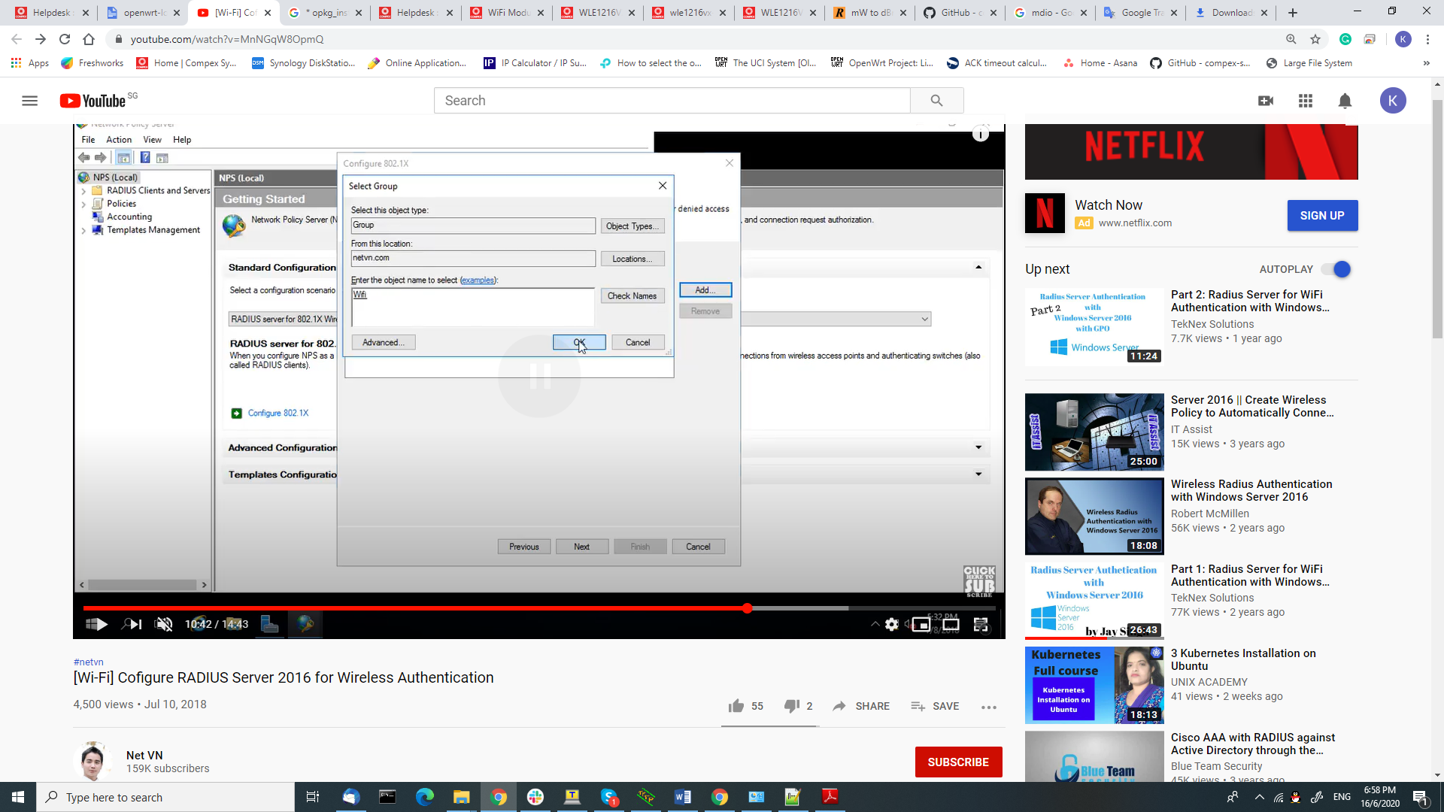

**You could assign this PC as DNS server as well.

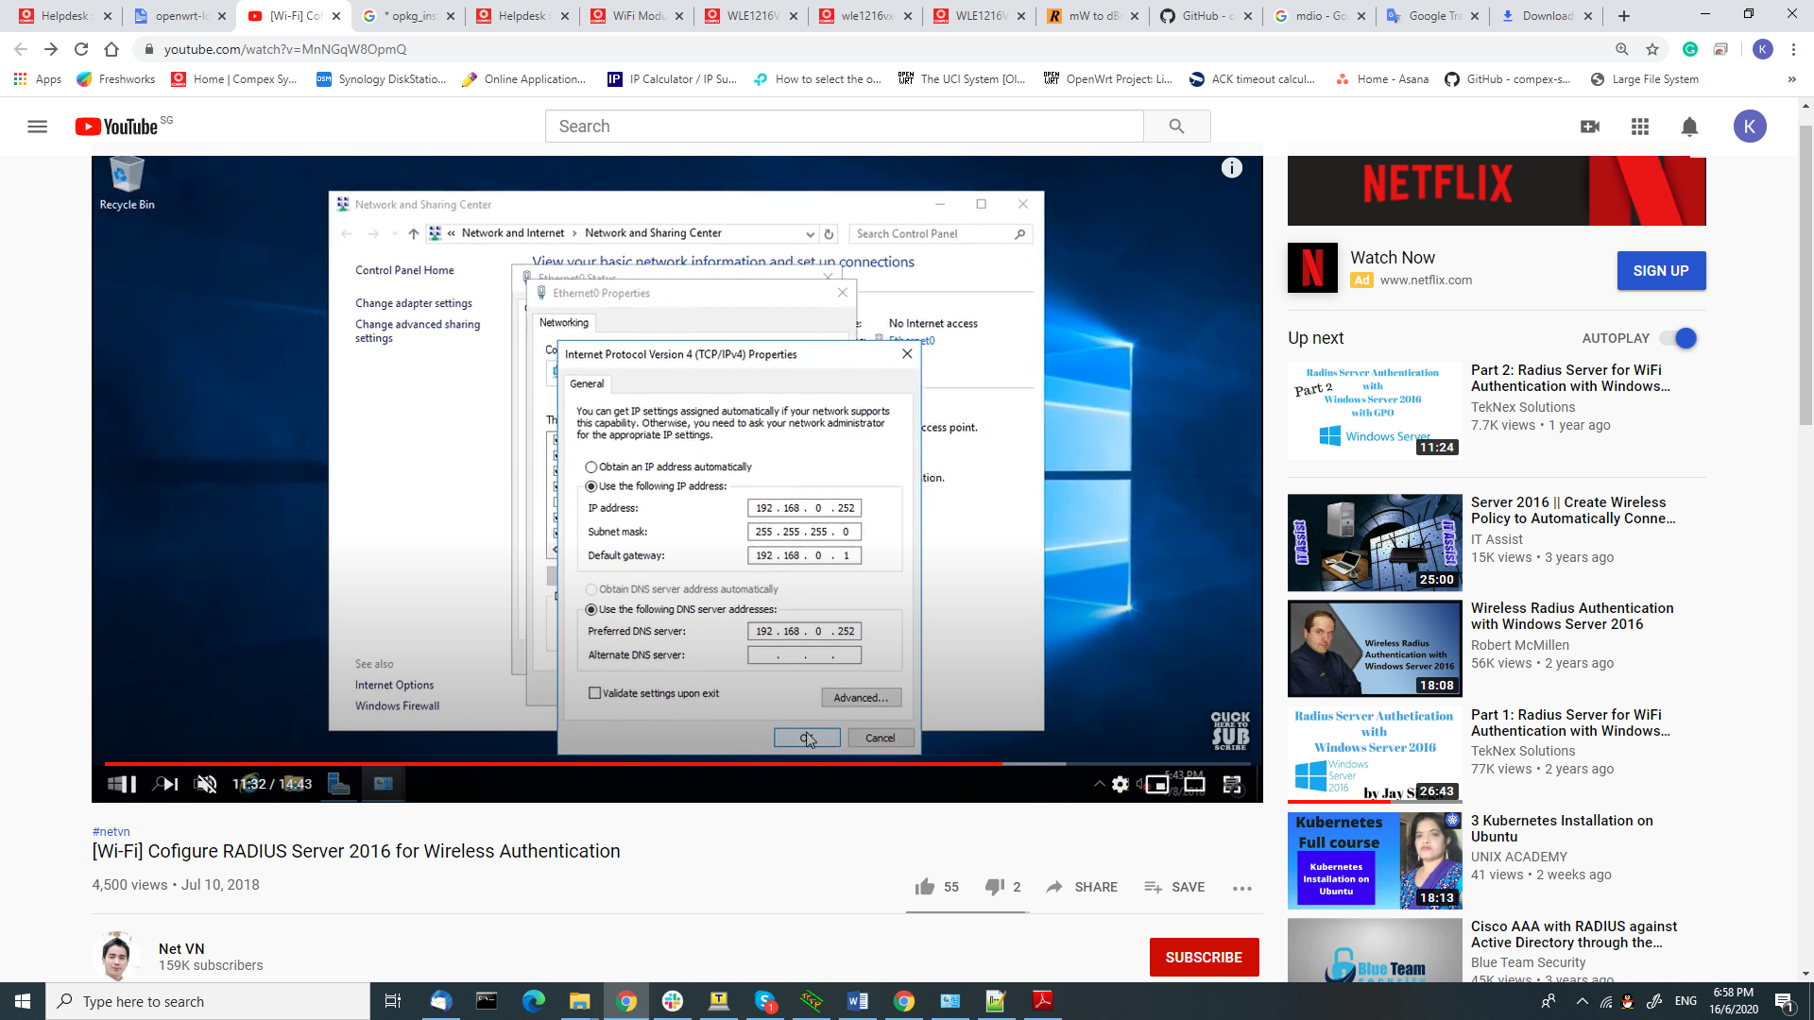

AP setup:

* Enter the Ip address of the PC host Radius server ( LAN IP)
* Auth Port default = 1812
* Secret = the secret u configured on Radius server



# // athtestcmd

// for txpwr 20, VHT80, MCS0, Channel 5210

athtestcmd -i wifi0 --tx tx99 --txfreq 5210 --txchain 8 --txrate 120 --mode vht --txpwr 26

## //measure tgt power

athtestcmd -i wifi0 --tx tx99 --txfreq 5180 --txrate 4 --txchain 3 --tpcm tgtpwr

# Hk01 Flash Firmware

//To flash Firmware

setenv ipaddr 192.168.1.1 && setenv serverip 192.168.1.10 && ping $serverip

tftpboot 0x44000000 spf114_norplusnand-ipq807x_64-single.img

imgaddr=0x44000000 && source $imgaddr:script

reset

SPF113norplusnand-ipq807x_64-single.img

# HK01 USB boot

There is S3 switches on the HK01 board. Set DIP3 to ON to force USB boot.  
Details are in AP.HK01 setup guide.  
  
Most USB boot files mentioned in the SoC Software User Guide are available in the QCA SPF8.0 QSDK release  
inside the BOOT.xxx, RPM.xxx, TZ.xxx  directories.  
The u-boot binary needs to be compiled using the QSDK.  
The Soc guide already contains all the necessary info for usb emergency download.  
  
On Windows host side, needs to install Qualcomm USB driver, just google  
"Qualcomm HS-USB QDLoader 9008 Driver"  
  
Basically, only two commands are needed on Windows:  
if boot from USB switch enabled:  
QsaharaServer.exe -p \\.\COM3 -s 21:sbl1_flashless.mbn -v 3  
  
if board was bricked (flash does not have a valid SBL and switches in normal position):  
QsaharaServer.exe -p \\.\COM3 -s 13:sbl1_flashless.mbn -v 3  
  
QsaharaServer.exe -p \\.\COM3 -s 1:cdt-AP-HK01-C1_256M32_DDR3.bin -s 25:tz.mbn -s 34:devcfg_noac.mbn -s 23:rpm.mbn -s 5:openwrt-ipq807x-u-boot.mbn -v 3  
  
The u-boot runs after the commands,  the firmware image can then be flashed using the usual u-boot command.  
Our firmware images are in Prelease\ROUTER\AP.HK01\qca-reference\spf80cus2\b181016   
  
PS. Primary boot loader does not output anything to serial port, the first message from serial is from SBL, which resides in flash.

# //Command to change date and time

root@MimoAP:~# date

Wed Jun 24 09:31:05 UTC 2020

date -s 07.01-09:28

/etc/init.d/cpxpingwdog.init start

//Auto reboot

Auto reboot based on hour, is not referring to reboot your system for every hour. Auto reboot based on hour is referring to perform a reboot with this particular number of hours.

Auto Reboot -> Enable -> Number of hour -> 168. (**168 = 1week**)

Example: Today date and time Wed Jun 24 09:31:05 UTC 2020.

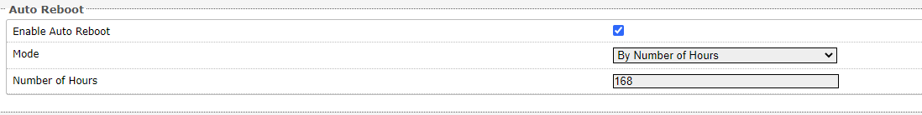

Output: The board will be expected reboot around Wed July 1 09: 29:05 UTC 2020.

Quick simulate: At least set the time on the board 3 minutes before the "**number of hour**" configured. You could configure the time on the board with this command: **date -s 07.01-09:28     (Format: date -s Month-Day-Time)**

**​**

And the provided ping watchdog is the latest tool.

### Some log explanation:

VDEV_MGR_BEACON_MISS_TIMER_TIMEOUT  
- wireless data transmission is done by beacon frame from vap to client,  
- the times between beacon frame is called beacon interval.  
- These beacon interval can be related to timeout,  
- as times for transmission must be numbers of beacon interval (default is 100ms)  
- so if more than timeout 100ms, indicate miss number of beacon frame and report miss timer timeout.  
- this can be controlled by setting timeout higher value.

​

VDEV_MGR_BEACON_MISS_DETECTED  
- Beacon missing is to conclude no beacon found.  
- this can happens after timeout or no beacon found.

WAL_DBGID_STA_VDEV_XRETRY  
- WAL make client retry receive signal from AP.

1. - Ensure sufficient signal strength, tx power should be high enough to cover the area
2. Ensure minimum basic rate (MBR) isn't too high

​

WAL_DBGID_DEV_RESET  
- reset the network device after several times

​

WAL_DBGID_DEV_TX_TIMEOUT  
- reached the timeout for device receive

​

WHAL is API to configure the data rate, frequency, tx power for the channel

​

WHAL API has some function like,

whal_mcs_to_kbps, whal_ratecode_to_kbps  
ctlFreqbin2G[WHAL_NUM_CTLS_2G][WHAL_NUM_BAND_EDGES_2G];  
[WHAL_NUM_BAND_EDGES_5G];  
ctlData5G[WHAL_NUM_CTLS_5G] and etc;  
  
WHAL_ERROR_RESET_CHANNF1  
Once, fail to create VDEV, the VDEV parameter, data must be reset.

WAL_DBGID_BB_WDOG_TRIGGERED

After that, the watchdog is being call to monitor baseband.

# RD1 server, PC network already in use error, to fix it:

1. CMD, login as admin
2. net use * /delete
3. net use Z: \\192.168.8.66\rd1 /user:kiven_kong kiven998

# Phy Model AQR107 10Gbps port : Hk01, Hk01.2

QCA8081: 2.5 Gbps port for WPQ872 and WPQ873

QCA8075 ( 5 x 1Gbps port): WPQ872

# WPQ864 SPF10 Firmware

**Printenv output:**

host 192.168.1.10 is alive

IPQ806x# printenv

baudrate=115200

bootargs=console=ttyMSM0,115200n8

bootcmd=bootipq

bootdelay=2

eth1addr=00:03:7f:ab:bd:02

ethact=eth1

ethaddr 00:03:7f:ab:bd:01

fdt_high=0xffffffff

fdtcontroladdr=420623a0

flash_type=2

ipaddr=192.168.1.1

machid=1260

serverip=192.168.1.10

soc_version_major=2

soc_version_minor=0

stderr=serial@16340000

stdin=serial@16340000

stdout=serial@16340000

**Nand Flash command:**

tftpboot 0x44000000 nand-ipq806x-single.img

imgaddr=0x44000000 && source $imgaddr:script

# //SPF11 Configured Monitor Mode on WPQ873

**2.4 GHz Monitor Mode**

uci set wireless.wifi1=wifi-device

uci set wireless.wifi1.type= qcawificfg80211

uci set wireless.wifi1.macaddr=00:60:02:00:c9:c8

uci set wireless.wifi1.hwmode=**11axg**

uci set wireless.wifi1.disabled=0

uci set wireless.wifi1.htmode=HT20

uci set wireless.wifi1.channel=1

uci set wireless.wifi1.txchainmask=15

uci set wireless.wifi1.rxchainmask=15

uci set wireless.wifi1.mode=ap

uci set wireless.@wifi-iface[1]=wifi-iface

uci set wireless.@wifi-iface[1].device=wifi1

uci set wireless.@wifi-iface[1].network=lan

uci set wireless.@wifi-iface[1].mode=**monitor**

uci set wireless.@wifi-iface[1].ssid=2g_open

uci set wireless.@wifi-iface[1].encryption=none

uci commit wireless

wifi down

wifi up

**5 GHz Monitor Mode**

uci set wireless.wifi0=wifi-device

uci set wireless.wifi0.type= qcawificfg80211

uci set wireless.wifi0.macaddr=00:60:02:00:c9:c9

uci set wireless.wifi0.hwmode=**11axa**

uci set wireless.wifi0.disabled=0

uci set wireless.wifi0.htmode=HT80

uci set wireless.wifi0.channel=36

uci set wireless.wifi0.txchainmask='0x0ff'

uci set wireless.wifi0.rxchainmask='0x0ff'

uci set wireless.wifi0.mode=**ap**

uci set wireless.@wifi-iface[0]=wifi-iface

uci set wireless.@wifi-iface[0].device=wifi0

uci set wireless.@wifi-iface[0].network=lan

uci set wireless.@wifi-iface[0].mode=monitor

uci set wireless.@wifi-iface[0].ssid=5g_open

uci commit wireless

wifi down

wifi up

# Simplify way to setup monitor mode

Enter monitor mode:

uci set wireless.wifi0.hwmode=11axa

uci set wireless.wifi0.htmode=HT80

uci set wireless.wifi0.channel=36

uci set wireless.wifi0.mode=**ap**

uci set wireless.@wifi-iface[0].mode=monitor

uci commit wireless

wifi down

wifi up

wlanconfig ath0 destroy

wlanconfig ath0 create wlandev wifi0 wlanmode monitor

wifi

root@OpenWrt:/# iwconfig ath0

ath0 IEEE 802.11axa ESSID:""

Mode:Monitor Frequency:5.2 GHz Access Point: Not-Associated

Bit Rate:4.8039 Gb/s Tx-Power:23 dBm

RTS thr:off Fragment thr:off

Encryption key:off

Power Management:off

Link Quality=0/94 Signal level=-83 dBm Noise level=-83 dBm (BDF averaged NF value in dBm)

Rx invalid nwid:0 Rx invalid crypt:0 Rx invalid frag:0

Tx excessive retries:0 Invalid misc:0 Missed beacon:0

//to capture tcpdump pcaplog , file should located at /tmp folder

tcpdump -i ath0 -w /tmp/log_file1.pcapng

# Install tcpdump and libpcap

opkg --force-space install libpcap_1.5.3-1_ar71xx.ipk

opkg --force-space --nodeps install tcpdump_4.9.2-1_ar71xx.ipk

# 6Ghz Frequency list: Total Channel = 58 ?

Ch1 – 5945 Mhz

Ch5 – 5965 Mhz

Ch9 – 5985 Mhz

Ch13 - 6005 Mhz

Ch17 – 6025 Mhz

Ch21 – 6045 Mhz

Ch25 – 6065 Mhz

Ch29 – 6085 Mhz

Ch33 – 6105 Mhz

Ch37 – 6125 Mhz

Ch41 – 6145 Mhz

Ch45 – 6165 Mhz

Ch49 – 6185 Mhz

Ch53 – 6205 Mhz

Ch57 – 6225 Mhz

Ch61 – 6245 Mhz

Ch65 – 6265 Mhz

Ch69 – 6285 Mhz

Ch73 – 6305 Mhz

Ch77 – 6325 Mhz

Ch81 – 6345 Mhz

Ch85 – 6365 Mhz

Ch89 – 6385 Mhz

Ch93 – 6405 Mhz

Ch97 – 6425 Mhz

Ch101 – 6445 Mhz

Ch105 – 6465 Mhz

Ch109 – 6485 Mhz

Ch113 – 6505 Mhz

Ch117 – 6525 Mhz

Ch121 – 6545 Mhz

Ch125 – 6565 Mhz

Ch129 – 6585 Mhz

Ch133 – 6605 Mhz

Ch137 – 6625 Mhz

Ch141 – 6645 Mhz

Ch145 – 6665 Mhz

Ch149 – 6685 Mhz

Ch153 – 6705 Mhz

Ch157 – 6725 Mhz

Ch161 - 6745Mhz

Ch165 – 6765 Mhz

Ch169 – 6785 Mhz

Ch173 – 6805 Mhz

Ch177 – 6825 Mhz

Ch181 – 6845 Mhz

Ch185 – 6865 Mhz

Ch189 – 6885 Mhz

Ch193 – 6905 Mhz

Ch197 – 6925 Mhz

Ch201 – 6945 Mhz

Ch205 – 6965 Mhz

Ch209 – 6985 Mhz

Ch213 – 7005 Mhz

Ch217 – 7025 Mhz

Ch221 – 7045 Mhz

Ch225 – 7065 Mhz

Ch229 – 7085 Mhz

Ch233 – 7105 Mhz

Ch237 – 7125 Mhz //seem not exist in Pine

## //Set 6Ghz command:

root@OpenWrt:/tmp/run# uci show wireless

wireless.wifi0=wifi-device

wireless.wifi0.type='qcawificfg80211'

wireless.wifi0.macaddr='04:f0:21:65:3f:6d'

wireless.wifi0.hwmode='11axa'

wireless.wifi0.disabled='0'

wireless.wifi0.htmode='HT80'

**wireless.wifi0.band='3'**

**wireless.wifi0.channel='5'**

wireless.@wifi-iface[0]=wifi-iface

wireless.@wifi-iface[0].device='wifi0'

wireless.@wifi-iface[0].network='lan'

wireless.@wifi-iface[0].mode='ap'

wireless.@wifi-iface[0].ssid='OpenWrt'

wireless.@wifi-iface[0].encryption='none'

root@OpenWrt:/tmp/run# iwconfig ath0

ath0 IEEE 802.11axa ESSID:"OpenWrt"

Mode:Master Frequency:5.975 GHz Access Point: 04:F0:21:65:3F:6D

Bit Rate:2.4019 Gb/s Tx-Power:14 dBm

RTS thr:off Fragment thr:off

Encryption key:off

Power Management:off

Link Quality=0/94 Signal level=-89 dBm Noise level=-89 dBm (BDF averaged NF value in dBm)

Rx invalid nwid:0 Rx invalid crypt:0 Rx invalid frag:0

Tx excessive retries:0 Invalid misc:0 Missed beacon:0

# For PN9024/PN9074 board data

setenv bootargs 'console=ttyMSM0,115200n8 cnss2.bdf_pci0=0xac’

For 4x4 Series:

0xa0 = 5Ghz

0xa1 = 2.4Gz

0xa2 = 6Ghz

For 2x2 Series:

0xa5 = 5Ghz

0xa6 = 2.4Ghz

# DDNS Configuration ?

1. Register an account in no-ip.com
2. Hostname: kivenkong.hopto.org
3. Username: admin717
4. Password: ** (usual) 9

Verify ?

From your no-ip.com . you may found the ip reflect the URL u have key in in firmware

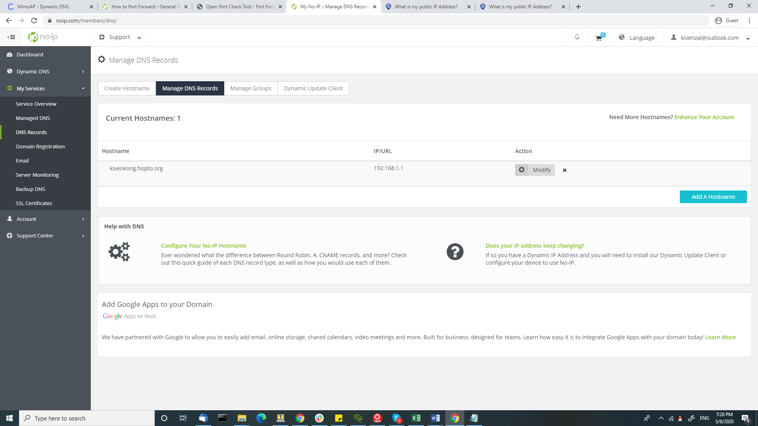

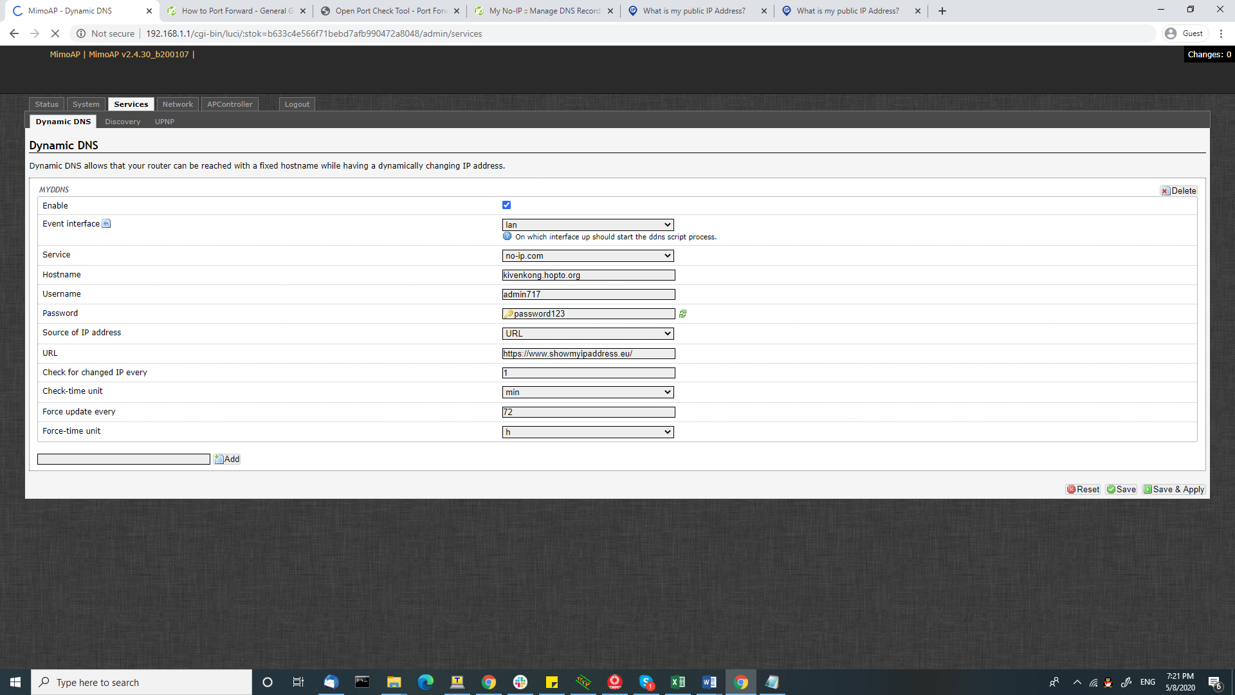

//WAP3-EAP

* CCMP-256 and GCMP-256 only support on 11ax WiFi6 chipset. 11ac Wave2 possible?

# CPT2 Firmware

* Default IP = 192.168.1.2

# //Ath10k example of hostapf.conf

### hostapd configuration file  
ctrl_interface=/var/run/hostapd  
ctrl_interface_group=0  
interface=wlp4s0  
driver=nl80211  
bridge=br0  
  
### IEEE 802.11  
ssid=bethaniaven9  
hw_mode=a  
channel=52  
max_num_sta=128  
auth_algs=1  
  
### DFS  
country_code=CH  
ieee80211d=1  
ieee80211h=1  
  
### IEEE 802.11n  
ieee80211n=1  
ht_capab=[HT40+][LDPC][SHORT-GI-20][SHORT-GI-40][TX-STBC][RX-STBC1][DSSS_CCK-40]  
  
### IEEE 802.11ac  
ieee80211ac=1  
vht_oper_chwidth=1  
vht_capab=[MAX-MPDU-11454][RXLDPC][SHORT-GI-80][TX-STBC-2BY1][RX-STBC-1]  
vht_oper_centr_freq_seg0_idx=62  
  
### IEEE 802.11i  
wpa=2  
wpa_key_mgmt=WPA-PSK  
wpa_passphrase=XXX  
rsn_pairwise=CCMP

**QCA Hostapd.conf**

// located in /tmp/run

driver=nl80211

interface=ath0

#

logger_syslog=127

logger_syslog_level=2

logger_stdout=127

logger_stdout_level=2

channel=auto

ieee80211ac=1

ieee80211n=1

vht_oper_chwidth=1

vht_oper_centr_freq_seg0_idx=auto

ht_capab=[LDPC][SMPS-DYNAMIC][TX-STBC][RX-STBC-1][MAX-AMSDU-7935][DSSS_CCK-40] [SHORT-GI-40]

vht_capab=[MAX-MPDU-11454][VHT160-80PLUS80][RXLDPC][SHORT-GI-80][SHORT-GI-160][TX-STBC-2BY1][RX-STBC1][SU-BEAMFORMER][SOUNDING-DIMENSION-4][SU-BEAMFORMEE][MAX-A-MPDU-LEN-EXP7][MU-BEAMFORMER][RX-ANTENNA-PATTERN][TX-ANTENNA-PATTERN]

hw_mode=a

wmm_enabled=1

dtim_period=1

ignore_broadcast_ssid=0

ctrl_interface=/var/run/hostapd-wifi0

send_probe_response=0

auth_server_addr=192.168.1.120

auth_server_port=1812

auth_server_shared_secret=test1234

eapol_key_index_workaround=1

ieee8021x=1

wpa_pairwise=GCMP-256

auth_algs=1

wpa=2

ssid=Eries1

bridge=br-lan

ieee80211w=2

group_mgmt_cipher=BIP-GMAC-256

wpa_key_mgmt=WPA-EAP-SUITE-B-192

# //cisco login

Ip: 192.168.1.1

Username: Cisco

Password: Cisco

# //Regarding Operating temperature.

Customer question:

* If the WLE1216 Wifi module does have a thermal protection mechanism which put him in a standby mode (no data traffic) above a certain temperature?
* And, if so, what is the maximum temperature when this happens?
* Finally, if the 70°C maximum operating temperature is the environment (ambient) temperature of the module in which it may be used or its junction temperature?

Answer :

1. When the chipset junction temperature approaches 105C, based on the temperature slope written in the Tensilica firmware, the chipset will stop its heavy-duty tasks and allow itself to cool down. The radio itself will not power down completely. This is known as thermal throttling, preventing the chipset from being damaged due to high ambient temperature operation.

2. It is quite hard to understand your 2nd question, but the 70C refers to the ambient temperature (environment), not case temperature nor junction temperature of the chipset. At 70C, depending on how the module being enclosed, the module/chipset surface temperature varies.

# SIM Slot Spec

Hi Kiven

SIM卡槽的供电电压一般是1.8V或者3.3V，这个是根据4G卡侦测到的信息去给SIM卡输送电压的，没有5V这种情况的。

LL

# Check Mu-Mimo Frame

After spending endless hours  figuring out on how to sniff the 802.11AC sounding frames ,I was finally able to get to it . So , I decided to blog it to help reduce the learning curve for others.

**What do you need to Sniff Mu-Mimo Frames ?**

* Linksys AP EA8500.
* Acer Aspire E14 / Aspire E15 clients.
* Acrylic WiFi sniffer ( Just to sniff the frames;Sniff well on 20Mhz but doesn’t decode ).
* Netgear A6200 wireless card on a Windows machine .(To Sniff Frames).
* Wireshark: The latest Development build( to decode them); Stable version can’t decode  Feedback Matrix from Client  .

How do you know if they really support Mu-Mimo?

* AP -> VHT capabilities in the Beacon frame  should have  Mu-Mimo Beamformer bit set to 1 .
* Client ->VHT capabilities in the  Association request frame  should have  Mu-Mimo Beamformee bit set to 1 .

[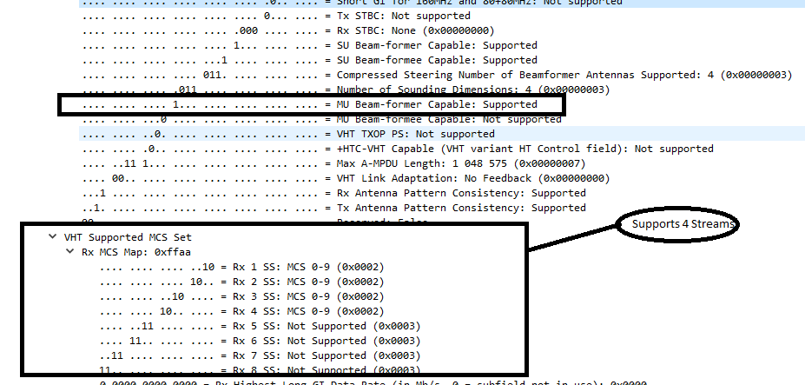](https://wizardonwireless.files.wordpress.com/2015/09/ap.png)

Mu-Mimo Beamformer[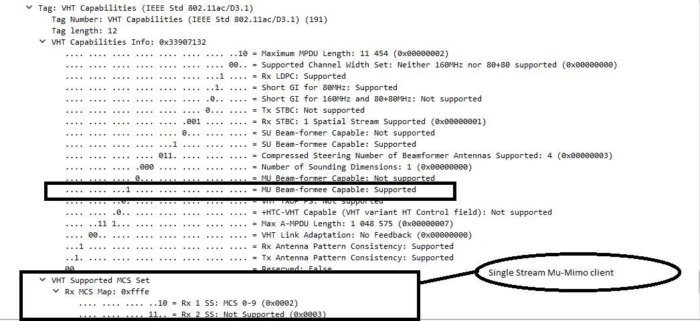](https://wizardonwireless.files.wordpress.com/2015/09/client.png)Mu-Mimo Beamformee

**Why did I choose Acrylic for Sniffer?**

REPORT THIS AD

REPORT THIS AD

It was the only sniffer that was able to sniff all the frames in 20Mhz ;Unfortunately , the other best bets were not able to sniff Frames consistently .  Please note that Acrylic doesn’t decode  the frames properly,  and works well only in 20Mhz with Mu-Mimo supported devices.

I suggest to use  Netgear A6200 with Acrylic.

**Why do we need the development version of Wireshark ?**

The stable version of Wireshark won’t decode the Feedback Matrix from the Mu-mimo Beamformee.  Use   dev version 1.99.9 for Decoding .

**What triggers Mu-Mimo feedback request / Announcement from the AP ?**

A minimum of two Mu-mimo clients is required  to Trigger Mu-mimo Beamforming request .  If the throughput need of the client is less, the AP wont trigger Mu-Mimo . All you will see is Su-mimo request /Responses .

VHT Sounding Frame from AP

[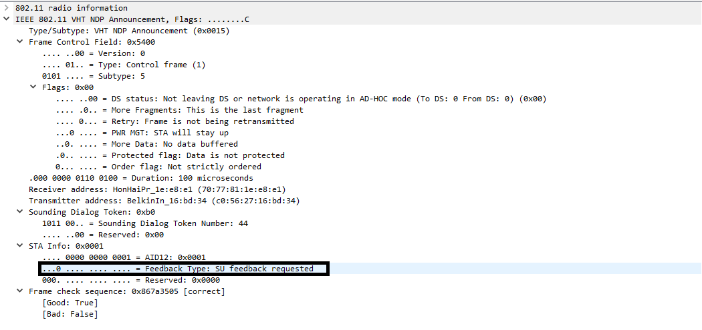](https://wizardonwireless.files.wordpress.com/2015/09/su_mimo-feedback-request-vht-sounding-copy.png)

Using QSDK, For Mu-Mimo capture, you could refer line 5647 to 5650. It's the same behaviour as ath10k-ct we captured.

And for iperf throughput, I have done a quick test in my office environment, 1 client is located at 1m near the AP, the other is placed at 4m

Feedback Matrix from Mu-mimo Client.

REPORT THIS AD

REPORT THIS AD

[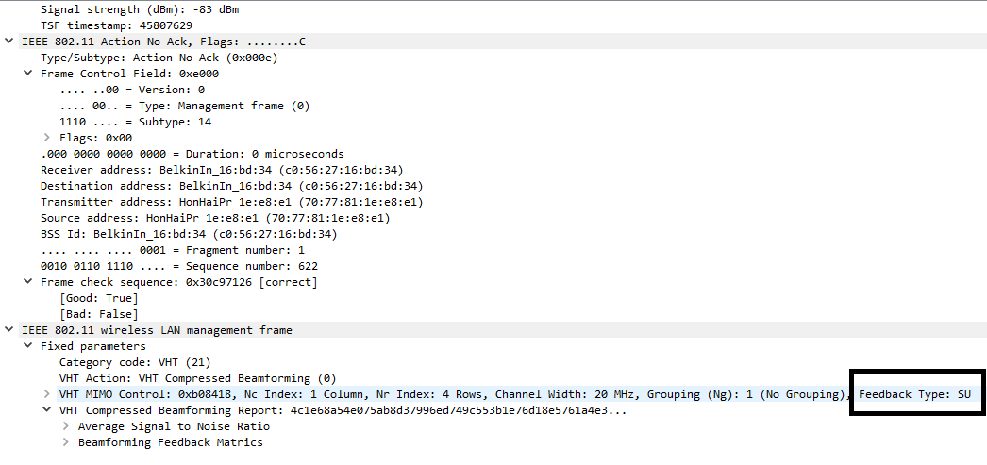](https://wizardonwireless.files.wordpress.com/2015/09/su-mimo-feedback.png)

* Place the Mu-mimo clients statically  in Different direction  from the AP.
* Connect a Wired PC with 1G Ethernet interface to one of the LAN ports of the AP.
* Run Iperf  TCP traffic from both the clients to the Wired client connected to the AP.

You will see Mu-Mimo sounding frames getting triggered in few minutes .

VHT Announcement from AP  (Mu-Mimo feedback Request).

[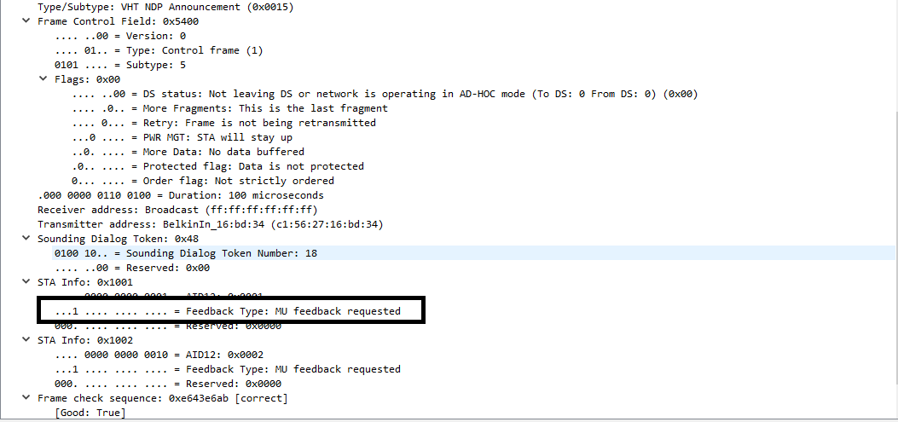](https://wizardonwireless.files.wordpress.com/2015/09/vht-mu-mimo.png)

REPORT THIS AD

REPORT THIS AD

Feedback Matrix from Client 1

[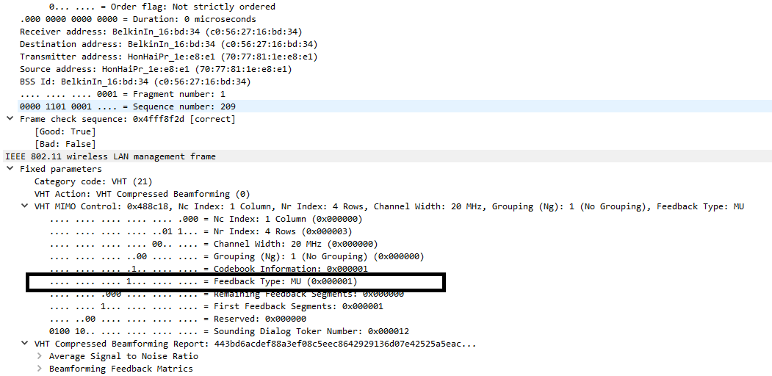](https://wizardonwireless.files.wordpress.com/2015/09/mu-mimo-feeback.png)

Beamform report Poll from AP  to Client 2

[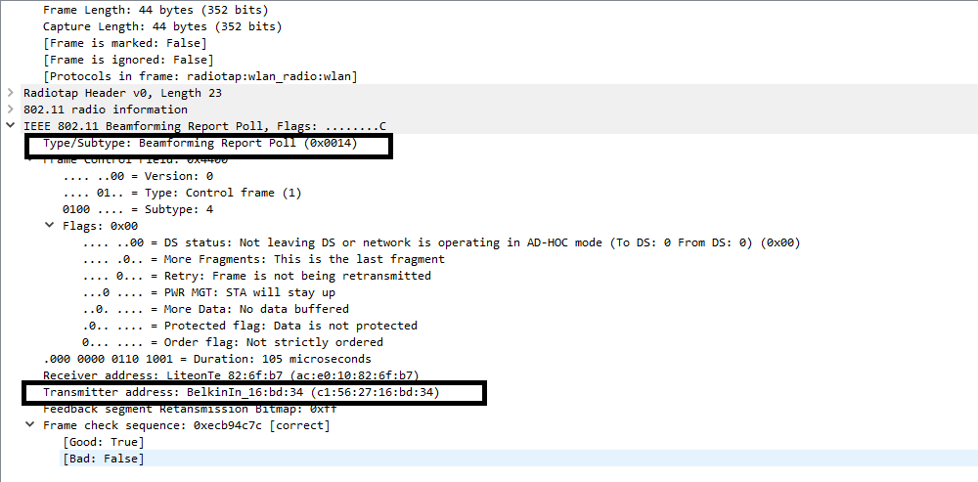](https://wizardonwireless.files.wordpress.com/2015/09/beamform-poll.png)Feedback matrix from Client 2

[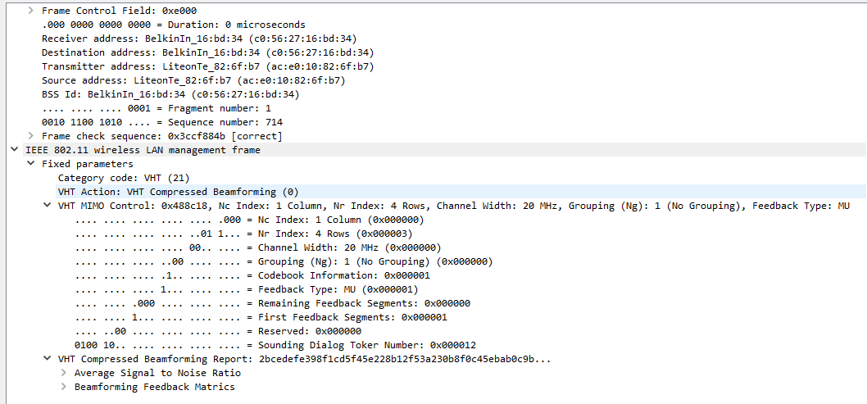](https://wizardonwireless.files.wordpress.com/2015/09/feedback-matrix-client-2.png)

REPORT THIS AD

REPORT THIS AD

Su-mimo & Mu-mimo frames are uploaded at <https://jumpshare.com/v/1TpN9CMvLj302z6i8LuR>   for your viewing pleasure .

# //Em12G Testing.

Quectel RM500Q – reload Quectel manager cmd

**root@MimoAP:~# quectel-**

**quectel-CM quectel-inf**

**root@MimoAP:~# quectel-CM**

Command to check SIM ICCID: gcom -d /dev/ttyUSB1 -s /etc/gcom/geticcidq.gcom

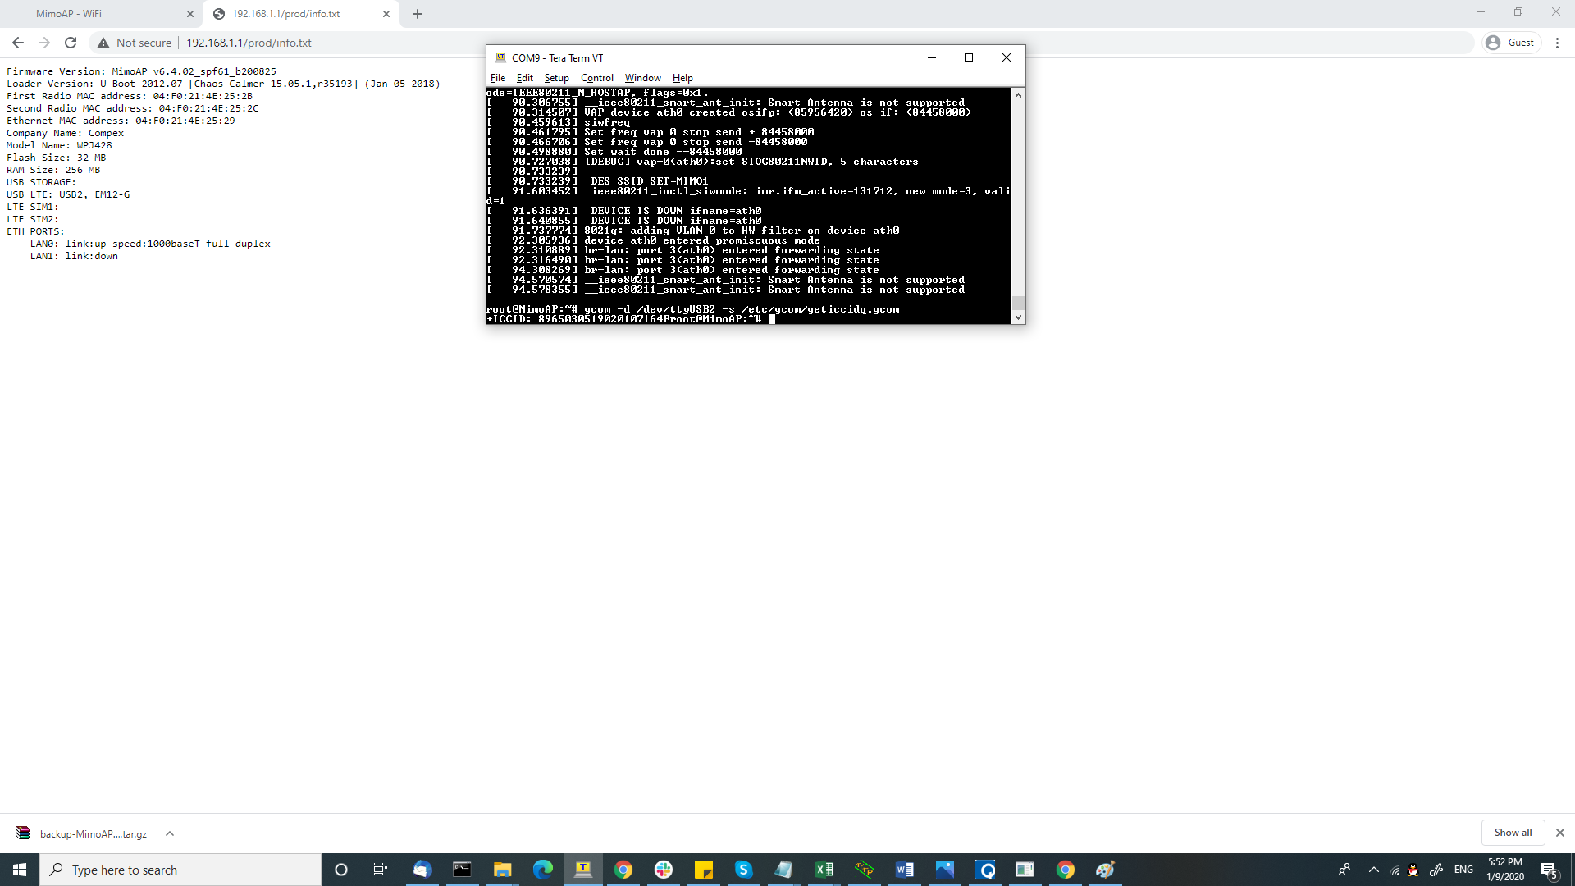



**Modem Infor**

root@MimoAP:/etc/gcom# gcom -d /dev/ttyUSB2 -s /etc/gcom/getcardinfo.gcom

ATI

Manufacturer: Sierra Wireless, Incorporated

Model: EM7690

Revision: SWIX55C_01.07.12.00 000000 jenkins 2020/12/15 00:45:35

IMEI: 352175380101638

IMEI SV: 6

FSN: 8X0302002601AA

+GCAP: +CGSM

**Modem Signal Level**

root@MimoAP:/# gcom -d /dev/ttyUSB0 -s /etc/gcom/getstrength.gcom

AT+CSQ

+CSQ: 24,99

OK

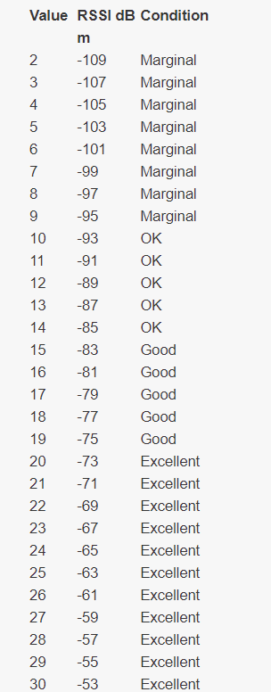

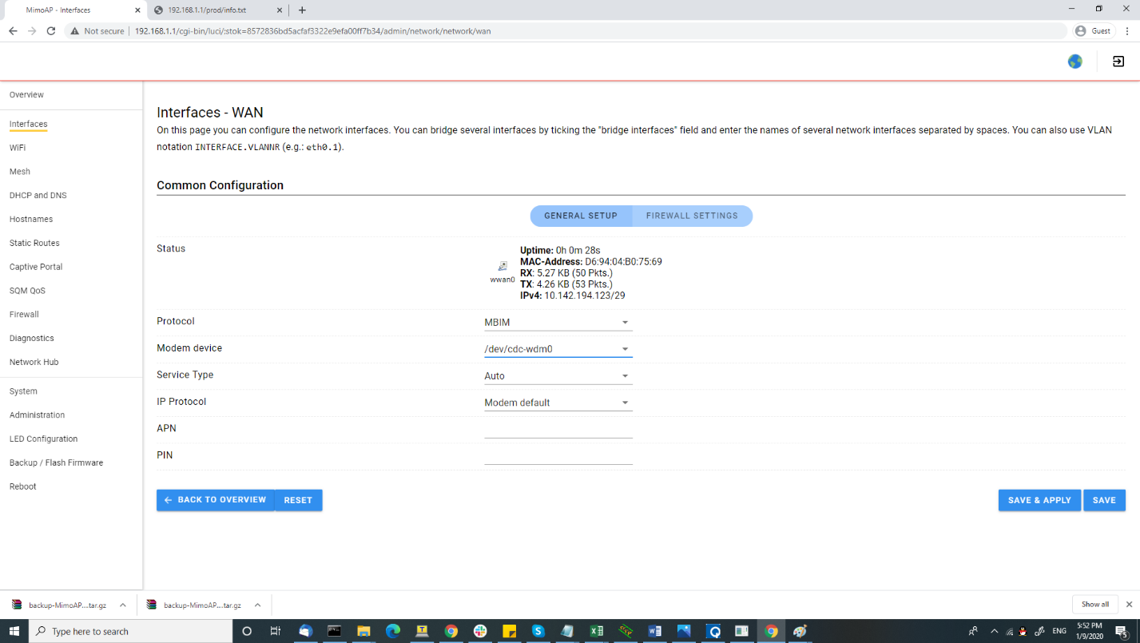

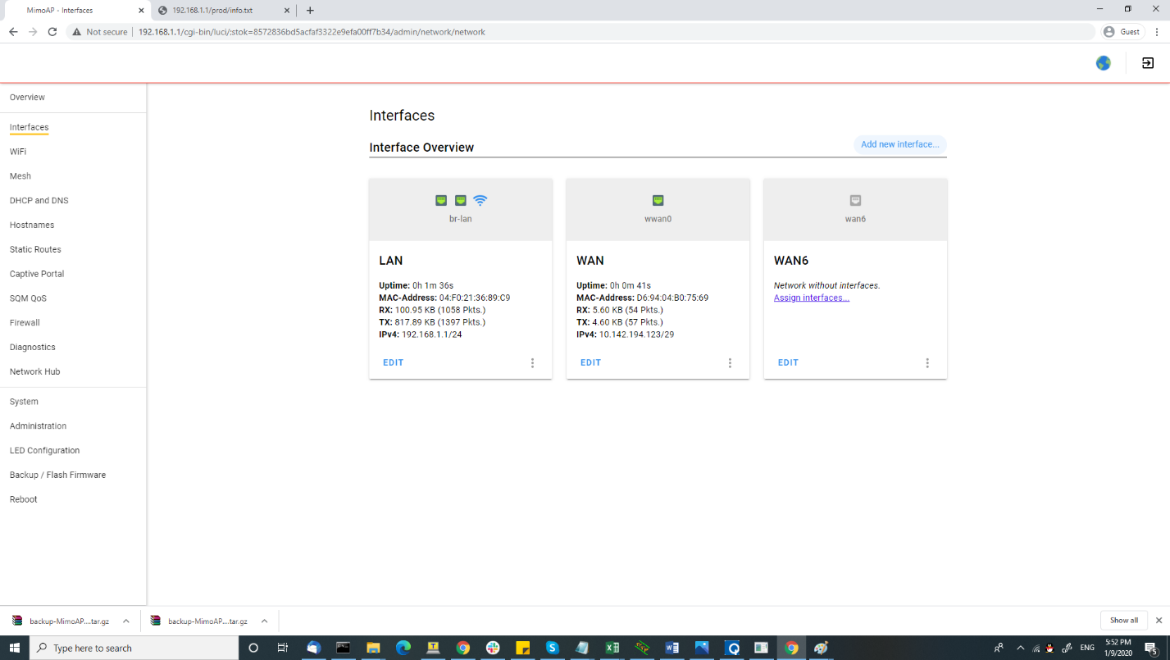

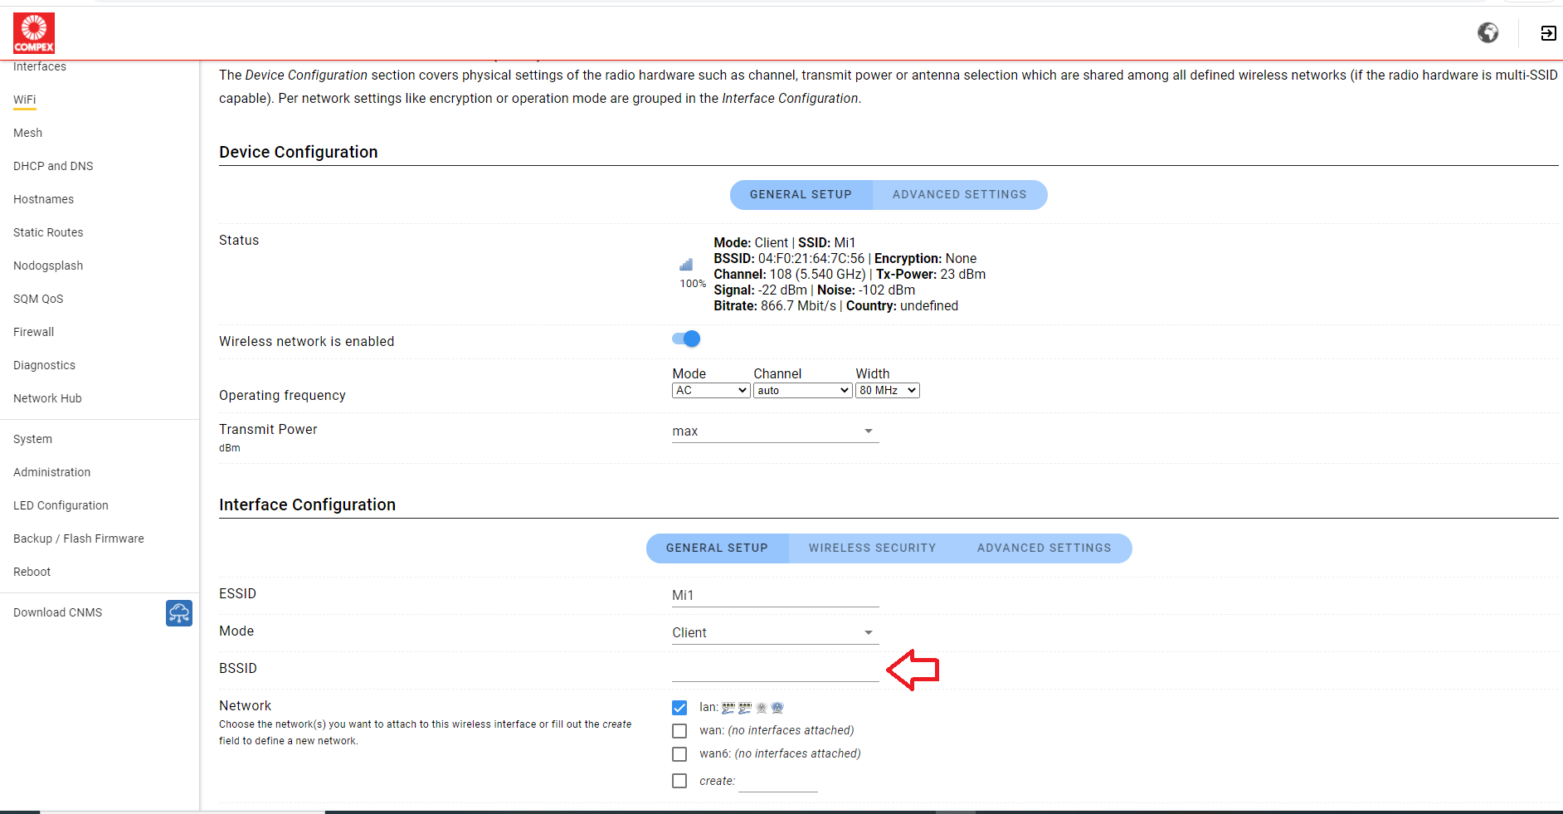

# 5G network

**NSA (Non-Standalone Access)** and **SA (Standalone Access)**are the two 5G network modes.

**NSA**relies on the 4G network facilities to provide more speed and higher data bandwidth. A 5G-enabled smartphone will connect to 5G or 4G network depending on conditions.

On the other hand, **SA** is the true 5G network, where the 5G network has its dedicated 5G facilities to provide enormous speed improvements and minimal network latency (delay). The 5G SA network is independent of the 4G network.

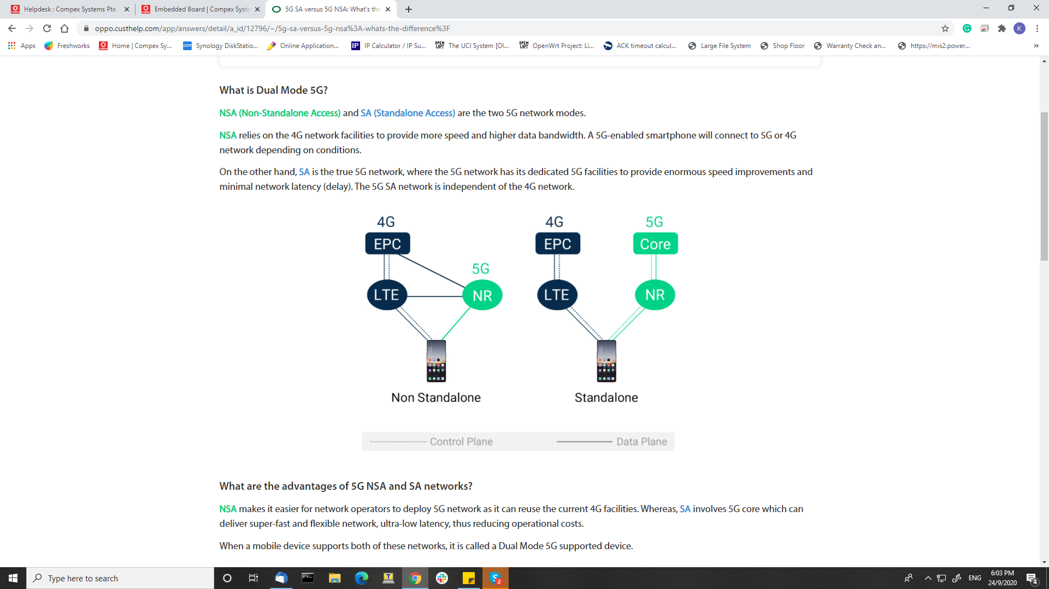

### What are the advantages of 5G NSA and SA networks?

**NSA** makes it easier for network operators to deploy 5G network as it can reuse the current 4G facilities. Whereas, **SA** involves 5G core which can deliver super-fast and flexible network, ultra-low latency, thus reducing operational costs.

When a mobile device supports both of these networks, it is called a Dual Mode 5G supported device.

# USB Boot CP01

S2 config : 1100

USB C to USB A cable

QSaharaServer.exe -p \\.\COM12 -s 21:xbl.elf -v 3

QsaharaServer.exe -p \\.\COM4 -s 1:cdt-AP-CP01-C1_256M32_DDR3.bin -s 34:devcfg_noac.mbn -s 25:tz.mbn -s 23:rpm.mbn -s 5:openwrt-ipq6018-uboot.mbn -v 3

**Flash WPQ618 or CP01 Reference Firmware**

tftpboot spff114norplusnand-ipq6018-single.img

imgaddr=$fileaddr && source $imgaddr:script

res

tftpboot 0x44000000 spf115_norplusnand-ipq807x-single.img

imgaddr=$fileaddr && source $imgaddr:script

res

tftpboot DG_qca_norplusnand-ipq6018-single.img

# //WLT6391 kernel infor

Run on kernel 4.9.11

# // HK01.2 dts detail

Yes, qcom-ipq807x-hk01.dts for normal config.  
For the optical SFP support, please use qcom-ipq807x-hk01.c5.dts,

Default machid=8010000

Set machid = 8010100

Reflash single image

After enable, only eth2, eth3 ( black = 00110) by default can use, 2.5Gbps also can use

1 = can use

0 = cant use

SFP+ por twill located at eth4

# //WPA3-EAP

root@MimoAP:~# uci show wireless

wireless.wifi0=wifi-device

wireless.wifi0.type='qcawificfg80211'

wireless.wifi0.macaddr='04:f0:21:63:ad:e4'

wireless.wifi0.hwmode='11axa'

wireless.wifi0.htmode='HT80'

wireless.wifi0.country='196'

wireless.wifi0.channel='36'

wireless.@wifi-iface[0]=wifi-iface

wireless.@wifi-iface[0].device='wifi0'

wireless.@wifi-iface[0].network='lan'

wireless.@wifi-iface[0].mode='ap'

wireless.@wifi-iface[0].suite_b='192'

wireless.@wifi-iface[0].auth_server='192.168.1.120'

wireless.@wifi-iface[0].auth_port='1812'

wireless.@wifi-iface[0].auth_secret='test1234'

wireless.@wifi-iface[0].ssid='Mies1'

wireless.wifi1=wifi-device

wireless.wifi1.type='qcawificfg80211'

wireless.wifi1.macaddr='04:f0:21:63:ad:e5'

wireless.wifi1.hwmode='11axg'

wireless.wifi1.country='826'

wireless.wifi1.channel='12'

wireless.wifi1.htmode='HT40'

wireless.@wifi-iface[1]=wifi-iface

wireless.@wifi-iface[1].device='wifi1'

wireless.@wifi-iface[1].network='lan'

wireless.@wifi-iface[1].mode='ap'

wireless.@wifi-iface[1].ssid='MimoSeries2'

wireless.@wifi-iface[1].encryption='none'

wireless.@wifi-iface[1].disablecoext='1'

wireless.@wifi-iface[1].vht_11ng='1'

// **Generate target core dump**

iwpriv wifi0 dump_target 1

# //WPJ419 Flash OpenWRT image

tftpboot openwrt-ipq40xx-generic-compex_wpj419-squashfs-nand-factory.ubi

nand erase.chip; nand write ${fileaddr} 0x0 ${filesize}

set fsbootargs ubi.mtd=rootfs root=/dev/ubiblock0_1 rootfstype=squashfs

saveenv

res

//Check OFDMA infor

**iwpriv ath0 txrx_stats 258 //FOR RX**

root@OpenWrt:/# iwpriv ath0 txrx_stats 258

[ 4303.481650] wlan: [3884:F:DP] Rx Rate Info:

[ 4303.481650]

[ 4303.481683] wlan: [3884:F:DP] OFDM 48 Mbps = 0

[ 4303.486561] wlan: [3884:F:DP] OFDM 24 Mbps = 0

[ 4303.490634] wlan: [3884:F:DP] OFDM 12 Mbps = 0

[ 4303.495248] wlan: [3884:F:DP] OFDM 6 Mbps = 0

[ 4303.499663] wlan: [3884:F:DP] OFDM 54 Mbps = 13

[ 4303.504271] wlan: [3884:F:DP] OFDM 36 Mbps = 0

[ 4303.509037] wlan: [3884:F:DP] OFDM 18 Mbps = 70

[ 4303.513319] wlan: [3884:F:DP] OFDM 9 Mbps = 0

[ 4303.518286] wlan: [3884:F:DP] INVALID = 0

[ 4303.522403] wlan: [3884:F:DP]

[ 4303.522403]

[ 4303.526681] wlan: [3884:F:DP] CCK 11 Mbps Long = 0

[ 4303.531094] wlan: [3884:F:DP] CCK 5.5 Mbps Long = 0

[ 4303.536394] wlan: [3884:F:DP] CCK 2 Mbps Long = 0

[ 4303.541331] wlan: [3884:F:DP] CCK 1 Mbps Long = 0

[ 4303.546478] wlan: [3884:F:DP] CCK 11 Mbps Short = 0

[ 4303.551401] wlan: [3884:F:DP] CCK 5.5 Mbps Short = 0

[ 4303.556540] wlan: [3884:F:DP] CCK 2 Mbps Short = 0

[ 4303.561469] wlan: [3884:F:DP] INVALID = 0

[ 4303.566646] wlan: [3884:F:DP]

[ 4303.566646]

[ 4303.570503] wlan: [3884:F:DP] HT MCS 0 (BPSK 1/2) = 0

[ 4303.575121] wlan: [3884:F:DP] HT MCS 1 (QPSK 1/2) = 0

[ 4303.580566] wlan: [3884:F:DP] HT MCS 2 (QPSK 3/4) = 0

[ 4303.585962] wlan: [3884:F:DP] HT MCS 3 (16-QAM 1/2) = 0

[ 4303.591158] wlan: [3884:F:DP] HT MCS 4 (16-QAM 3/4) = 0

[ 4303.596564] wlan: [3884:F:DP] HT MCS 5 (64-QAM 2/3) = 0

[ 4303.601746] wlan: [3884:F:DP] HT MCS 6 (64-QAM 3/4) = 0

[ 4303.607143] wlan: [3884:F:DP] HT MCS 7 (64-QAM 5/6) = 0

[ 4303.612338] wlan: [3884:F:DP] INVALID = 0

[ 4303.617752] wlan: [3884:F:DP]

[ 4303.617752]

[ 4303.621537] wlan: [3884:F:DP] VHT MCS 0 (BPSK 1/2) = 0

[ 4303.626159] wlan: [3884:F:DP] VHT MCS 1 (QPSK 1/2) = 0

[ 4303.631957] wlan: [3884:F:DP] VHT MCS 2 (QPSK 3/4) = 0

[ 4303.637710] wlan: [3884:F:DP] VHT MCS 3 (16-QAM 1/2) = 0

[ 4303.643264] wlan: [3884:F:DP] VHT MCS 4 (16-QAM 3/4) = 0

[ 4303.648989] wlan: [3884:F:DP] VHT MCS 5 (64-QAM 2/3) = 0

[ 4303.654610] wlan: [3884:F:DP] VHT MCS 6 (64-QAM 3/4) = 0

[ 4303.660168] wlan: [3884:F:DP] VHT MCS 7 (64-QAM 5/6) = 0

[ 4303.665926] wlan: [3884:F:DP] VHT MCS 8 (256-QAM 3/4) = 0

[ 4303.671475] wlan: [3884:F:DP] VHT MCS 9 (256-QAM 5/6) = 0

[ 4303.677202] wlan: [3884:F:DP] VHT MCS 10 (1024-QAM 3/4) = 0

[ 4303.682737] wlan: [3884:F:DP] VHT MCS 11 (1024-QAM 5/6) = 0

[ 4303.688484] wlan: [3884:F:DP] INVALID = 0

[ 4303.694087] wlan: [3884:F:DP]

[ 4303.694087]

[ 4303.697927] wlan: [3884:F:DP] HE MCS 0 (BPSK 1/2) = 0

[ 4303.702440] wlan: [3884:F:DP] HE MCS 1 (QPSK 1/2) = 47

[ 4303.708132] wlan: [3884:F:DP] HE MCS 2 (QPSK 3/4) = 8

[ 4303.713900] wlan: [3884:F:DP] HE MCS 3 (16-QAM 1/2) = 137

[ 4303.719247] wlan: [3884:F:DP] HE MCS 4 (16-QAM 3/4) = 245

[ 4303.725112] wlan: [3884:F:DP] HE MCS 5 (64-QAM 2/3) = 444

[ 4303.730827] wlan: [3884:F:DP] HE MCS 6 (64-QAM 3/4) = 236

[ 4303.736575] wlan: [3884:F:DP] HE MCS 7 (64-QAM 5/6) = 1939

[ 4303.742285] wlan: [3884:F:DP] HE MCS 8 (256-QAM 3/4) = 2328

[ 4303.748056] wlan: [3884:F:DP] HE MCS 9 (256-QAM 5/6) = 8158

[ 4303.753830] wlan: [3884:F:DP] HE MCS 10 (1024-QAM 3/4) = 603

[ 4303.759664] wlan: [3884:F:DP] HE MCS 11 (1024-QAM 5/6) = 2084

[ 4303.765475] wlan: [3884:F:DP] INVALID = 0

[ 4303.771220] wlan: [3884:F:DP]

[ 4303.771220]

[ 4303.775294] wlan: [3884:F:DP] NSS(1-8) = 250 16062 0 0 0 0 0 0

[ 4303.779788] wlan: [3884:F:DP] SGI = 0.8us 11434 0.4us 0 1.6us 3517 3.2us 1361

[ 4303.785709] wlan: [3884:F:DP] BW Counts = 20MHZ 117, 40MHZ 6, 80MHZ 16189, 160MHZ 0

[ 4303.792985] wlan: [3884:F:DP] Reception Type =SU: 16297 MU_MIMO:0 MU_OFDMA:15 MU_OFDMA_MIMO:0

[ 4303.800467] wlan: [3884:F:DP] Aggregation:

[ 4303.800467]

[ 4303.809140] wlan: [3884:F:DP] Number of Msdu's Part of Ampdus = 0

[ 4303.814521] wlan: [3884:F:DP] Number of Msdu's With No Mpdu Level Aggregation : 15391

[ 4303.820785] wlan: [3884:F:DP] Number of Msdu's Part of Amsdu: 921

[ 4303.828587] wlan: [3884:F:DP] Number of Msdu's With No Msdu Level Aggregation: 16308

**iwpriv ath0 txrx_stats 259 //FOR TX**

**root@OpenWrt:/# iwpriv ath0 txrx_stats 259**

**[ 4327.313862] wlan: [3886:F:DP] Tx Rate Info:**

**[ 4327.313862]**

**[ 4327.313897] wlan: [3886:F:DP] OFDM 48 Mbps = 0**

**[ 4327.318639] wlan: [3886:F:DP] OFDM 24 Mbps = 0**

**[ 4327.322887] wlan: [3886:F:DP] OFDM 12 Mbps = 0**

**[ 4327.327382] wlan: [3886:F:DP] OFDM 6 Mbps = 4118**

**[ 4327.331877] wlan: [3886:F:DP] OFDM 54 Mbps = 0**

**[ 4327.336750] wlan: [3886:F:DP] OFDM 36 Mbps = 0**

**[ 4327.341161] wlan: [3886:F:DP] OFDM 18 Mbps = 0**

**[ 4327.345694] wlan: [3886:F:DP] OFDM 9 Mbps = 0**

**[ 4327.350190] wlan: [3886:F:DP] INVALID = 0**

**[ 4327.354718] wlan: [3886:F:DP]**

**[ 4327.354718]**

**[ 4327.358872] wlan: [3886:F:DP] CCK 11 Mbps Long = 0**

**[ 4327.363393] wlan: [3886:F:DP] CCK 5.5 Mbps Long = 0**

**[ 4327.368612] wlan: [3886:F:DP] CCK 2 Mbps Long = 0**

**[ 4327.373654] wlan: [3886:F:DP] CCK 1 Mbps Long = 0**

**[ 4327.378685] wlan: [3886:F:DP] CCK 11 Mbps Short = 0**

**[ 4327.383698] wlan: [3886:F:DP] CCK 5.5 Mbps Short = 0**

**[ 4327.388747] wlan: [3886:F:DP] CCK 2 Mbps Short = 0**

**[ 4327.393767] wlan: [3886:F:DP] INVALID = 0**

**[ 4327.398834] wlan: [3886:F:DP]**

**[ 4327.398834]**

**[ 4327.402794] wlan: [3886:F:DP] HT MCS 0 (BPSK 1/2) = 0**

**[ 4327.407331] wlan: [3886:F:DP] HT MCS 1 (QPSK 1/2) = 0**

**[ 4327.412866] wlan: [3886:F:DP] HT MCS 2 (QPSK 3/4) = 0**

**[ 4327.418178] wlan: [3886:F:DP] HT MCS 3 (16-QAM 1/2) = 0**

**[ 4327.423470] wlan: [3886:F:DP] HT MCS 4 (16-QAM 3/4) = 0**

**[ 4327.428788] wlan: [3886:F:DP] HT MCS 5 (64-QAM 2/3) = 0**

**[ 4327.434063] wlan: [3886:F:DP] HT MCS 6 (64-QAM 3/4) = 0**

**[ 4327.439340] wlan: [3886:F:DP] HT MCS 7 (64-QAM 5/6) = 0**

**[ 4327.444654] wlan: [3886:F:DP] INVALID = 0**

**[ 4327.449928] wlan: [3886:F:DP]**

**[ 4327.449928]**

**[ 4327.453836] wlan: [3886:F:DP] VHT MCS 0 (BPSK 1/2) = 0**

**[ 4327.458368] wlan: [3886:F:DP] VHT MCS 1 (QPSK 1/2) = 0**

**[ 4327.464267] wlan: [3886:F:DP] VHT MCS 2 (QPSK 3/4) = 0**

**[ 4327.469898] wlan: [3886:F:DP] VHT MCS 3 (16-QAM 1/2) = 0**

**[ 4327.475574] wlan: [3886:F:DP] VHT MCS 4 (16-QAM 3/4) = 0**

**[ 4327.481183] wlan: [3886:F:DP] VHT MCS 5 (64-QAM 2/3) = 0**

**[ 4327.486839] wlan: [3886:F:DP] VHT MCS 6 (64-QAM 3/4) = 0**

**[ 4327.492467] wlan: [3886:F:DP] VHT MCS 7 (64-QAM 5/6) = 0**

**[ 4327.498124] wlan: [3886:F:DP] VHT MCS 8 (256-QAM 3/4) = 0**

**[ 4327.503774] wlan: [3886:F:DP] VHT MCS 9 (256-QAM 5/6) = 0**

**[ 4327.509409] wlan: [3886:F:DP] VHT MCS 10 (1024-QAM 3/4) = 0**

**[ 4327.515051] wlan: [3886:F:DP] VHT MCS 11 (1024-QAM 5/6) = 0**

**[ 4327.520679] wlan: [3886:F:DP] INVALID = 0**

**[ 4327.526352] wlan: [3886:F:DP]**

**[ 4327.526352]**

**[ 4327.530225] wlan: [3886:F:DP] HE MCS 0 (BPSK 1/2) = 0**

**[ 4327.534753] wlan: [3886:F:DP] HE MCS 1 (QPSK 1/2) = 0**

**[ 4327.540296] wlan: [3886:F:DP] HE MCS 2 (QPSK 3/4) = 0**

**[ 4327.545866] wlan: [3886:F:DP] HE MCS 3 (16-QAM 1/2) = 0**

**[ 4327.551408] wlan: [3886:F:DP] HE MCS 4 (16-QAM 3/4) = 0**

**[ 4327.556976] wlan: [3886:F:DP] HE MCS 5 (64-QAM 2/3) = 0**

**[ 4327.562518] wlan: [3886:F:DP] HE MCS 6 (64-QAM 3/4) = 148**

**[ 4327.568089] wlan: [3886:F:DP] HE MCS 7 (64-QAM 5/6) = 106**

**[ 4327.574011] wlan: [3886:F:DP] HE MCS 8 (256-QAM 3/4) = 147**

**[ 4327.579731] wlan: [3886:F:DP] HE MCS 9 (256-QAM 5/6) = 1857**

**[ 4327.585454] wlan: [3886:F:DP] HE MCS 10 (1024-QAM 3/4) = 2307**

**[ 4327.591166] wlan: [3886:F:DP] HE MCS 11 (1024-QAM 5/6) = 17638**

**[ 4327.596996] wlan: [3886:F:DP] INVALID = 0**

**[ 4327.602807] wlan: [3886:F:DP]**

**[ 4327.602807]**

**[ 4327.606984] wlan: [3886:F:DP] SGI = 0.8us 26321 0.4us 0 1.6us 0 3.2us 0**

**[ 4327.611480] wlan: [3886:F:DP] BW Counts = 20MHZ 4118, 40MHZ 1, 80MHZ 22202, 160MHZ 0**

**[ 4327.618221] wlan: [3886:F:DP] OFDMA = 93**

**[ 4327.626077] wlan: [3886:F:DP] STBC = 0**

**[ 4327.630005] wlan: [3886:F:DP] LDPC = 22203**

**[ 4327.633529] wlan: [3886:F:DP] Retries = 1788**

**[ 4327.637626] wlan: [3886:F:DP] Last ack rssi = 43**

**[ 4327.637626]**

**[ 4327.642033] wlan: [3886:F:DP] Aggregation:**

**[ 4327.642033]**

**[ 4327.648038] wlan: [3886:F:DP] Number of Msdu's Part of Ampdus = 22196**

**[ 4327.653407] wlan: [3886:F:DP] Number of Msdu's With No Mpdu Level Aggregation : 4125**

**[ 4327.660022] wlan: [3886:F:DP] Number of Msdu's Part of Amsdu = 242**

**[ 4327.667835] wlan: [3886:F:DP] Number of Msdu's With No Msdu Level Aggregation = 21998**

**//Check peer stat of client**

**root@OpenWrt:/# iwpriv wifi0 fc_peer_stats c0:b8:83:1f:14:c7**

**[ 4732.915369] wlan: [3897:F:DP] Node Tx Stats:**

**[ 4732.915369]**

**[ 4732.915402] wlan: [3897:F:DP] Total Packet Completions = 11003**

**[ 4732.920103] wlan: [3897:F:DP] Total Bytes Completions = 4969230**

**[ 4732.925872] wlan: [3897:F:DP] Success Packets = 11001**

**[ 4732.931682] wlan: [3897:F:DP] Success Bytes = 4703749**

**[ 4732.936873] wlan: [3897:F:DP] Unicast Success Packets = 11001**

**[ 4732.941891] wlan: [3897:F:DP] Unicast Success Bytes = 4703749**

**[ 4732.947687] wlan: [3897:F:DP] Multicast Success Packets = 0**

**[ 4732.953347] wlan: [3897:F:DP] Multicast Success Bytes = 0**

**[ 4732.958747] wlan: [3897:F:DP] Broadcast Success Packets = 0**

**[ 4732.964313] wlan: [3897:F:DP] Broadcast Success Bytes = 0**

**[ 4732.969666] wlan: [3897:F:DP] Packets Failed = 0**

**[ 4732.975236] wlan: [3897:F:DP] Packets In OFDMA = 103**

**[ 4732.979923] wlan: [3897:F:DP] Packets In STBC = 0**

**[ 4732.984882] wlan: [3897:F:DP] Packets In LDPC = 11004**

**[ 4732.989456] wlan: [3897:F:DP] Packet Retries = 220**

**[ 4732.994505] wlan: [3897:F:DP] MSDU's Part of AMSDU = 133**

**[ 4732.999179] wlan: [3897:F:DP] Msdu's As Part of Ampdu = 4**

**[ 4733.004662] wlan: [3897:F:DP] Msdu's As Ampdu = 11000**

**[ 4733.009966] wlan: [3897:F:DP] Last Packet RSSI = 35**

**[ 4733.014994] wlan: [3897:F:DP] Dropped At FW: Removed Pkts = 0**

**[ 4733.019667] wlan: [3897:F:DP] Dropped At FW: Removed transmitted = 0**

**[ 4733.025588] wlan: [3897:F:DP] Dropped At FW: Removed Untransmitted = 0**

**[ 4733.032015] wlan: [3897:F:DP] Dropped : Age Out = 0**

**[ 4733.038342] wlan: [3897:F:DP] NAWDS :**

**[ 4733.043100] wlan: [3897:F:DP] Nawds multicast Drop Tx Packet = 0**

**[ 4733.046939] wlan: [3897:F:DP] Nawds multicast Tx Packet Count = 0**

**[ 4733.053088] wlan: [3897:F:DP] Nawds multicast Tx Packet Bytes = 0**

**[ 4733.059089] wlan: [3897:F:DP] Rate Info:**

**[ 4733.065338] wlan: [3897:F:DP] OFDM 48 Mbps = 0**

**[ 4733.069490] wlan: [3897:F:DP] OFDM 24 Mbps = 0**

**[ 4733.073744] wlan: [3897:F:DP] OFDM 12 Mbps = 0**

**[ 4733.078271] wlan: [3897:F:DP] OFDM 6 Mbps = 0**

**[ 4733.082786] wlan: [3897:F:DP] OFDM 54 Mbps = 0**

**[ 4733.087308] wlan: [3897:F:DP] OFDM 36 Mbps = 0**

**[ 4733.091800] wlan: [3897:F:DP] OFDM 18 Mbps = 0**

**[ 4733.096331] wlan: [3897:F:DP] OFDM 9 Mbps = 0**

**[ 4733.100828] wlan: [3897:F:DP] INVALID = 0**

**[ 4733.105353] wlan: [3897:F:DP]**

**[ 4733.105353]**

**[ 4733.109530] wlan: [3897:F:DP] CCK 11 Mbps Long = 0**

**[ 4733.114039] wlan: [3897:F:DP] CCK 5.5 Mbps Long = 0**

**[ 4733.119231] wlan: [3897:F:DP] CCK 2 Mbps Long = 0**

**[ 4733.124278] wlan: [3897:F:DP] CCK 1 Mbps Long = 0**

**[ 4733.129301] wlan: [3897:F:DP] CCK 11 Mbps Short = 0**

**[ 4733.134364] wlan: [3897:F:DP] CCK 5.5 Mbps Short = 0**

**[ 4733.139380] wlan: [3897:F:DP] CCK 2 Mbps Short = 0**

**[ 4733.144419] wlan: [3897:F:DP] INVALID = 0**

**[ 4733.149436] wlan: [3897:F:DP]**

**[ 4733.149436]**

**[ 4733.153430] wlan: [3897:F:DP] HT MCS 0 (BPSK 1/2) = 0**

**[ 4733.157972] wlan: [3897:F:DP] HT MCS 1 (QPSK 1/2) = 0**

**[ 4733.163502] wlan: [3897:F:DP] HT MCS 2 (QPSK 3/4) = 0**

**[ 4733.168812] wlan: [3897:F:DP] HT MCS 3 (16-QAM 1/2) = 0**

**[ 4733.174106] wlan: [3897:F:DP] HT MCS 4 (16-QAM 3/4) = 0**

**[ 4733.179388] wlan: [3897:F:DP] HT MCS 5 (64-QAM 2/3) = 0**

**[ 4733.184717] wlan: [3897:F:DP] HT MCS 6 (64-QAM 3/4) = 0**

**[ 4733.189987] wlan: [3897:F:DP] HT MCS 7 (64-QAM 5/6) = 0**

**[ 4733.195292] wlan: [3897:F:DP] INVALID = 0**

**[ 4733.200566] wlan: [3897:F:DP]**

**[ 4733.200566]**

**[ 4733.204489] wlan: [3897:F:DP] VHT MCS 0 (BPSK 1/2) = 0**

**[ 4733.208990] wlan: [3897:F:DP] VHT MCS 1 (QPSK 1/2) = 0**

**[ 4733.214932] wlan: [3897:F:DP] VHT MCS 2 (QPSK 3/4) = 0**

**[ 4733.220535] wlan: [3897:F:DP] VHT MCS 3 (16-QAM 1/2) = 0**

**[ 4733.226192] wlan: [3897:F:DP] VHT MCS 4 (16-QAM 3/4) = 0**

**[ 4733.231819] wlan: [3897:F:DP] VHT MCS 5 (64-QAM 2/3) = 0**

**[ 4733.237499] wlan: [3897:F:DP] VHT MCS 6 (64-QAM 3/4) = 0**

**[ 4733.243104] wlan: [3897:F:DP] VHT MCS 7 (64-QAM 5/6) = 0**

**[ 4733.248761] wlan: [3897:F:DP] VHT MCS 8 (256-QAM 3/4) = 0**

**[ 4733.254403] wlan: [3897:F:DP] VHT MCS 9 (256-QAM 5/6) = 0**

**[ 4733.260039] wlan: [3897:F:DP] VHT MCS 10 (1024-QAM 3/4) = 0**

**[ 4733.265691] wlan: [3897:F:DP] VHT MCS 11 (1024-QAM 5/6) = 0**

**[ 4733.271316] wlan: [3897:F:DP] INVALID = 0**

**[ 4733.276968] wlan: [3897:F:DP]**

**[ 4733.276968]**

**[ 4733.280869] wlan: [3897:F:DP] HE MCS 0 (BPSK 1/2) = 0**

**[ 4733.285396] wlan: [3897:F:DP] HE MCS 1 (QPSK 1/2) = 0**

**[ 4733.290956] wlan: [3897:F:DP] HE MCS 2 (QPSK 3/4) = 0**

**[ 4733.296504] wlan: [3897:F:DP] HE MCS 3 (16-QAM 1/2) = 0**

**[ 4733.302045] wlan: [3897:F:DP] HE MCS 4 (16-QAM 3/4) = 0**

**[ 4733.307615] wlan: [3897:F:DP] HE MCS 5 (64-QAM 2/3) = 0**

**[ 4733.313179] wlan: [3897:F:DP] HE MCS 6 (64-QAM 3/4) = 58**

**[ 4733.318726] wlan: [3897:F:DP] HE MCS 7 (64-QAM 5/6) = 34**

**[ 4733.324630] wlan: [3897:F:DP] HE MCS 8 (256-QAM 3/4) = 51**

**[ 4733.330257] wlan: [3897:F:DP] HE MCS 9 (256-QAM 5/6) = 147**

**[ 4733.335928] wlan: [3897:F:DP] HE MCS 10 (1024-QAM 3/4) = 49**

**[ 4733.341564] wlan: [3897:F:DP] HE MCS 11 (1024-QAM 5/6) = 10665**

**[ 4733.347286] wlan: [3897:F:DP] INVALID = 0**

**[ 4733.352908] wlan: [3897:F:DP]**

**[ 4733.352908]**

**[ 4733.357096] wlan: [3897:F:DP] SGI = 0.8us 11004 0.4us 0 1.6us 0 3.2us 0**

**[ 4733.361596] wlan: [3897:F:DP] Excess Retries per AC**

**[ 4733.368203] wlan: [3897:F:DP] Best effort = 0**

**[ 4733.373401] wlan: [3897:F:DP] Background= 0**

**[ 4733.377664] wlan: [3897:F:DP] Video = 0**

**[ 4733.382163] wlan: [3897:F:DP] Voice = 0**

**[ 4733.386175] wlan: [3897:F:DP] BW Counts = 20MHZ 0 40MHZ 1 80MHZ 11003 160MHZ 0**

**[ 4733.386175]**

**[ 4733.390177] wlan: [3897:F:DP] NSS(1-8) = 103 10901 0 0 0 0 0 0**

**[ 4733.398681] wlan: [3897:F:DP] Transmit Type :**

**[ 4733.404576] wlan: [3897:F:DP] SU 10901, MU_MIMO 0, MU_OFDMA 103, MU_MIMO_OFDMA 0**

**[ 4733.409089] wlan: [3897:F:DP] User position list for GID 00->15: [ 0 0 0 0 0 0 0 0 0 0 0 0 0 0 0 0]**

**[ 4733.416592] wlan: [3897:F:DP] User position list for GID 16->31: [ 0 0 0 0 0 0 0 0 0 0 0 0 0 0 0 0]**

**[ 4733.425363] wlan: [3897:F:DP] User position list for GID 32->47: [ 0 0 0 0 0 0 0 0 0 0 0 0 0 0 0 0]**

**[ 4733.434367] wlan: [3897:F:DP] User position list for GID 48->63: [ 0 0 0 0 0 0 0 0 0 0 0 0 0 0 0 0]**

**[ 4733.443398] wlan: [3897:F:DP] Last Packet RU index [19], Size [18]**

**[ 4733.452415] wlan: [3897:F:DP] RU Locations RU[26 52 106 242 484 996]:**

**[ 4733.458657] wlan: [3897:F:DP] RU_26: 0**

**[ 4733.465163] wlan: [3897:F:DP] RU 52: 0**

**[ 4733.468794] wlan: [3897:F:DP] RU 106: 0**

**[ 4733.472613] wlan: [3897:F:DP] RU 242: 0**

**[ 4733.476450] wlan: [3897:F:DP] RU 484: 103**

**[ 4733.480260] wlan: [3897:F:DP] RU 996: 0**

**[ 4733.484434] wlan: [3897:F:DP] Aggregation:**

**[ 4733.488066] wlan: [3897:F:DP] Number of Msdu's Part of Amsdu = 133**

**[ 4733.492253] wlan: [3897:F:DP] Number of Msdu's With No Msdu Level Aggregation = 10868**

**[ 4733.498425] wlan: [3897:F:DP] Bytes and Packets transmitted in last one sec:**

**[ 4733.506316] wlan: [3897:F:DP] Bytes transmitted in last sec: 598**

**[ 4733.513417] wlan: [3897:F:DP] Data transmitted in last sec: 8**

**[ 4733.519528] wlan: [3897:F:DP] Node Rx Stats:**

**[ 4733.525234] wlan: [3897:F:DP] Packets Sent To Stack = 9083**

**[ 4733.529649] wlan: [3897:F:DP] Bytes Sent To Stack = 936204**

**[ 4733.534961] wlan: [3897:F:DP] Ring Id = 0**

**[ 4733.540409] wlan: [3897:F:DP] Packets Received = 9083**

**[ 4733.544530] wlan: [3897:F:DP] Bytes Received = 936204**

**[ 4733.549525] wlan: [3897:F:DP] Ring Id = 1**

**[ 4733.554667] wlan: [3897:F:DP] Packets Received = 0**

**[ 4733.558728] wlan: [3897:F:DP] Bytes Received = 0**

**[ 4733.563413] wlan: [3897:F:DP] Ring Id = 2**

**[ 4733.568291] wlan: [3897:F:DP] Packets Received = 0**

**[ 4733.572269] wlan: [3897:F:DP] Bytes Received = 0**

**[ 4733.576977] wlan: [3897:F:DP] Ring Id = 3**

**[ 4733.581815] wlan: [3897:F:DP] Packets Received = 0**

**[ 4733.585824] wlan: [3897:F:DP] Bytes Received = 0**

**[ 4733.590498] wlan: [3897:F:DP] Multicast Packets Received = 1418**

**[ 4733.595402] wlan: [3897:F:DP] Multicast Bytes Received = 313521**

**[ 4733.601091] wlan: [3897:F:DP] Broadcast Packets Received = 760**

**[ 4733.607008] wlan: [3897:F:DP] Broadcast Bytes Received = 38791**

**[ 4733.613034] wlan: [3897:F:DP] Intra BSS Packets Received = 1418**

**[ 4733.618734] wlan: [3897:F:DP] Intra BSS Bytes Received = 313521**

**[ 4733.624571] wlan: [3897:F:DP] Raw Packets Received = 0**

**[ 4733.630429] wlan: [3897:F:DP] Raw Bytes Received = 0**

**[ 4733.635663] wlan: [3897:F:DP] Errors: MIC Errors = 0**

**[ 4733.640760] wlan: [3897:F:DP] Erros: Decryption Errors = 0**

**[ 4733.645736] wlan: [3897:F:DP] Msdu's Received As Part of Ampdu = 8776**

**[ 4733.651017] wlan: [3897:F:DP] Msdu's Recived As Ampdu = 309**

**[ 4733.657529] wlan: [3897:F:DP] Msdu's Received Not Part of Amsdu's = 9083**

**[ 4733.662897] wlan: [3897:F:DP] MSDUs Received As Part of Amsdu = 0**

**[ 4733.669854] wlan: [3897:F:DP] NAWDS :**

**[ 4733.675840] wlan: [3897:F:DP] Nawds multicast Drop Rx Packet = 0**

**[ 4733.679479] wlan: [3897:F:DP] SGI = 0.8us 8149 0.4us 0 1.6us 828 3.2us 108**

**[ 4733.685659] wlan: [3897:F:DP] BW Counts = 20MHZ 3 40MHZ 6 80MHZ 9076 160MHZ 0**

**[ 4733.692415] wlan: [3897:F:DP] Reception Type = SU 9079 MU_MIMO 0 MU_OFDMA 6 MU_OFDMA_MIMO 0**

**[ 4733.699660] wlan: [3897:F:DP] OFDM 48 Mbps = 0**

**[ 4733.707791] wlan: [3897:F:DP] OFDM 24 Mbps = 0**

**[ 4733.712286] wlan: [3897:F:DP] OFDM 12 Mbps = 0**

**[ 4733.716817] wlan: [3897:F:DP] OFDM 6 Mbps = 0**

**[ 4733.721321] wlan: [3897:F:DP] OFDM 54 Mbps = 0**

**[ 4733.725861] wlan: [3897:F:DP] OFDM 36 Mbps = 0**

**[ 4733.730341] wlan: [3897:F:DP] OFDM 18 Mbps = 0**

**[ 4733.734870] wlan: [3897:F:DP] OFDM 9 Mbps = 0**

**[ 4733.739371] wlan: [3897:F:DP] INVALID = 0**

**[ 4733.743883] wlan: [3897:F:DP]**

**[ 4733.743883]**

**[ 4733.748069] wlan: [3897:F:DP] CCK 11 Mbps Long = 0**

**[ 4733.752588] wlan: [3897:F:DP] CCK 5.5 Mbps Long = 0**

**[ 4733.757789] wlan: [3897:F:DP] CCK 2 Mbps Long = 0**

**[ 4733.762807] wlan: [3897:F:DP] CCK 1 Mbps Long = 0**

**[ 4733.767854] wlan: [3897:F:DP] CCK 11 Mbps Short = 0**

**[ 4733.772880] wlan: [3897:F:DP] CCK 5.5 Mbps Short = 0**

**[ 4733.777925] wlan: [3897:F:DP] CCK 2 Mbps Short = 0**

**[ 4733.782946] wlan: [3897:F:DP] INVALID = 0**

**[ 4733.787992] wlan: [3897:F:DP]**

**[ 4733.787992]**

**[ 4733.791973] wlan: [3897:F:DP] HT MCS 0 (BPSK 1/2) = 0**

**[ 4733.796503] wlan: [3897:F:DP] HT MCS 1 (QPSK 1/2) = 0**

**[ 4733.802069] wlan: [3897:F:DP] HT MCS 2 (QPSK 3/4) = 0**

**[ 4733.807355] wlan: [3897:F:DP] HT MCS 3 (16-QAM 1/2) = 0**

**[ 4733.812635] wlan: [3897:F:DP] HT MCS 4 (16-QAM 3/4) = 0**

**[ 4733.817944] wlan: [3897:F:DP] HT MCS 5 (64-QAM 2/3) = 0**

**[ 4733.823224] wlan: [3897:F:DP] HT MCS 6 (64-QAM 3/4) = 0**

**[ 4733.828533] wlan: [3897:F:DP] HT MCS 7 (64-QAM 5/6) = 0**

**[ 4733.833815] wlan: [3897:F:DP] INVALID = 0**

**[ 4733.839124] wlan: [3897:F:DP]**

**[ 4733.839124]**

**[ 4733.843014] wlan: [3897:F:DP] VHT MCS 0 (BPSK 1/2) = 0**

**[ 4733.847546] wlan: [3897:F:DP] VHT MCS 1 (QPSK 1/2) = 0**

**[ 4733.853458] wlan: [3897:F:DP] VHT MCS 2 (QPSK 3/4) = 0**

**[ 4733.859092] wlan: [3897:F:DP] VHT MCS 3 (16-QAM 1/2) = 0**

**[ 4733.864733] wlan: [3897:F:DP] VHT MCS 4 (16-QAM 3/4) = 0**

**[ 4733.870362] wlan: [3897:F:DP] VHT MCS 5 (64-QAM 2/3) = 0**

**[ 4733.876020] wlan: [3897:F:DP] VHT MCS 6 (64-QAM 3/4) = 0**

**[ 4733.881646] wlan: [3897:F:DP] VHT MCS 7 (64-QAM 5/6) = 0**

**[ 4733.887308] wlan: [3897:F:DP] VHT MCS 8 (256-QAM 3/4) = 0**

**[ 4733.892931] wlan: [3897:F:DP] VHT MCS 9 (256-QAM 5/6) = 0**

**[ 4733.898585] wlan: [3897:F:DP] VHT MCS 10 (1024-QAM 3/4) = 0**

**[ 4733.904251] wlan: [3897:F:DP] VHT MCS 11 (1024-QAM 5/6) = 0**

**[ 4733.909857] wlan: [3897:F:DP] INVALID = 0**

**[ 4733.915511] wlan: [3897:F:DP]**

**[ 4733.915511]**

**[ 4733.919403] wlan: [3897:F:DP] HE MCS 0 (BPSK 1/2) = 0**

**[ 4733.923919] wlan: [3897:F:DP] HE MCS 1 (QPSK 1/2) = 33**

**[ 4733.929513] wlan: [3897:F:DP] HE MCS 2 (QPSK 3/4) = 0**

**[ 4733.935415] wlan: [3897:F:DP] HE MCS 3 (16-QAM 1/2) = 9**

**[ 4733.940677] wlan: [3897:F:DP] HE MCS 4 (16-QAM 3/4) = 3**

**[ 4733.946273] wlan: [3897:F:DP] HE MCS 5 (64-QAM 2/3) = 10**

**[ 4733.951801] wlan: [3897:F:DP] HE MCS 6 (64-QAM 3/4) = 20**

**[ 4733.957712] wlan: [3897:F:DP] HE MCS 7 (64-QAM 5/6) = 355**

**[ 4733.963329] wlan: [3897:F:DP] HE MCS 8 (256-QAM 3/4) = 445**

**[ 4733.969005] wlan: [3897:F:DP] HE MCS 9 (256-QAM 5/6) = 8156**

**[ 4733.974715] wlan: [3897:F:DP] HE MCS 10 (1024-QAM 3/4) = 55**

**[ 4733.980431] wlan: [3897:F:DP] HE MCS 11 (1024-QAM 5/6) = 0**

**[ 4733.986263] wlan: [3897:F:DP] INVALID = 0**

**[ 4733.991537] wlan: [3897:F:DP]**

**[ 4733.991537]**

**[ 4733.995728] wlan: [3897:F:DP] NSS(1-8) = 33 9053 0 0 0 0 0 0**

**[ 4734.000221] wlan: [3897:F:DP] Aggregation:**

**[ 4734.006140] wlan: [3897:F:DP] Msdu's Part of Ampdu = 309**

**[ 4734.010110] wlan: [3897:F:DP] Msdu's With No Mpdu Level Aggregation = 8777**

**[ 4734.015589] wlan: [3897:F:DP] Msdu's Part of Amsdu = 0**

**[ 4734.022350] wlan: [3897:F:DP] Msdu's With No Msdu Level Aggregation = 9086**

**[ 4734.027568] wlan: [3897:F:DP] Bytes and Packets received in last one sec:**

**[ 4734.034526] wlan: [3897:F:DP] Bytes received in last sec: 311**

**[ 4734.041448] wlan: [3897:F:DP] Data received in last sec: 4**

**[ 4734.047221] wlan: [0:F:DP] REO queue stats (TID: 0):**

**[ 4734.047221] ssn: 880**

**[ 4734.047221] curr_idx : 37**

**[ 4734.047221] pn_31_0 : 00000000**

**[ 4734.047221] pn_63_32 : 00000000**

**[ 4734.047221] pn_95_64 : 00000000**

**[ 4734.047221] pn_127_96 : 00000000**

**[ 4734.047221] last_rx_enq_tstamp : 18799305**

**[ 4734.047221] last_rx_deq_tstamp : 18799305**

**[ 4734.047221] rx_bitmap_31_0 : 00000000**

**[ 4734.047221] rx_bitmap_63_32 : 00000000**

**[ 4734.047221] rx_bitmap_95_64 : 00000000**

**[ 4734.047221] rx_bitmap_127_96 : 00000000**

**[ 4734.047221] rx_bitmap_159_128 : 00000000**

**[ 4734.047221] rx_bitmap_191_160 : 00000000**

**[ 4734.047221] rx_bitmap_223_192 : 00000000**

**[ 4734.047221] rx_bitmap_255_224 : 00000000**

**[ 4734.047221]**

**[ 4734.094671] wlan: [0:F:DP] curr_mpdu_cnt : 0**

**[ 4734.094671] curr_msdu_cnt : 0**

**[ 4734.094671] fwd_timeout_cnt : 0**

**[ 4734.094671] fwd_bar_cnt : 0**

**[ 4734.094671] dup_cnt : 0**

**[ 4734.094671] frms_in_order_cnt : 9071**

**[ 4734.094671] bar_rcvd_cnt : 0**

**[ 4734.094671] mpdu_frms_cnt : 9072**

**[ 4734.094671] msdu_frms_cnt : 9072**

**[ 4734.094671] total_byte_cnt : 935366**

**[ 4734.094671] late_recv_mpdu_cnt : 0**

**[ 4734.094671] win_jump_2k : 0**

**[ 4734.094671] hole_cnt : 1**

**[ 4734.094671]**

**[ 4734.142741] wlan: [0:F:DP] Addba Req : 1**

**[ 4734.142741] Addba Resp : 1**

**[ 4734.142741] Addba Resp success : 1**

**[ 4734.142741] Addba Resp failed : 0**

**[ 4734.142741] Delba Req received : 0**

**[ 4734.142741] Delba Tx success : 0**

**[ 4734.142741] Delba Tx Fail : 0**

**[ 4734.142741] BA window size : 64**

**[ 4734.142741] Pn size : 0**

**[ 4734.142741]**

**[ 4734.175822] wlan: [0:F:DP] REO queue stats (TID: 6):**

**[ 4734.175822] ssn: 14**

**[ 4734.175822] curr_idx : 9**

**[ 4734.175822] pn_31_0 : 00000000**

**[ 4734.175822] pn_63_32 : 00000000**

**[ 4734.175822] pn_95_64 : 00000000**

**[ 4734.175822] pn_127_96 : 00000000**

**[ 4734.175822] last_rx_enq_tstamp : 1e94b8b0**

**[ 4734.175822] last_rx_deq_tstamp : 1e94b8b0**

**[ 4734.175822] rx_bitmap_31_0 : 00000000**

**[ 4734.175822] rx_bitmap_63_32 : 00000000**

**[ 4734.175822] rx_bitmap_95_64 : 00000000**

**[ 4734.175822] rx_bitmap_127_96 : 00000000**

**[ 4734.175822] rx_bitmap_159_128 : 00000000**

**[ 4734.175822] rx_bitmap_191_160 : 00000000**

**[ 4734.175822] rx_bitmap_223_192 : 00000000**

**[ 4734.175822] rx_bitmap_255_224 : 00000000**

**[ 4734.175822]**

**[ 4734.239704] wlan: [0:F:DP] curr_mpdu_cnt : 0**

**[ 4734.239704] curr_msdu_cnt : 0**

**[ 4734.239704] fwd_timeout_cnt : 0**

**[ 4734.239704] fwd_bar_cnt : 0**

**[ 4734.239704] dup_cnt : 0**

**[ 4734.239704] frms_in_order_cnt : 13**

**[ 4734.239704] bar_rcvd_cnt : 0**

**[ 4734.239704] mpdu_frms_cnt : 13**

**[ 4734.239704] msdu_frms_cnt : 13**

**[ 4734.239704] total_byte_cnt : 1053**

**[ 4734.239704] late_recv_mpdu_cnt : 0**

**[ 4734.239704] win_jump_2k : 0**

**[ 4734.239704] hole_cnt : 0**

**[ 4734.239704]**

**[ 4734.287271] wlan: [0:F:DP] Addba Req : 1**

**[ 4734.287271] Addba Resp : 1**

**[ 4734.287271] Addba Resp success : 1**

**[ 4734.287271] Addba Resp failed : 0**

**[ 4734.287271] Delba Req received : 0**

**[ 4734.287271] Delba Tx success : 0**

**[ 4734.287271] Delba Tx Fail : 0**

**[ 4734.287271] BA window size : 64**

**[ 4734.287271] Pn size : 0**

**[ 4734.287271]**

**[ 4734.320352] wlan: [0:F:DP] REO queue stats (TID: 16):**

**[ 4734.320352] ssn: 0**

**[ 4734.320352] curr_idx : 0**

**[ 4734.320352] pn_31_0 : 00000000**

**[ 4734.320352] pn_63_32 : 00000000**

**[ 4734.320352] pn_95_64 : 00000000**

**[ 4734.320352] pn_127_96 : 00000000**

**[ 4734.320352] last_rx_enq_tstamp : 00000000**

**[ 4734.320352] last_rx_deq_tstamp : 00000000**

**[ 4734.320352] rx_bitmap_31_0 : 00000000**

**[ 4734.320352] rx_bitmap_63_32 : 00000000**

**[ 4734.320352] rx_bitmap_95_64 : 00000000**

**[ 4734.320352] rx_bitmap_127_96 : 00000000**

**[ 4734.320352] rx_bitmap_159_128 : 00000000**

**[ 4734.320352] rx_bitmap_191_160 : 00000000**

**[ 4734.320352] rx_bitmap_223_192 : 00000000**

**[ 4734.320352] rx_bitmap_255_224 : 00000000**

**[ 4734.320352]**

**[ 4734.384235] wlan: [0:F:DP] curr_mpdu_cnt : 0**

**[ 4734.384235] curr_msdu_cnt : 0**

**[ 4734.384235] fwd_timeout_cnt : 0**

**[ 4734.384235] fwd_bar_cnt : 0**

**[ 4734.384235] dup_cnt : 0**

**[ 4734.384235] frms_in_order_cnt : 0**

**[ 4734.384235] bar_rcvd_cnt : 0**

**[ 4734.384235] mpdu_frms_cnt : 0**

**[ 4734.384235] msdu_frms_cnt : 0**

**[ 4734.384235] total_byte_cnt : 0**

**[ 4734.384235] late_recv_mpdu_cnt : 0**

**[ 4734.384235] win_jump_2k : 0**

**[ 4734.384235] hole_cnt : 0**

**[ 4734.384235]**

**[ 4734.431109] wlan: [0:F:DP] Addba Req : 0**

**[ 4734.431109] Addba Resp : 0**

**[ 4734.431109] Addba Resp success : 0**

**[ 4734.431109] Addba Resp failed : 0**

**[ 4734.431109] Delba Req received : 0**

**[ 4734.431109] Delba Tx success : 0**

**[ 4734.431109] Delba Tx Fail : 0**

**[ 4734.431109] BA window size : 1**

**[ 4734.431109] Pn size : 0**

# // put script to start run by itself

**Vi /etc/rc.local**

# //STBC

Space time block coding (STBC) transmits multiple copies of one data flow in wireless communication. STBC uses many antennas to produce multiple receive versions of data, improving data transmission reliability. Among these data copies, optimal copies are combined to provide most reliable data. This redundancy increases the chance of using one or more copies of received data to correctly decode the received data. STBC combines all the copies of received signals to produce the useful data.

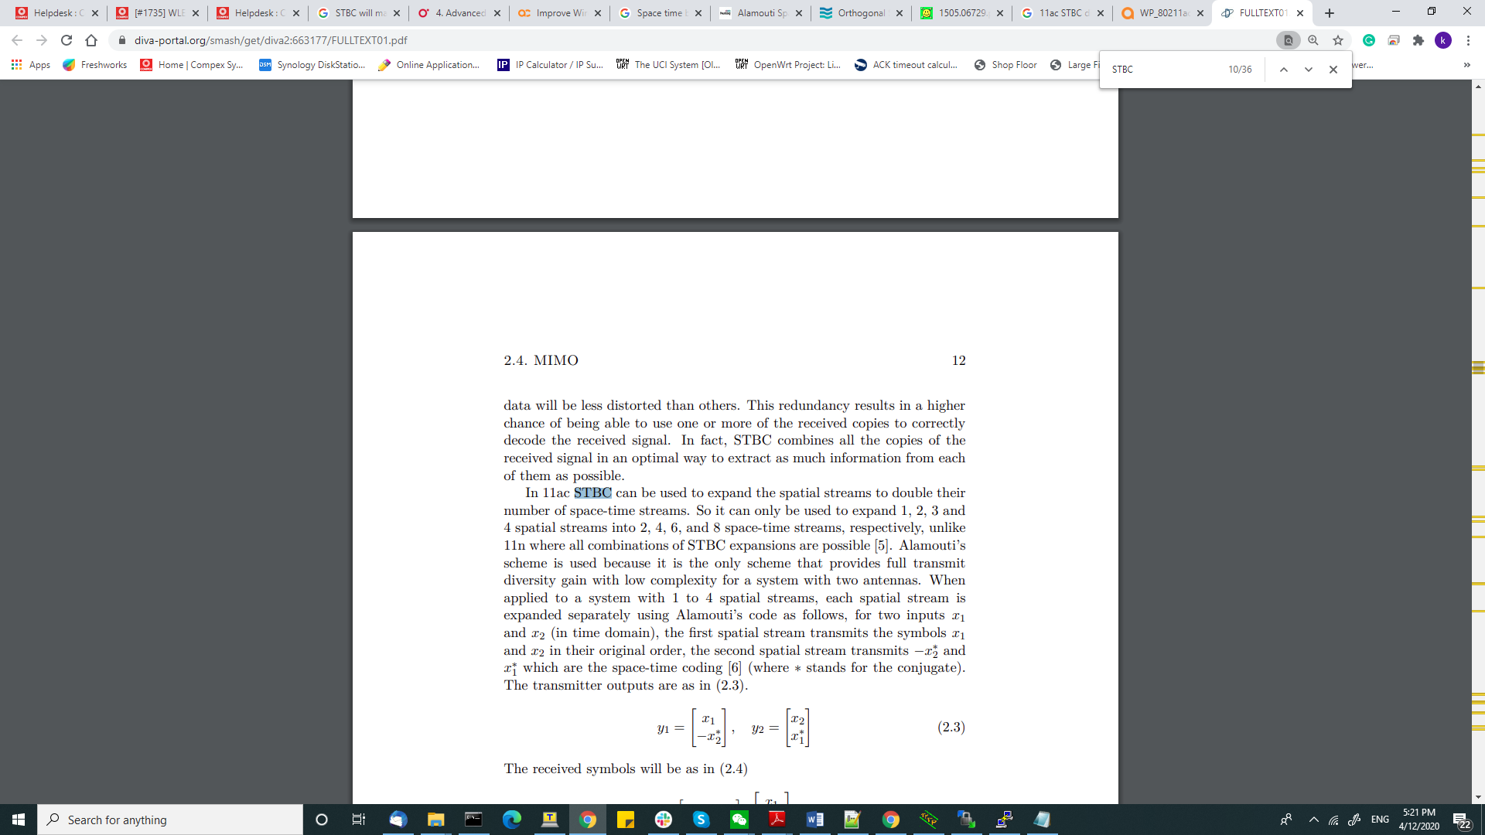

//HK01.2 to use PN module, if change dts c6

Pn can use on miniPCIE 1

//Hk01 to use PN module, if use original Hk01 firmware.

PN can use on miniPCIE 0

# //Flash Hk01 Firmware to support PN Module.

##进入uboot

//change cnss2_pci0 or pci1 according

setenv bootargs 'console=ttyMSM0,115200n8 cnss2.bdf_pci0=0xa5'

setenv machid 8010500

saveenv

tftpboot 0x44000000 norplusnand-ipq807x_PN_Hk012-single.img

imgaddr=0x44000000 && source $imgaddr:script

reset

##再次进入uboot -> optional for WLE3000 Series

输入 “smeminfo” 指令查看WIFIFW的位置， 如下:

20: 0:WIFIFW 0x0100ffff 0x3400000 0xa00000

- tftpboot 0x44000000 wifi_fw_ipq8074_qcn9000_ubi_v2.img

- nand erase 0x3400000 0xa00000

- nand write 0x44000000 0x3400000 $filesize

For PN 02.1 => 5Ghz

setenv bootargs 'console=ttyMSM0,115200n8 cnss2.bdf_pc1=0xa0'

saveenv

res

For PN01.1 => 2.4Ghz

setenv bootargs 'console=ttyMSM0,115200n8 cnss2.bdf_pci1=0xa1'

saveenv

res

RM500Q GL

有以下命令请试一下

# show current interface:  
quectel-inf  
# set pcie interface:  
quectel-inf pcie  
# set usb interface:  
quectel-inf usb

**//Set uboot env inside fw HK01.2**

root@OpenWrt:~# fw_printenv

baudrate=115200

bootargs=console=ttyMSM0,115200n8 cnss2.bdf_pci0=0xa2

bootcmd=bootipq

bootdelay=2

ethact=eth0

ethaddr=00:03:7f:ba:db:ad

fdt_high=0x4A400000

fdtcontroladdr=4a96c460

fileaddr=465d302c

filesize=3e0000

flash_type=7

ipaddr=192.168.1.1

machid=8010500

netmask=255.255.255.0

serverip=192.168.1.10

soc_version_major=2

soc_version_minor=0

stderr=serial@78B3000

stdin=serial@78B3000

stdout=serial@78B3000

root@OpenWrt:~# fw_setenv bootargs console=ttyMSM0,115200n8 cnss2.bdf_pci0=0xa2

# //PCIE interrupt issue for qca988x:

* Ticket **1772**

[ 6.992694] NET: Registered protocol family 24

[ 7.016261] ath10k_pci 0000:00:00.0: pci irq msi oper_irq_mode 2 irq_mode 0 reset_mode 0

[ 7.259494] ath10k_pci 0000:00:00.0: Direct firmware load for ath10k/pre-cal-pci-0000:00:00.0.bin failed with error -2

[ 11.334089] ath10k_pci 0002:04:00.0: failed to receive control response completion, polling..

Suspected your issue may related to PCIe slot interrupt mode. Find this file **drivers/net/wireless/ath/ath10k/pci.c**in your LSDK source, modify the following :

​

**From:**

**static unsigned int ath10k_pci_irq_mode = ATH10K_PCI_IRQ_AUTO;**  
  
**To:**

**static unsigned int ath10k_pci_irq_mode = ATH10K_PCI_IRQ_LEGACY;**

Recompile your firmware and try again.

# //WPQ873 printenv

IPQ807x# printenv

baudrate=115200

bootargs=console=ttyMSM0,115200n8

bootcmd=bootipq

bootdelay=1

eth1addr=4:f0:21:63:18:e6

eth2addr=4:f0:21:63:18:e7

eth3addr=4:f0:21:63:18:e8

eth4addr=4:f0:21:63:18:e9

ethact=eth0

ethaddr=4:f0:21:63:18:e5

fdt_high=0x4A400000

fdtcontroladdr=4a96fea0

flash_type=7

ipaddr=192.168.1.1

machid=8010008

netmask=255.255.255.0

serverip=192.168.1.10

soc_version_major=2

soc_version_minor=0

stderr=serial@78B3000

stdin=serial@78B3000

# PCIe speed

* s **Base Clock Speed:** PCIe 3.0 = 8.0GHz, PCIe 2.0 = 5.0GHz, PCIe 1.1 = 2.5GHz
* **Data Rate:** PCIe 3.0 = 1000MB/s, PCIe 2.0 = 500MB/s, PCIe 1.1 = 250MB/s
* **Total Bandwidth:** (x16 link): PCIe 3.0 = 32GB/s, PCIe 2.0 = 16GB/s, PCIe 1.1 = 8GB/s
* **Data Transfer Rate:** PCIe 3.0 = 8.0GT/s, PCIe 2.0= 5.0GT/s, PCIe 1.1 = 2.5GT/s

# //USB speed

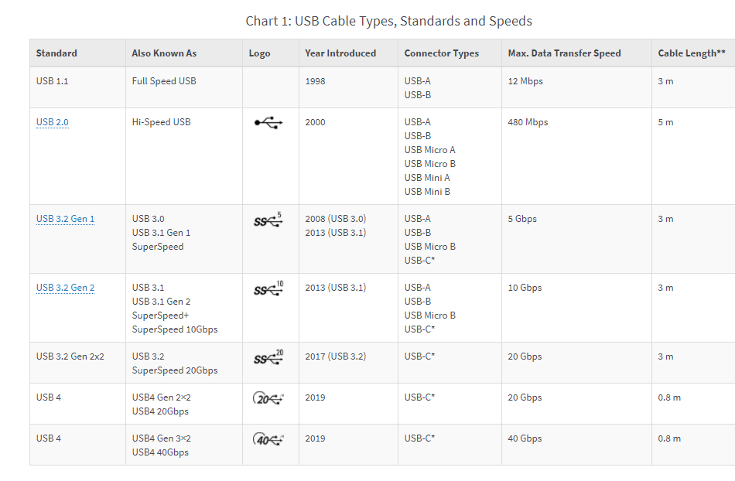

# WiFI CAC = Channel Availability Check

ity Check 4.7.2.1.1 Definition The Channel Availability Check (CAC) is defined as a mechanism by which a RLAN device checks a channel for the presence of radar signals. This mechanism is used for identifying Available Channels. There shall be no transmissions by the device within the channel being checked during this process. If no radars have been detected, the channel becomes an Available

# // Autoreboot based on date and time command:

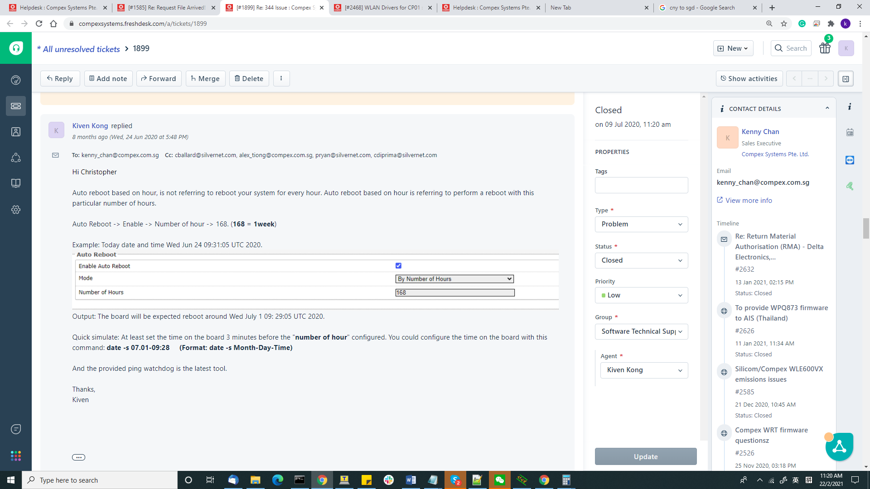

Output: The board will be expected reboot around Wed July 1 09: 29:05 UTC 2020.

Quick simulate: At least set the time on the board 3 minutes before the "**number of hour**" configured. You could configure the time on the board with this command: **date -s 07.01-09:28     (Format: date -s Month-Day-Time)**

# // Change CPIO State/Export

Example, control GPIO 19.

echo 19> /sys/class/gpio/exportecho out > /sys/class/gpio/gpio70/direction  
  
**To change output state:**  
echo 0 > /sys/class/gpio/gpio70/value  
echo 1 > /sys/class/gpio/gpio70/value

**To read the output state:**  
  
cat /sys/class/gpio/gpio70/value

//872 LED

cd /sys/devices/platform/soc/soc:leds/leds/led1_b

echo 255 > brightness

# // WPA3+ SAE Conf

AP Configuration:

uci set wireless.@wifi-iface[0].encryption='psk2+ccmp'

uci set wireless.@wifi-iface[0].key='1234567890'

uci set wireless.@wifi-iface[0].sae='1'

uci add_list wireless.@wifi-iface[1].sae_password='1234567890'

uci set wireless.@wifi-iface[0].ieee80211w='2'

uci commit wireless

wifi

Expected output:

root@OpenWrt:~# uci show wireless

wireless.wifi0=wifi-device

wireless.wifi0.type='qcawificfg80211'

wireless.wifi0.channel='auto'

wireless.wifi0.macaddr='04:f0:21:64:1e:c3'

wireless.wifi0.hwmode='11axa'

wireless.wifi0.disabled='0'

wireless.wifi0.htmode='HT80'

wireless.@wifi-iface[0]=wifi-iface

wireless.@wifi-iface[0].device='wifi0'

wireless.@wifi-iface[0].network='lan'

wireless.@wifi-iface[0].mode='ap'

wireless.@wifi-iface[0].ssid='5GLAB1'

wireless.@wifi-iface[0].wds='1'

wireless.@wifi-iface[0].encryption='psk2+ccmp'

wireless.@wifi-iface[0].key='1234567890'

wireless.@wifi-iface[0].ieee80211w='2'

wireless.@wifi-iface[0].sae='1'

wireless.@wifi-iface[0].sae_password='1234567890'

Client configuration:

uci set wireless.@wifi-iface[0].mode='sta'

wireless.@wifi-iface[0].wds='1'

wireless.@wifi-iface[0].sae='1'

wireless.@wifi-iface[0].ieee80211w='2'

wireless.@wifi-iface[0].encryption='psk2+ccmp'

wireless.@wifi-iface[0].sae_password='1234567890'

uci set wireless.@wifi-iface[0].key='1234567890'

root@OpenWrt:/# uci show wireless

wireless.wifi0=wifi-device

wireless.wifi0.type='qcawificfg80211'

wireless.wifi0.channel='auto'

wireless.wifi0.macaddr='00:03:7f:12:10:1f'

wireless.wifi0.htmode='VHT80'

wireless.wifi0.disabled='0'

wireless.wifi0.hwmode='11axa'

wireless.@wifi-iface[0]=wifi-iface

wireless.@wifi-iface[0].device='wifi0'

wireless.@wifi-iface[0].mode='sta'

wireless.@wifi-iface[0].wds='1'

wireless.@wifi-iface[0].ssid='5GLAB1'

wireless.@wifi-iface[0].sae='1'

wireless.@wifi-iface[0].ieee80211w='2'

wireless.@wifi-iface[0].network='lan'

wireless.@wifi-iface[0].encryption='psk2+ccmp'

wireless.@wifi-iface[0].sae_password='1234567890'

[wireless.@wifi-iface[0].key='1234567890](mailto:wireless.@wifi-iface[0].key='1234567890)'

# ## HK10 刷固件指令： to test 1500H5

setenv ipaddr 192.168.1.1 && setenv serverip 192.168.1.10 && ping $serverip

setenv bootargs 'console=ttyMSM0,115200n8 cnss2.bdf_pci0=0xa2'

setenv machid 801000e

saveenv

tftpboot 0x44000000 SPF113_csu1_norplusnand-ipq807x-single_B210302.img

imgaddr=0x44000000 && source $imgaddr:script

reset

//Flash wifi fw format

tftpboot 0x44000000 wifi_fw_ubi_WLE3000_WLE1500_QCN90x4_b04082021.img

nand erase <WIFIFW_start_address> <WIFIFW_size>

nand write 0x44000000 <WIFIFW_start_address> $filesize

reset

//actual cmd

//pcie 1 for HK01.2?

tftpboot 0x44000000 wifi_fw_ubi_WLE3000_WLE1500_QCN90x4_b04082021.img

nand erase 0x3400000 0x800000

nand write 0x44000000 0x3400000 $filesize

reset

## WLE15000-H5 uboot 设置

setenv bootargs 'console=ttyMSM0,115200n8 cnss2.bdf_pci0=0xa5'

saveenv

reset

## WLE1500-H2 uboot 设置

setenv bootargs 'console=ttyMSM0,115200n8 cnss2.bdf_pci0=0xa6'

saveenv

reset

**EM9191 or EM7160 show ICCID**

root@MimoAP:/tmp# cat ltesim.log

readystate: 0001 - initialized

simiccid: 8965051942295070764F

subscriberid: 525058182633826

root@MimoAP:/tmp# cat infod.log

29.61 ~~1~~ 1199, 90d3, , 0, AT^ICCID?, /dev/cdc-wdm0

29.62 ~~2~~ 0

29.62 ~~6~~ 0, 1

30.36 ~~7~~ 0,

30.37 ~~2.1~~ , , , AT^ICCID?,

8042.10 ~~1~~ 1199, 90d3, , 0, AT^ICCID?, /dev/cdc-wdm0

8042.11 ~~2~~ 0

8042.11 ~~6~~ 0, 1

8042.94 ~~7~~ 0,

8042.95 ~~2.1~~ , , , AT^ICCID?,

8141.20 ~~1~~ 1199, 90d3, , 0, AT^ICCID?, /dev/cdc-wdm0

8141.21 ~~2~~ 0

8141.22 ~~6~~ 0, 1

8142.01 ~~7~~ 0,

8142.02 ~~2.1~~ , , , AT^ICCID?,

# // CLI command for backup/restore config

//Please ensure allow login with root password is enable !

1， Backup Config file , under Serial Console of Board

#Generate backup

umask go=sysupgrade -b /tmp/backup-${HOSTNAME}-$(date +%F).tar.gz

ls /tmp/backup-*.tar.gz

# Download backup, from window cmd, execute following command:

scp root@192.168.1.1:/tmp/backup-*.tar.gz .

2. Restore -> Upload backup from PC to board

# Upload Backup

scp root@192.168.1.1:/tmp/backup-*.tar.gz .

#restore backup

ls /tmp/backup-*.tar.gz

sysupgrade -r /tmp/backup-*.tar.gz

# wireless Tx-rx statistic etc in linux

root@MimoAP:/sys/devices/virtual/net/wifi0/statistics# ls

collisions rx_frame_errors tx_compressed

multicast rx_length_errors tx_dropped

rx_bytes rx_missed_errors tx_errors

rx_compressed rx_over_errors tx_fifo_errors

rx_crc_errors rx_packets tx_heartbeat_errors

rx_dropped tx_aborted_errors tx_packets

rx_errors tx_bytes tx_window_errors

rx_fifo_errors tx_carrier_errors

root@MimoAP:/sys/devices/virtual/net/wifi0/statistics# cat rx_frame_errors

0

root@MimoAP:/sys/devices/virtual/net/wifi0/statistics# cat rx_packets

# ///hostapd eap.conf

ctrl_interface=/etc

interface=wlan1

ssid=AP_24G

hw_mode=g

ht_capab=[HT40-][SHORT-GI-20][SHORT-GI-40]

channel=11

auth_algs=1

ieee80211n=1

ieee80211ax=1

wmm_enabled=1

dtim_period=1

auth_algs=1

wpa=1

ieee8021x=1

Auth_server_addr=192.168.1.10 //IP address of the radius server

auth_server_port=1812

Auth_server_shared_secret=testing123 //pre-shared secret word

wpa_key_mgmt=WPA-EAP

wpa_pairwise=TKIP

**WLE3000H25**

**//load board data**

WinSCP this BDF to directory /lib/firmware/qcn9000

vi /etc/init.d/wifi_fw_mount

:119 ##go to line 119

change this line "cd qcn9000 && ln -sf /lib/firmware/" to "cd qcn9000 && ln -s /lib/firmware/"

:wq ##save the changes

cd /lib/firmware/qcn9000

ln –sf WLE1500-H5-bdwlan-ba5.bin bdwlan.ba5

reboot

board data number = ba0 = WLE3000H5

board data number = ba1 = WLE3000H2

**Erase EEPROM data for PN9074 and skip driver read cal data**

For SPF11.1 or 11.2

1. Stop the u-boot autoboot. Enter this command:   
setenv bootargs "console=ttyMSM0,115200n8 cnss2.bdf_pci0=0xa2 cnss2.flashcal_support=0" && bootipq   
- the flashcal_support=0 parameter cause the driver not to use the current caldata, the board should boot normally   
  
2. Reload the driver in testmode:   
uci set wireless.qcawifi=qcawifi   
uci set wireless.qcawifi.testmode='1'   
uci commit   
sync   
wifi load   
- use this command to confirm the driver is in testmode   
cat /sys/module/qca_ol/parameters/testmode   
  
3. Erase the eeprom using this command   
qcatestcmd -i wifi2 --eepromerase   
- to dump the eeprom contents,   
qcatestcmd -i wifi2 --eepromdump

//qcatestcmd with size

qcatestcmd -i wifi0 --eepromdump --totalsize 1024 --offset 4096 --blocksize 1000  
  
4. To save some time, the on chip radio can be disabled via bootargs in uboot   
setenv bootargs "console=ttyMSM0,115200n8 cnss2.bdf_pci0=0xa0 cnss2.skip_cnss=2"   
- only wifi0 (qcn9000) will appear if the above is used.   
- skip_cnss=1 to skip all, 3 to skip pci qcn9000

**For new SPF11.3 //skip driver to read cal data**

setenv bootargs ‘console=ttyMSM0,115200n8 cnss2.bdf_pci0=0xa2 cnss2.disable_caldata_bmap=0x2

Bmap = ？

0x0 onboard

0x1 pcie 0

0x2 pcie 1

# Check Wireless Statistic

 cat /sys/devices/virtual/net/wlan0/statistics

# AT Comamnd to enter FTM mode for Sierra Wireless EM7690/EM9191

AT!ENTERCND="A710"

AT!DAFTMACT

AT!DASUB6TECHACT=1

Set band without MIMO -> For MAIN port, 39200 = 1960 Mhz

AT!DAUPDATEPARAM=18,2

AT!DARCONFIG=0,6,2,376000,5,392000

Test with -30dBm (For MAIN and AUX)

AT!DAGFTMRXAGC=0,6,-300,0

AT!DAGFTMRXAGC=0,6,-300,3

In order to test MIMO port

AT!DARCONFIGDROP=6

AT!DAUPDATEPARAM=18,2

AT!DARCONFIG=0,6,2,376000,5,392000,1

Test with -30dBm (For MIMO Port)

AT!DAGFTMRXAGC=0,6,-300,1

AT!DAGFTMRXAGC=0,6,-300,2

Disable FTM mode

AT!DARCONFIGDROP=6

AT!DASUB6TECHACT=0

Show AT command

ate1

# 11ax radio qcatestcmd (tgt pw)

rmmod monitor

rmmod wifi_3_0

rmmod wifi_2_0

rmmod qca_ol

insmod qca_ol testmode=1

insmod wifi_3_0

insmod wifi_2_0

/etc/init.d/ftm start

ftm -n -dd &

//For calibration

rmmod monitor

rmmod wifi_3_0

rmmod wifi_2_0

rmmod qca_ol

insmod qca_ol testmode=1

insmod wifi_3_0

insmod wifi_2_0

sleep 1

diag_socket_app -a 192.168.1.10 &

/etc/init.d/ftm start

ftm -n -dd &

**Second : Paste each line of command to check the tgt power**

**11**axg **2.4Ghz HE20**

**MCS 0**

qcatestcmd -i wifi1 --tx tx99 --phyId 1 --txfreq 2412 --txrate 20 --rateBw 8 --nss 1 --tpcm tgtpwr --txchain 1

qcatestcmd -i wifi1 --tx tx99 --phyId 1 --txfreq 2412 --txrate 20 --rateBw 8 --nss 1 --tpcm tgtpwr --txchain 2

qcatestcmd -i wifi1 --tx tx99 --phyId 1 --txfreq 2412 --txrate 20 --rateBw 8 --nss 1 --tpcm tgtpwr --txchain 4

qcatestcmd -i wifi1 --tx tx99 --phyId 1 --txfreq 2412 --txrate 20 --rateBw 8 --nss 1 --tpcm tgtpwr --txchain 8

**MCS 6**

qcatestcmd -i wifi1 --tx tx99 --phyId 1 --txfreq 2412 --txrate 26 --rateBw 8 --nss 1 --tpcm tgtpwr --txchain 1

qcatestcmd -i wifi1 --tx tx99 --phyId 1 --txfreq 2412 --txrate 26 --rateBw 8 --nss 1 --tpcm tgtpwr --txchain 2

qcatestcmd -i wifi1 --tx tx99 --phyId 1 --txfreq 2412 --txrate 26 --rateBw 8 --nss 1 --tpcm tgtpwr --txchain 4

qcatestcmd -i wifi1 --tx tx99 --phyId 1 --txfreq 2412 --txrate 26 --rateBw 8 --nss 1 --tpcm tgtpwr --txchain 8

**MCS 11**

qcatestcmd -i wifi1 --tx tx99 --phyId 1 --txfreq 2412 --txrate 31 --rateBw 8 --nss 1 --tpcm tgtpwr --txchain 1

qcatestcmd -i wifi1 --tx tx99 --phyId 1 --txfreq 2412 --txrate 31 --rateBw 8 --nss 1 --tpcm tgtpwr --txchain 2

qcatestcmd -i wifi1 --tx tx99 --phyId 1 --txfreq 2412 --txrate 31 --rateBw 8 --nss 1 --tpcm tgtpwr --txchain 4

qcatestcmd -i wifi1 --tx tx99 --phyId 1 --txfreq 2412 --txrate 31 --rateBw 8 --nss 1 --tpcm tgtpwr --txchain 8

**11axa 5Ghz HE20**

**MCS 0**

qcatestcmd -i wifi0 --tx tx99 --phyId 0 --txfreq 5180 --txrate 20 --rateBw 8 --nss 1 --tpcm tgtpwr --txchain 1

qcatestcmd -i wifi0 --tx tx99 --phyId 0 --txfreq 5180 --txrate 20 --rateBw 8 --nss 1 --tpcm tgtpwr --txchain 2

qcatestcmd -i wifi0 --tx tx99 --phyId 0 --txfreq 5180 --txrate 20 --rateBw 8 --nss 1 --tpcm tgtpwr --txchain 4

qcatestcmd -i wifi0 --tx tx99 --phyId 0 --txfreq 5180 --txrate 20 --rateBw 8 --nss 1 --tpcm tgtpwr --txchain 8

**MCS 6**

qcatestcmd -i wifi2 --tx tx99 --phyId 0 --txfreq 5180 --txrate 26 --rateBw 8 --nss 1 --tpcm tgtpwr --txchain 1

qcatestcmd -i wifi0 --tx tx99 --phyId 0 --txfreq 5180 --txrate 26 --rateBw 8 --nss 1 --tpcm tgtpwr --txchain 2

qcatestcmd -i wifi0 --tx tx99 --phyId 0 --txfreq 5180 --txrate 26 --rateBw 8 --nss 1 --tpcm tgtpwr --txchain 4

qcatestcmd -i wifi0 --tx tx99 --phyId 0 --txfreq 5180 --txrate 26 --rateBw 8 --nss 1 --tpcm tgtpwr --txchain 8

**MCS 11**

qcatestcmd -i wifi2 --tx tx99 --phyId 0 --txfreq 5180 --txrate 31 --rateBw 8 --nss 1 --tpcm tgtpwr --txchain 1

qcatestcmd -i wifi0 --tx tx99 --phyId 0 --txfreq 5180 --txrate 31 --rateBw 8 --nss 1 --tpcm tgtpwr --txchain 2

qcatestcmd -i wifi0 --tx tx99 --phyId 0 --txfreq 5180 --txrate 31 --rateBw 8 --nss 1 --tpcm tgtpwr --txchain 4

qcatestcmd -i wifi0 --tx tx99 --phyId 0 --txfreq 5180 --txrate 31 --rateBw 8 --nss 1 --tpcm tgtpwr --txchain 8

# //measure txpower

qcatestcmd -i wifi2 --tx tx99 --phyId 0 --txfreq 5180 --txrate 20 --rateBw 8 --nss 1 --mode vht20 --txpwr 28 --txchain 15

qcatestcmd -i wifi2 --tx off

Test firmware in:

Prelease\ROUTER\AP.HK09\qca-reference\spf114csu1\b210716-lm512

bdwlan.bin is same as bdwlan.b290   
In default build, bdwlan.bin is same as bdwlan.b210, this will also cause firmware crash.   
To try wpq872 custom bdwlan:   
cd /lib/firmware/IPQ8074   
ln -sf /lib/firmware/IPQ8074/WIFI_FW/wpq872-bdwlan.b290 bdwlan.bin

To enable AT command using minicom?

**To save minicom output? The ***.txt will save the corresponding infor

**minicom -C test.txt**

1) minicom –s

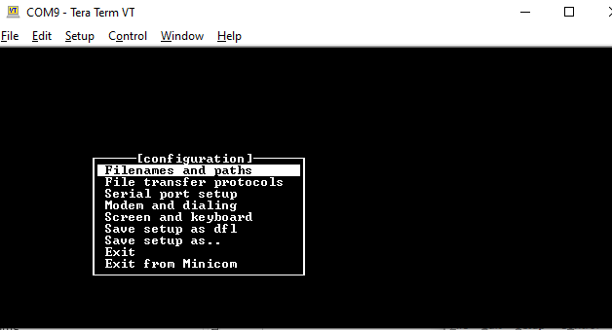

2) Serial Port Setup -> Serial Device -> A -> ttySS1 -> ttyUSB0 -> Enter -> Enter

3) save setup as 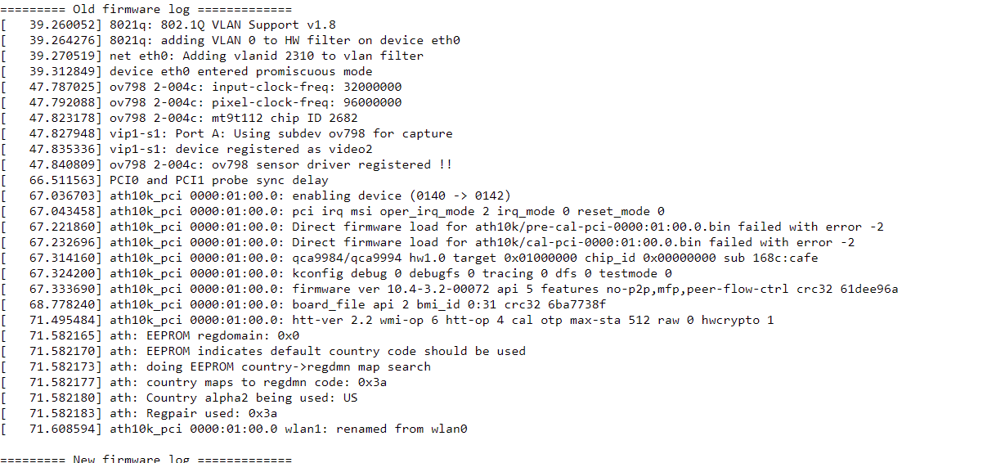dfl

4) Exit

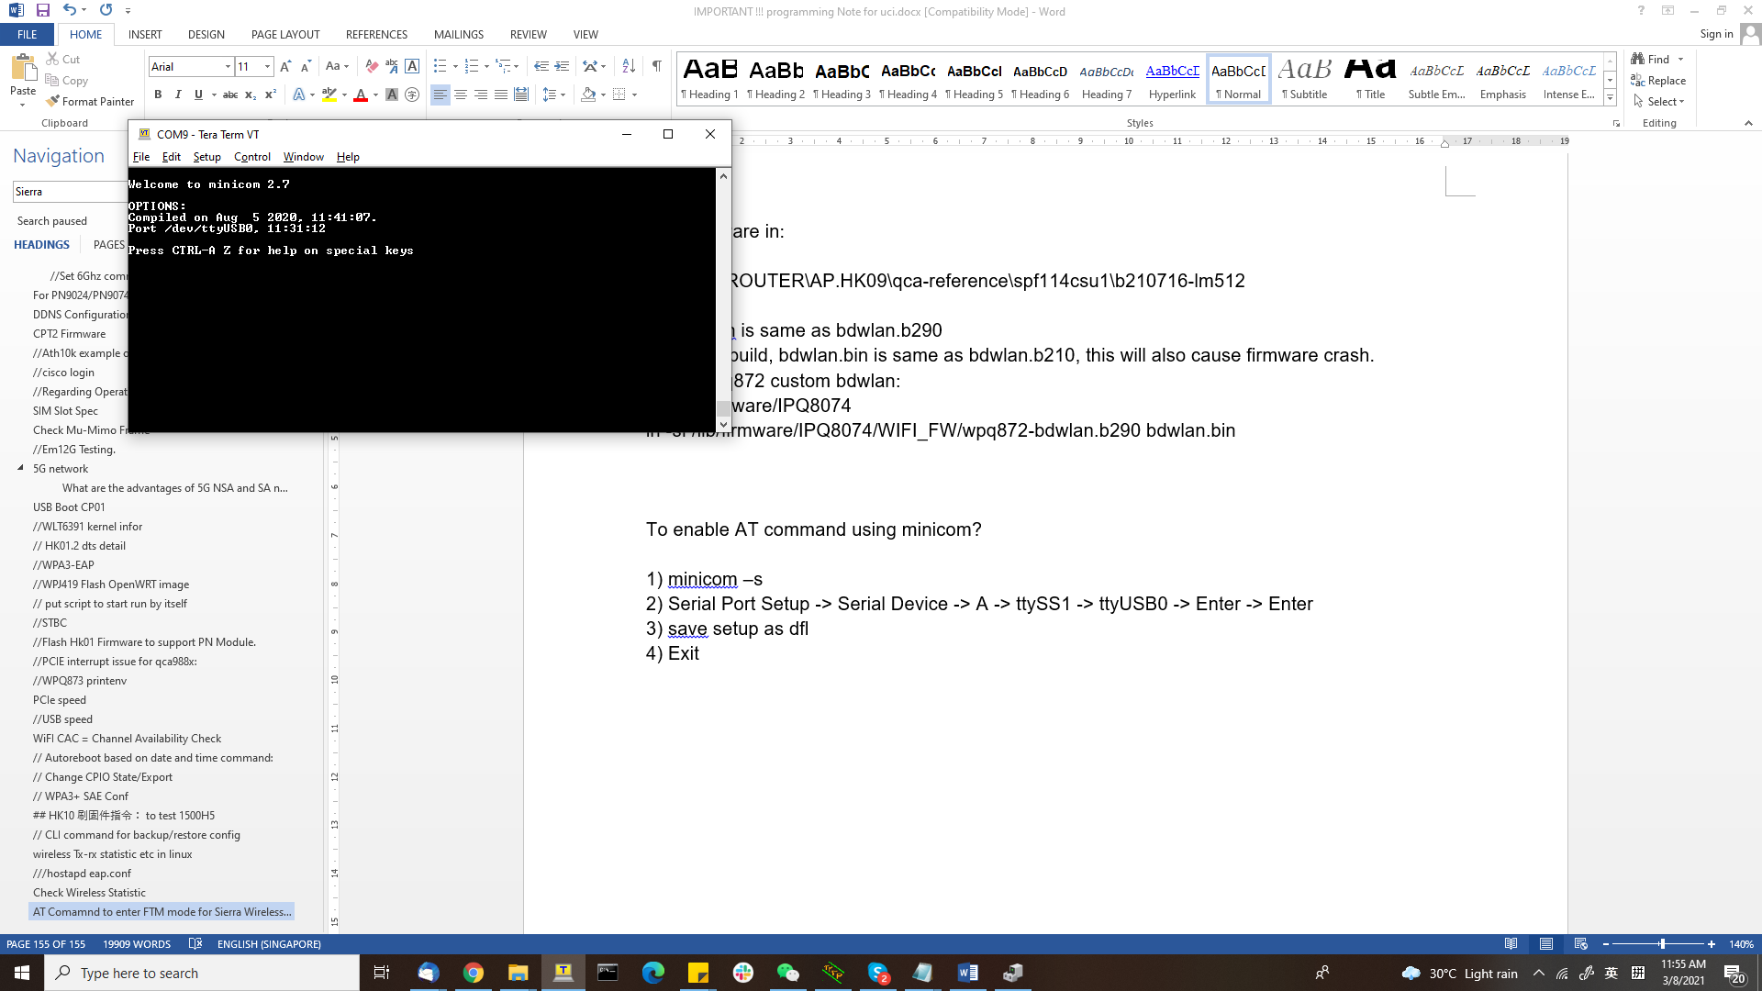

5) to exit from minicom, press ctrl + a, then press “z”, then press “x”

6) Modem image ver: **AT!IMAGE?**

**Convert Board data from .txt to .bin**

1. cd C:\Users\RD\Desktop\SPF11-3-CS-bdfUtil\bdfConvert

2. python txt2bin.py SPF11-3-FC-pine6G-bdwlan-ba2.txt SPF11-3-FC-pine6G-bdwlan-ba2.bin

# Transfer Fimrware through tftp feature through Ethernet connection:

tftp -i 192.168.1.1 put "C:\Program Files\Tftpd64\openwrt-ipq-ipq807x-wpq873-ubi-factory.img"

qca4024 ble

/etc/init.d/qca-iot restart

/etc/init.d/ftm start

ftm –n &

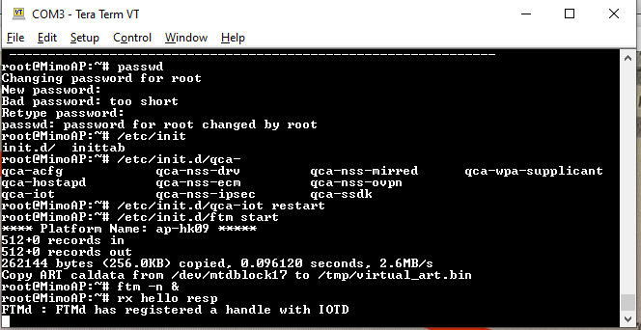

To write BLE MAC

1. First enable FTM amd ensure QPST must close

/etc/init.d/qca-iot restart

/etc/init.d/ftm start

ftm -n &

diag_socket_app -a 192.168.1.10 -p 2500&

2. Then proceed with following command:

( first command is to write BLE MAC, second is to read)

mfg_tool.exe --otptlv --write --tag=1 --sip=192.168.1.1 --port=2500 --file=BTS67892C.MAC

mfg_tool.exe --otptlv --read --tag=1 --sip=192.168.1.1 --port=2500

mfg_tool.exe --misc --fwup --trial --sip=192.168.1.1 --port=2500

mfg_tool.exe --misc --reboot --sip=192.168.1.1 --port=2500

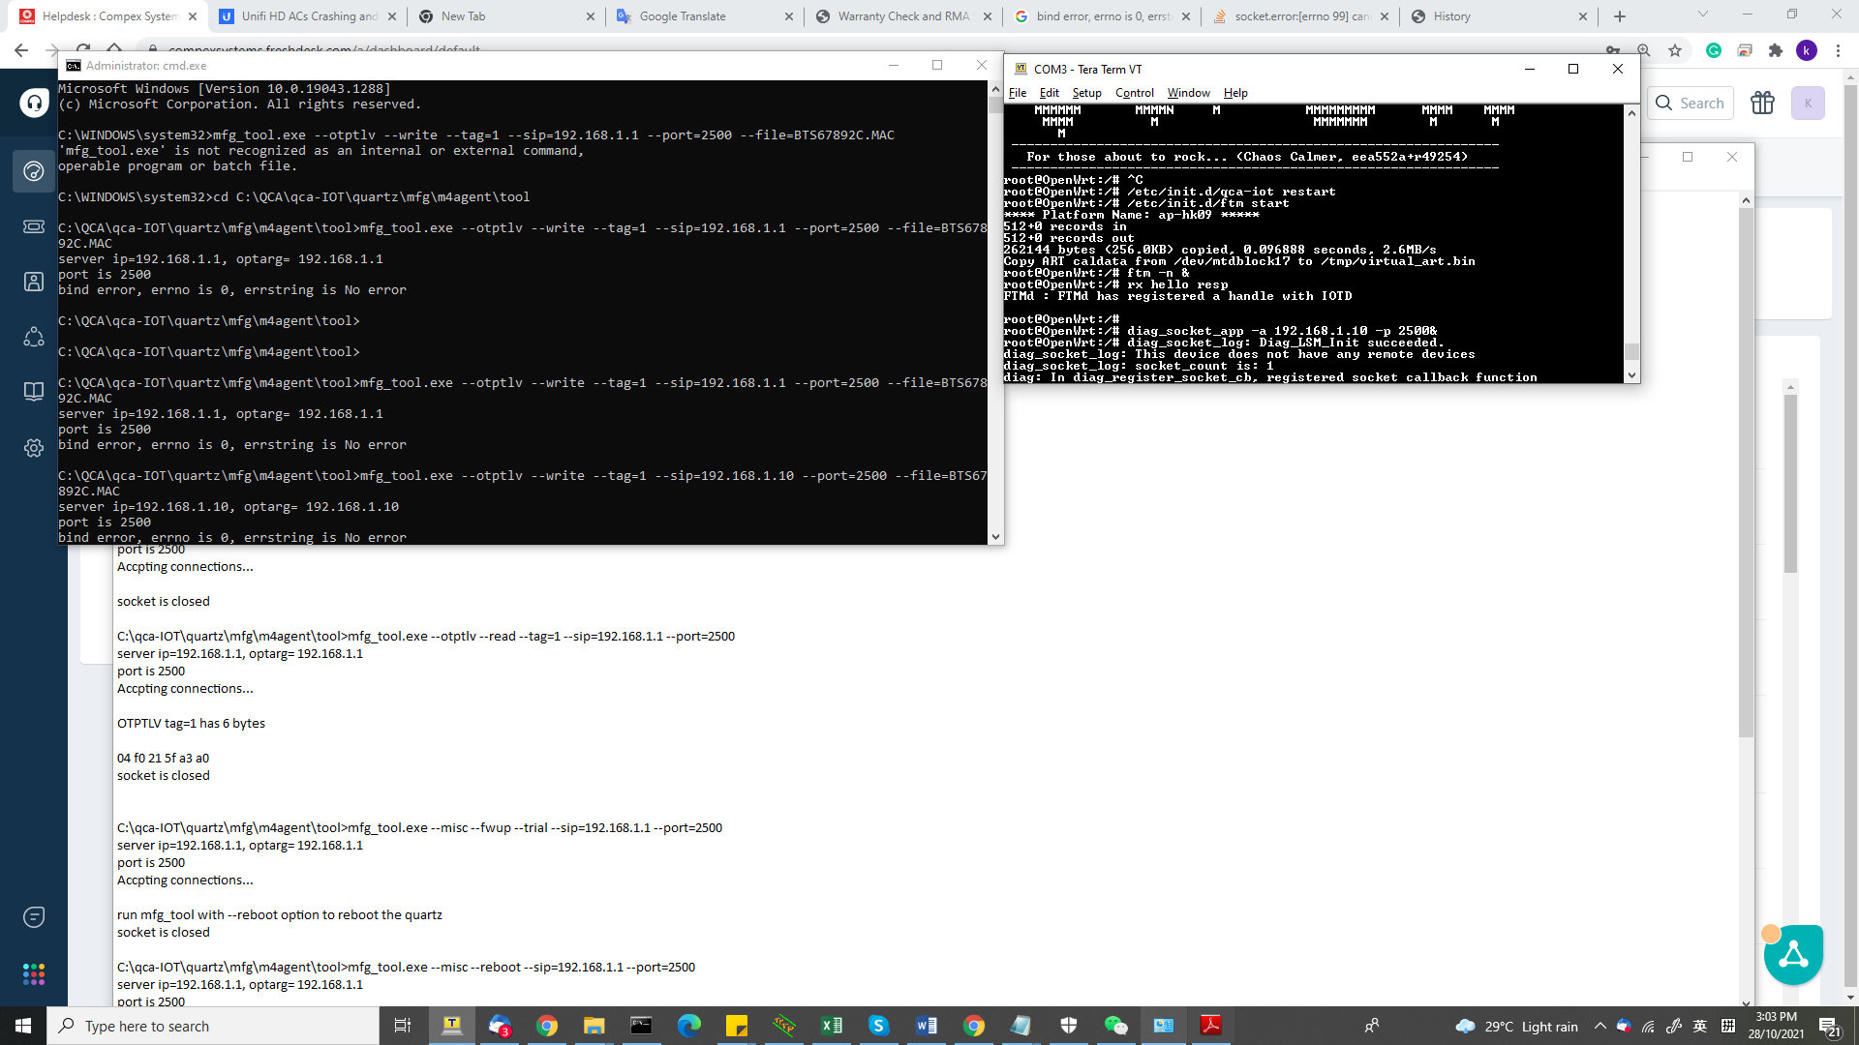

Example 11ax hostapd

interface=/etc

interface=wlan0

ssid=123abc

hw_mode=a

channel=auto

auth_algs=1

ieee80211n=1

ht_capab=[HT40+]

ieee80211ac=1

vht_oper_chwidth=1

ieee80211ax=1

he_oper_chwidth=1

wmm_enabled=1

dtim_period=1

wpa=2

wpa_passphrase=nicenice

wpa_key_mgmt=WPA-PSK

rsn_pairwise=CCMP

wpa_pairwise=CCMP

vht_capab=[MAX-MPDU-11454][RXLDPC][SHORT-GI-80][TX-STBC-2BY1][RX-STBC-1][MAX-A-MPDU-LEN-EXP7][RX-ANTENNA-PATTERN][TX-ANTENNA-PATTERN]

'iw dev wlan0 set bitrates vht-mcs-5 1:9', which means nss=1 mcs0-9 actuall

WLE3002HX

- based on spf 11.3 csu2 LM512 profile

- with WLE1500HX board data files, WLE1500HX_2G.bin and WLE1500HX_5G.bin

- the firmware will load the default bdwlan.bin file, which is same as

WLE1500HX_2G.bin in this firmware

- to use WLE1500HX_5G.bin, do:

cd /lib/firmware/IPQ8074/WIFI_FW/qcn9000

cp WLE1500HX_5G.bin bdwlan.bin

rm /etc/config/wireless

reboot

Under loader, set following:

setenv bootargs console=ttyMSM0,115200n8 cnss2.bdf_pci0=0xae

saveenv

reset

//Inside firmware, through winscp, duplicate the bae board data

copy the SPF-11-3-CSU1_WLE3002HX_bae_5G.bin and SPF-11-3 CSU1_WLE3002HX_baf_2G.bin to **/lib/firmware/ath11k/QCN9074/hw1.0/**

**Under winscp, duplicate the bab board data**

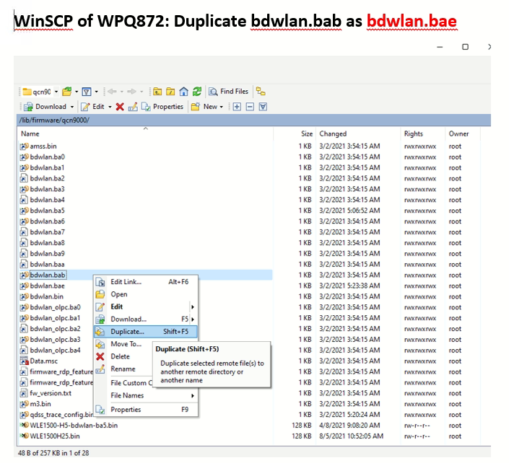

//link the board data

ln -sf SPF-11-3-CSU1_WLE3002HX_bae_5G.bin bdwlan.bae

ln –sf “destination” “source”

example link des to source

Spectral scan

ip link set dev wlan0 up

echo background > /sys/kernel/debug/ieee80211/phy0/ath11k/spectral_scan_ctl

echo trigger > /sys/kernel/debug/ieee80211/phy0/ath11k/spectral_scan_ctl

iw dev wlan0 scan

echo disable > /sys/kernel/debug/ieee80211/phy0/ath11k/spectral_scan_ctl

cat /sys/kernel/debug/ieee80211/phy0/ath11k/spectral_scan0 > samples

ath11k for open source

Exclude the request for SDK if this is the case. It's glad if you could attached any log for our debugging references.

Our Engineer found from the latest open source release, ath11k with kernel version: 5.14.21 could directly run the WLE3000H2 and WLE3000H5. For WiFi firmware, you can get it from the following link:

<https://github.com/kvalo/ath11k-firmware/tree/master/QCN9074/hw1.0/2.5.0.1/WLAN.HK.2.5.0.1-01100-QCAHKSWPL_SILICONZ-1>  
for amss.bin and m3.bin  
  
The board-2.bin from <https://source.codeaurora.org/quic/qsdk/oss/ath11k-bdf/tree/QCN9074/hw1.0/WLAN.HK.2.5.0.1/WLAN.HK.2.5.0.1-01100-QCAHKSWPL_SILICONZ-1> ​

iw

.

.

dev <devname> set bitrates [legacy-<2.4|5> <legacy rate in Mbps>*]

[ht-mcs-<2.4|5> <MCS index>*] [vht-mcs-<2.4|5> <NSS:MCSx,MCSy... | NSS:MCSx-MCSy>*]

will setup VHT, nss=2, mcs=9

iw wlanX set bitrates legacy-5 18 ht-mcs-5 vht-mcs-5

CP SPF driver details:

From the sample of CP appliance we have, the qca driver version match the following release： **qca-networking-2018-spf-6-1-0_qca_oem 2019-05-09 Commit label r6.1.0.r1_00003.0.200388.0** and this release note: **80-YB302-3_B_QCA_Networking_2018.SPF.6.1.0 CS Release Notes_B180830.** So QCA provide the corresponding built number: **spf 6.1 version r6.1.0.r1_00003.0.377630.0** for us to generate and release the patch for your references.

# Ath11k load and unload board data

ln –sf WLE3000H2.bin board.bin

The board data file will be loaded when ath11k_pci.ko is loaded.  
rmmod ath11k_pci  
modprobe ath11k_pci  
The above will reload the bdf.  
But the phy name will become phy1.  
The phy name will change every time the above are run.  
  
To keep the phy name as phy0, do  
rmmod ath11k_pci  
rmmod ath11k  
rmmod mac80211  
rmmod cfg80211  
modprobe ath11k_pci

# ****Fix An Incorrect Size USB Drive Using Command Prompt****

The wrong USB drive size issue can be fixed using Command Prompt as well. There’s a command that allows you to remove all the partitions, [format your drive](https://www.online-tech-tips.com/software-reviews/5-hard-drive-formatting-and-partitioning-utilities/), and then re-create partitions on the drive.

Open the **Start Menu**, search for **Command Prompt**, right-click on it when you see it in the results, and select **Run as administrator**.

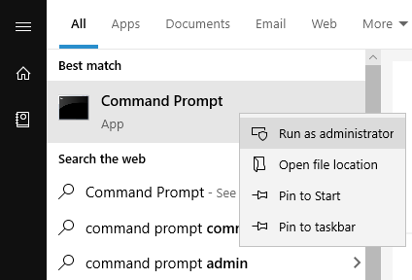

Type the following command into the Command Prompt window and hit **Enter**. It’ll launch the command-line version of the Disk Utility program.  
  
**diskpart**

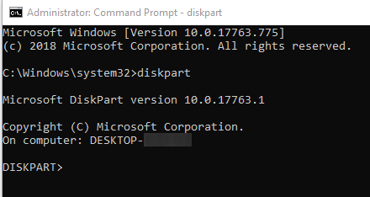

Type in the following command to view all the disks attached to your computer. Your USB drive will be one of these disks.  
  
**list disk**

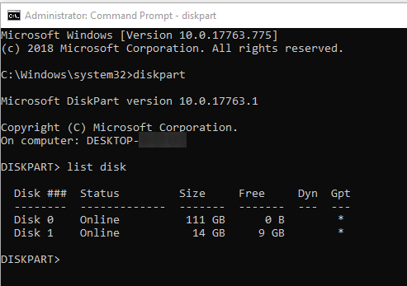

To perform an operation on your drive, run the following command replacing **N** with the actual number for your USB drive.  
  
**select disk N**

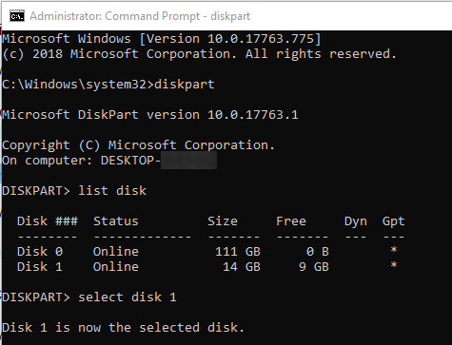

Use the following command to clean up your USB drive.  
  
**clean**

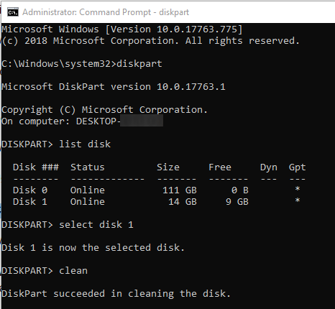

When the drive is cleaned, run the following command to create new partitions.  
  
**create partition primary**

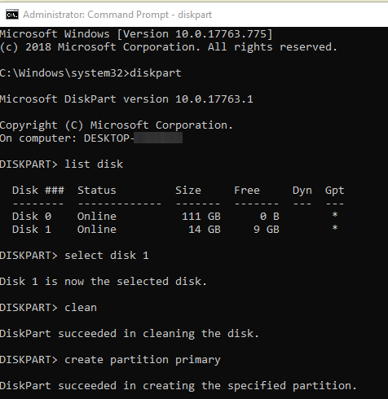

Finally, use the following command to format the drive to FAT32 format.  
  
**format fs=fat32 quick**

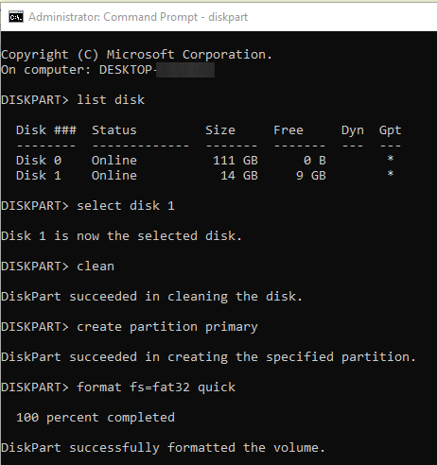

Once [your drive is formatted](https://www.online-tech-tips.com/computer-tips/windows-7-wants-to-format-your-usb-drive-ipod-and-sd-card/), you may need to unplug it and then plug it back into your computer. You’ll then find that your computer allows you to use the full storage capacity of your drive.

# WPQ873 ath11k fw

nand erase 0 3400000

tftpboot WPQ873_Ath11k.img

nand write $fileaddr 0 $filesize

# Extract a .gz file

tar –xvf

# Cannot read from /dev/random: Resource temporarily unavailable

issue

|  |  |
| --- | --- |
| 1 2 3 4 5 6 7 8 | Configuration file: /etc/hostapd/hostapd.conf Using interface wlp4s0 with hwaddr 3c:33:00:f6:67:2b and ssid "Codz" random: Cannot read from /dev/random: Resource temporarily unavailable random: Only 0/20 bytes of strong random data available from /dev/random random: Not enough entropy pool available for secure operations WPA: Not enough entropy in random pool for secure operations - update keys later when the first station connects wlp4s0: interface state UNINITIALIZED->ENABLED wlp4s0: AP-ENABLED |

Solution

mv /dev/random /dev/random.orig  
ln -s /dev/urandom /dev/random

# //WPA supplicant

iw dev wlan0 set 4addr on

ip link set dev wlan0 up

wpa_supplicant -D nl80211 -i wlan0 -c /etc/wpa2.conf & udhcpc -i wlan0

ifconfig wlan0 192.168.1.X

ping 192.168.1.X

//Ensure wlan0 IP subnet differ with br-lan IP, example if br-lan IP is 192.168.1.3, assign 2.3 to wlan0, or just remove br-lan IP.

wpa_supplicant -i wlan0 -D nl80211 -c /etc/wpa2.conf -b br-lan

wpa supplicant config

ctrl_interface=/var/run/wpa_qcn9000

network={

ssid="Mimo"

key_mgmt=NONE

scan_ssid=1

}

3002HX client mode:

wireless.wifi2=wifi-device

wireless.wifi2.type='qcawificfg80211'

wireless.wifi2.channel='auto'

wireless.wifi2.macaddr='04:f0:21:a1:c3:d7'

wireless.wifi2.hwmode='11axa'

wireless.wifi2.htmode='HT80'

wireless.wifi2.disabled='1'

wireless.@wifi-iface[2]=wifi-iface

wireless.@wifi-iface[2].device='wifi2'

wireless.@wifi-iface[2].network='lan'

wireless.@wifi-iface[2].encryption='none'

wireless.@wifi-iface[2].ssid='testath'

wireless.@wifi-iface[2].mode='sta'

wireless.@wifi-iface[2].extap='1'